Consumer Price Index - September 2026 | City of Tetouan
In September 2026, the consumer price index for households in the city of Tetouan increased by 0,4% compared to the previous month. On an annual level, the consumer price index increased by 1,2%.

Over a month, The food product price index increased by 0,9% in September 2026 compared to August 2026, due to the rise in prices of «Meats» by 3,7%, «Fruits» by 2,5%, «Milk, Cheese and Eggs» by 1,1%, «Bread and Cereals» by 1,0%, «Food Products not elsewhere classified» by 0,4%, «Mineral Waters, Soft Drinks, Fruit and Vegetable Juices» by 0,3% and «Sugar, Jam, Honey, Chocolate and Confectionery» by 0,2%.
Moreover, The monthly variation of the index for the non-food products stagnated following stagnation in prices of «Health». Also, the increase in prices of the following divisions: «Transports» by 1,0%, «Education» by 0,6%, «Clothing and Shoes» by 0,5% and «Various Goods and Services» by 0,1% and the decrease in prices of the following divisions: «Restaurants and Hotels» by 0,8%, «Furniture, Household Items and Routine Home Maintenance» by 0,7%, «Housing, Water, Gas, Electricity and Other Fuels» by 0,5%, «Leisure and Culture» by 0,4% and «Communications» by 0,3%, did not impact the general evolution.
Over a year, the food product price index decreased by 0,7% in September 2026 compared to September 2025 , due to the decrease in the prices of «Oils and Fats» by 18,7%, «Milk, Cheese and Eggs» by 4,1%, «Vegetables» by 3,9% and «Fish and Seafood» and «Fruits» by 2,9%. Moreover, the rise in prices of «Meats» by 12,0%, «Tobacco» by 4,0%, «Sugar, Jam, Honey, Chocolate and Confectionery» by 2,8%, «Food Products not elsewhere classified» by 1,7%, «Bread and Cereals» by 1,2%, «Mineral Waters, Soft Drinks, Fruit and Vegetable Juices» by 0,8% and «Cafe, Tea and Cocoa» by 0,2% did not affect the general evolution.
On the other hand, the annual variation in the non-food product index increased by 2,8%. While the price variation of the divisions that constitute non-food products fluctuated between a decrease of 2,0% for the division of «Leisure and Culture» and the rise of 15,1% for the division of «Transports»
3- Annual evolution (%) of the consumer price index for the month of September
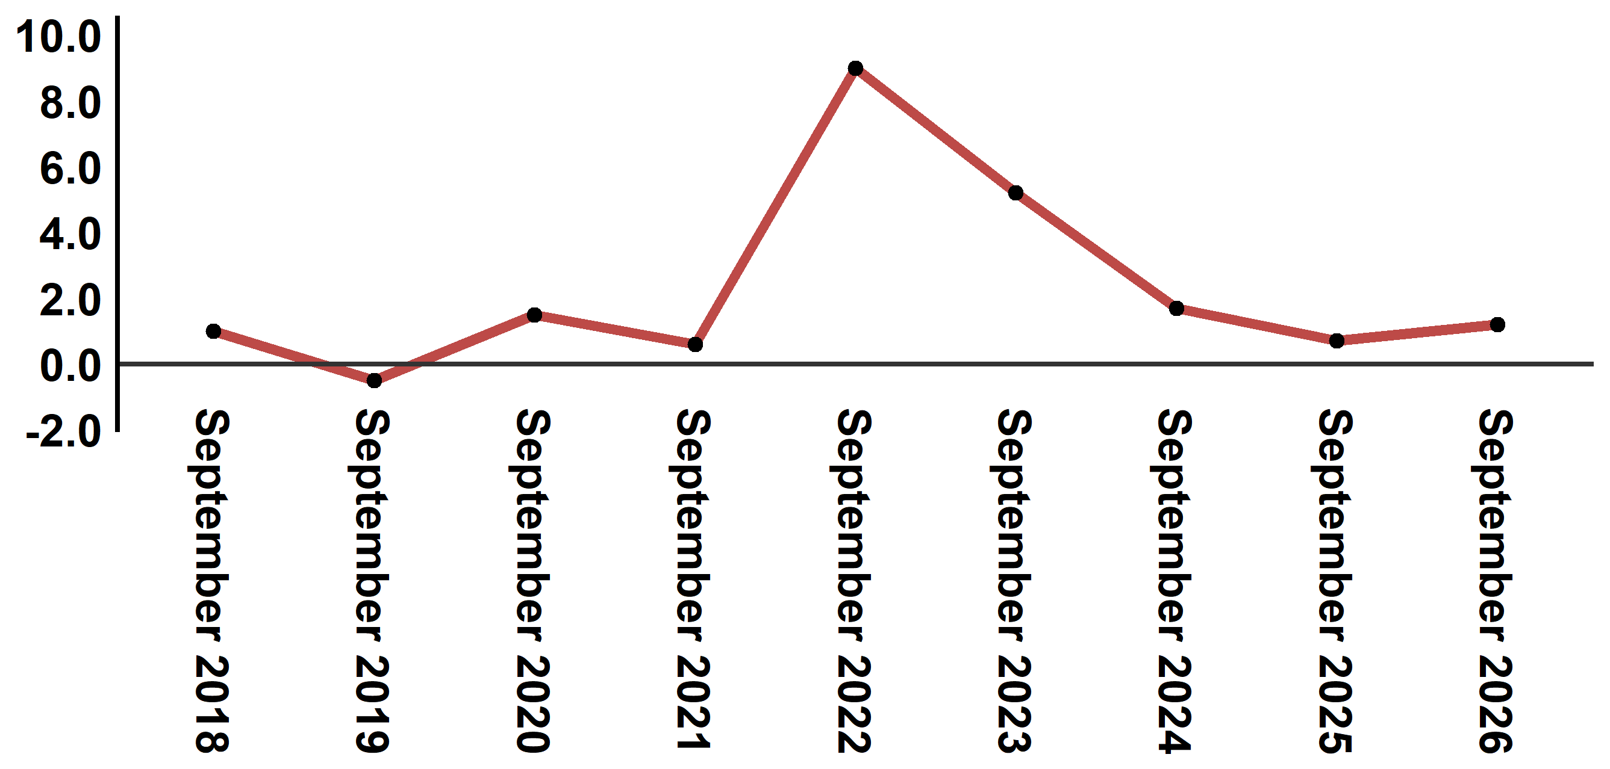
Reading: In September 2026, the consumer price index increased by 1,2% compared to September 2025
4- Evolution of the monthly variation (%) of the consumer price index
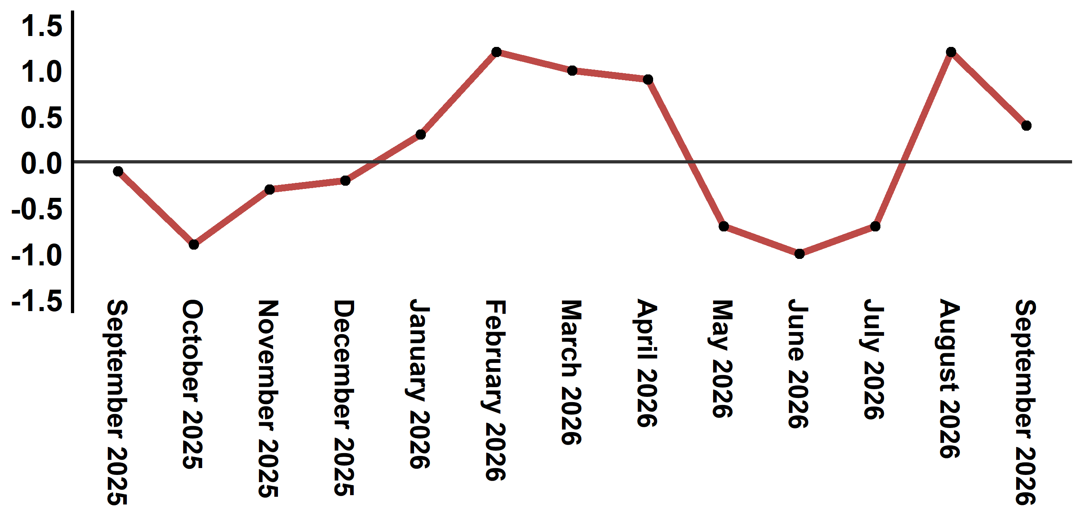
Reading: The level of price variation in September 2026 increased by 0,4% after being 1,2% in August 2026

Table 3: Consumer price index for the city of Tetouan: September 2026 (base 2017: 100)
Product Divisions | Weightings | Monthly index |  |  |  |  | Variation (%)
Product Divisions | Weightings | September 2025 | June 2026 | July 2026 | August 2026 | September 2026 | 1 month | 3 months | 12 months
Food products | 40,725 | 134,4 | 132,1 | 130,1 | 132,2 | 133,4 | 0,9 | 1,0 | -0,7
01 – Food products and non-alcoholic | 38,964 | 133,9 | 131,2 | 129,1 | 131,3 | 132,6 | 1,0 | 1,1 | -1,0
02 –Alcoholicbeverages and tobacco | 1,761 | 146,1 | 152,0 | 152,0 | 152,0 | 152,0 | 0,0 | 0,0 | 4,0
Non foodproducts | 59,275 | 112,1 | 114,3 | 114,2 | 115,2 | 115,2 | 0,0 | 0,8 | 2,8
03 – Clothing and shoes | 5,835 | 113,6 | 112,2 | 111,8 | 111,6 | 112,2 | 0,5 | 0,0 | -1,2
04 - Housing, water, gas, electricity and other fuel | 14,202 | 109,3 | 110,8 | 110,9 | 110,9 | 110,3 | -0,5 | -0,5 | 0,9
05- Furniture, household items and routine maintenance of the home | 5,602 | 110,8 | 111,6 | 111,4 | 111,5 | 110,7 | -0,7 | -0,8 | -0,1
06 –Health | 6,594 | 103,5 | 103,0 | 103,0 | 103,0 | 103,0 | 0,0 | 0,0 | -0,5
07 – Transport | 7,416 | 111,4 | 121,8 | 119,5 | 126,9 | 128,2 | 1,0 | 5,3 | 15,1
08 – Communication | 2,560 | 97,4 | 97,3 | 97,6 | 97,4 | 97,1 | -0,3 | -0,2 | -0,3
09 – Leisure and culture | 2,432 | 107,1 | 105,6 | 105,4 | 105,4 | 105,0 | -0,4 | -0,6 | -2,0
10 –Education | 5,358 | 128,6 | 129,5 | 129,5 | 129,5 | 130,3 | 0,6 | 0,6 | 1,3
11 - Restaurants and hotels | 2,468 | 116,7 | 123,1 | 129,1 | 130,2 | 129,2 | -0,8 | 5,0 | 10,7
12 – Variousgoods and services | 6,808 | 119,5 | 122,4 | 122,5 | 122,7 | 122,8 | 0,1 | 0,3 | 2,8
General index | 100,000 | 121,3 | 121,6 | 120,7 | 122,2 | 122,7 | 0,4 | 0,9 | 1,2
Source: High Commission for Planning, Department of Statistics - National consumer price survey
:::

