Consumer Price Index - September 2026 | City of Tangier
In September 2026, the consumer price index for households in the city of Tangier increased by 0,6% compared to the previous month. On an annual level, the consumer price index increased by 0,5%.

Over a month, The food product price index increased by 1,2% in September 2026 compared to August 2026, due to the rise in prices of «Meats» by 4,7%, «Vegetables» by 4,1%, «Milk, Cheese and Eggs» by 1,4%, «Sugar, Jam, Honey, Chocolate and Confectionery» and «Food Products not elsewhere classified» by 0,4%, «Oils and Fats» by 0,3% and «Mineral Waters, Soft Drinks, Fruit and Vegetable Juices» by 0,2%.
Similarly, the monthly variation of the index for the non-food products index increased by 0,3% due to the increase in prices in the following divisions: «Education» by 2,1%, «Transports» by 0,7%, «Furniture, Household Items and Routine Home Maintenance», «Communications» and «Restaurants and Hotels» by 0,4% and «Leisure and Culture» by 0,2%. Also, the decrease in prices of the following divisions: «Various Goods and Services» by 0,5% and «Clothing and Shoes» by 0,1%. As well as, the stagnation of the indices of the other divisions did not impact the general evolution.
Over a year, the food product price index decreased by 2,4% in September 2026 compared to September 2025 , due to the decrease in the prices of «Oils and Fats» by 19,6%, «Fruits» by 5,2%, «Vegetables» by 2,8%, «Cafe, Tea and Cocoa» by 1,0%, «Milk, Cheese and Eggs» by 0,7% and «Food Products not elsewhere classified» by 0,3%. Moreover, the rise in prices of «Tobacco» by 4,0%, «Fish and Seafood» by 3,8%, «Mineral Waters, Soft Drinks, Fruit and Vegetable Juices» by 2,3%, «Meats» by 1,5%, «Bread and Cereals» by 1,2% and «Sugar, Jam, Honey, Chocolate and Confectionery» by 1,1% did not affect the general evolution.
On the other hand, the annual variation in the non-food product index increased by 2,7%. While the price variation of the divisions that constitute non-food products fluctuated between a decrease of 1,0% for the division of «Communications» and the rise of 8,2% for the division of «Transports»
1- Annual evolution (%) of the consumer price index for the month of September
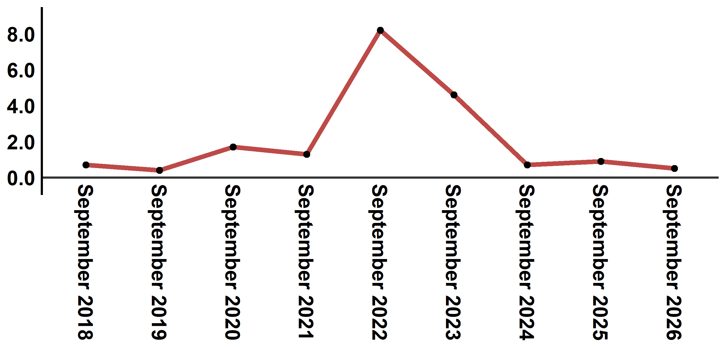
Reading: In September 2026, the consumer price index increased by 0,5% compared to September 2025
2- Evolution of the monthly variation (%) of the consumer price index
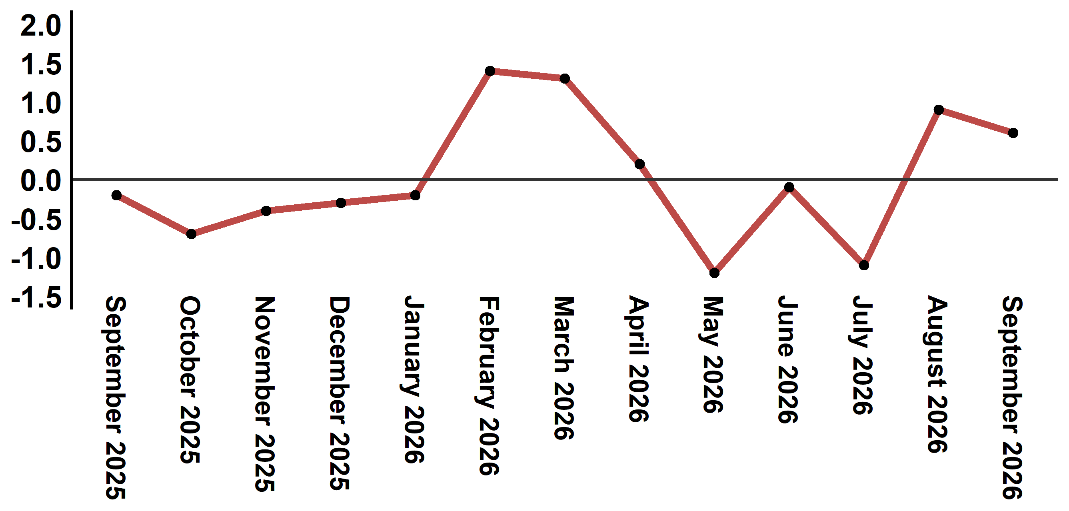
Reading: The level of price variation in September 2026 increased by 0,6% after being 0,9% in August 2026

Table 2: Consumer price index for the city of Tangier: September 2026 (base 2017: 100)
Product Divisions | Weightings | Monthly index |  |  |  |  | Variation (%)
Product Divisions | Weightings | September 2025 | June 2026 | July 2026 | August 2026 | September 2026 | 1 month | 3 months | 12 months
Food products | 36,115 | 133,2 | 129,3 | 126,8 | 128,4 | 130,0 | 1,2 | 0,5 | -2,4
01 – Food products and non-alcoholic | 34,708 | 132,7 | 128,4 | 125,8 | 127,5 | 129,1 | 1,3 | 0,5 | -2,7
02 –Alcoholicbeverages and tobacco | 1,407 | 145,4 | 151,1 | 151,1 | 151,1 | 151,1 | 0,0 | 0,0 | 3,9
Non foodproducts | 63,885 | 112,4 | 114,9 | 114,4 | 115,1 | 115,4 | 0,3 | 0,4 | 2,7
03 – Clothing and shoes | 6,449 | 113,4 | 113,3 | 113,4 | 113,6 | 113,5 | -0,1 | 0,2 | 0,1
04 - Housing, water, gas, electricity and other fuel | 16,656 | 111,6 | 112,8 | 112,8 | 112,8 | 112,8 | 0,0 | 0,0 | 1,1
05- Furniture, household items and routine maintenance of the home | 4,100 | 112,2 | 112,1 | 112,2 | 112,2 | 112,6 | 0,4 | 0,4 | 0,4
06 –Health | 8,218 | 109,3 | 109,4 | 109,5 | 109,5 | 109,5 | 0,0 | 0,1 | 0,2
07 – Transport | 9,751 | 115,0 | 121,5 | 119,4 | 123,5 | 124,4 | 0,7 | 2,4 | 8,2
08 – Communication | 3,199 | 101,2 | 99,3 | 99,6 | 99,8 | 100,2 | 0,4 | 0,9 | -1,0
09 – Leisure and culture | 2,350 | 104,8 | 104,7 | 104,6 | 104,3 | 104,5 | 0,2 | -0,2 | -0,3
10 –Education | 5,047 | 113,4 | 113,4 | 113,4 | 113,4 | 115,8 | 2,1 | 2,1 | 2,1
11 - Restaurants and hotels | 1,280 | 128,8 | 129,9 | 129,9 | 131,0 | 131,5 | 0,4 | 1,2 | 2,1
12 – Variousgoods and services | 6,835 | 117,7 | 129,1 | 127,2 | 127,7 | 127,0 | -0,5 | -1,6 | 7,9
General index | 100,000 | 120,1 | 120,2 | 118,9 | 120,0 | 120,7 | 0,6 | 0,4 | 0,5
Source: High Commission for Planning, Department of Statistics - National consumer price survey
:::

