Consumer Price Index - September 2026 | City of Al Hoceima
In September 2026, the consumer price index for households in the city of Al Hoceima decreased by 0,3% compared to the previous month. On an annual level, the consumer price index maintained the same value.

Over a month, The food product price index decreased by 0,8% in September 2026 compared to August 2026, due to the decline in prices of «Fish and Seafood» by 9,3%, «Fruits» by 3,3%, «Mineral Waters, Soft Drinks, Fruit and Vegetable Juices» by 0,6%, «Oils and Fats» by 0,4% and «Cafe, Tea and Cocoa» by 0,1%.
On the other hand, the monthly variation of the index for the non-food products index increased by 0,4% due to the increase in prices in the following divisions: «Transports» by 2,3%, «Health» by 2,2%, «Clothing and Shoes» by 1,4%, «Education» by 0,9%, «Various Goods and Services» by 0,8%, «Leisure and Culture» by 0,5% and «Furniture, Household Items and Routine Home Maintenance» by 0,1%. Also, the decrease in prices of «Restaurants and Hotels» by 11,2%. As well as, the stagnation of the indices of the other divisions did not impact the general evolution.
Over a year, the food product price index decreased by 3,2% in September 2026 compared to September 2025 , due to the decrease in the prices of «Oils and Fats» by 26,5%, «Fruits» by 8,3%, «Vegetables» by 3,7%, «Bread and Cereals» by 1,8% and «Food Products not elsewhere classified» by 1,4%. Moreover, the rise in prices of «Meats» by 8,5%, «Cafe, Tea and Cocoa» by 5,6%, «Tobacco» by 5,0%, «Mineral Waters, Soft Drinks, Fruit and Vegetable Juices» by 3,8%, «Fish and Seafood», «Sugar, Jam, Honey and Chocolate and Confectionery» by 0,5% and «Milk, Cheese and Eggs» by 0,2% did not affect the general evolution.
On the other hand, the annual variation in the non-food product index increased by 4,5%. While the price variation of the divisions that constitute non-food products fluctuated between a decrease of 0,5% for the division of «Furniture, Household Items and Routine Home Maintenance» and the rise of 15,3% for the division of «Transports»
4- Annual evolution (%) of the consumer price index for the month of September
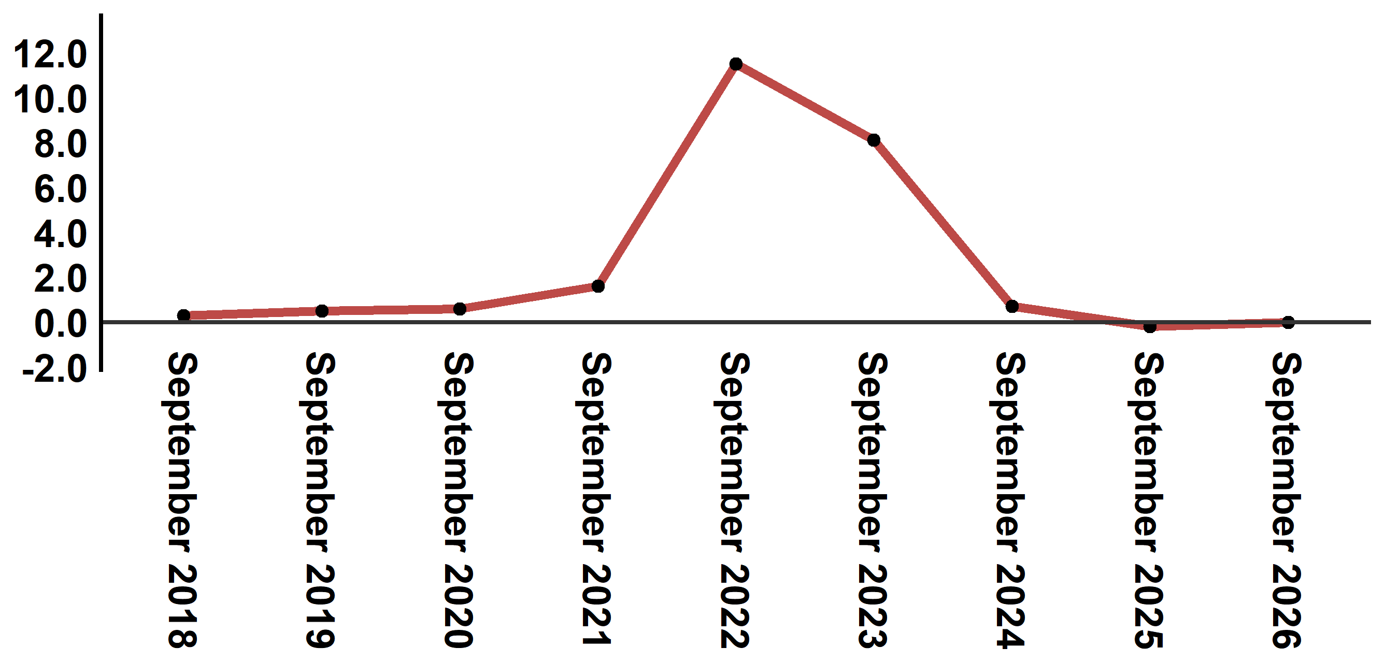
Reading: In September 2026, the consumer price index decreased stagnated compared to September 2025
6- Evolution of the monthly variation (%) of the consumer price index
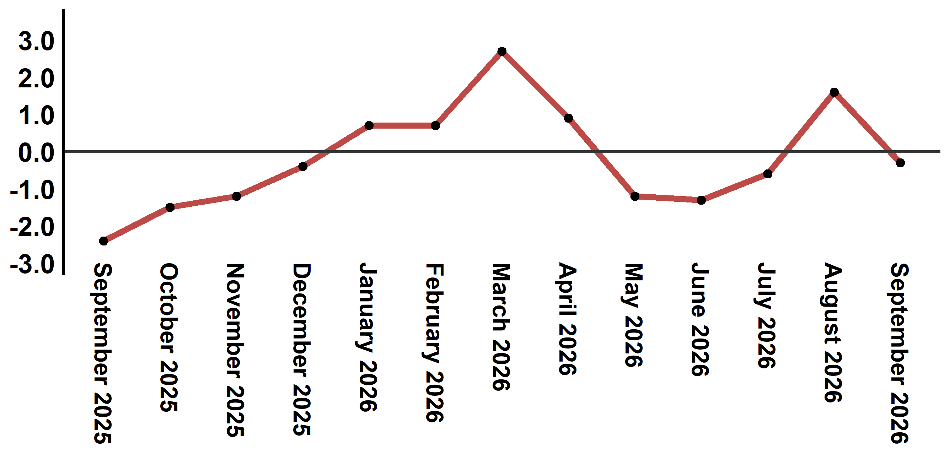
Reading: The level of price variation in September 2026 decreased by 0,3% after being 1,6% in August 2026

Table 4: Consumer price index for the city of Al Hoceima: September 2026 (base 2017: 100)
Product Divisions | Weightings | Monthly index |  |  |  |  | Variation (%)
Product Divisions | Weightings | September 2025 | June 2026 | July 2026 | August 2026 | September 2026 | 1 month | 3 months | 12 months
Food products | 49,716 | 141,8 | 137,1 | 135,4 | 138,3 | 137,2 | -0,8 | 0,1 | -3,2
01 – Food products and non-alcoholic | 48,371 | 141,6 | 136,5 | 134,8 | 137,7 | 136,6 | -0,8 | 0,1 | -3,5
02 –Alcoholicbeverages and tobacco | 1,345 | 150,1 | 158,1 | 158,1 | 158,1 | 158,1 | 0,0 | 0,0 | 5,3
Non foodproducts | 50,284 | 109,8 | 112,9 | 113,1 | 114,2 | 114,7 | 0,4 | 1,6 | 4,5
03 – Clothing and shoes | 5,155 | 117,4 | 118,8 | 118,9 | 118,9 | 120,6 | 1,4 | 1,5 | 2,7
04 - Housing, water, gas, electricity and other fuel | 11,732 | 106,3 | 109,9 | 109,3 | 109,3 | 109,3 | 0,0 | -0,5 | 2,8
05- Furniture, household items and routine maintenance of the home | 3,094 | 113,0 | 112,7 | 112,3 | 112,3 | 112,4 | 0,1 | -0,3 | -0,5
06 –Health | 6,413 | 98,8 | 99,1 | 99,1 | 99,1 | 101,3 | 2,2 | 2,2 | 2,5
07 – Transport | 7,704 | 117,4 | 129,6 | 125,3 | 132,3 | 135,4 | 2,3 | 4,5 | 15,3
08 – Communication | 2,892 | 101,6 | 101,4 | 101,5 | 101,5 | 101,5 | 0,0 | 0,1 | -0,1
09 – Leisure and culture | 1,933 | 94,7 | 96,5 | 96,4 | 96,4 | 96,9 | 0,5 | 0,4 | 2,3
10 –Education | 3,842 | 114,1 | 114,8 | 114,8 | 114,8 | 115,8 | 0,9 | 0,9 | 1,5
11 - Restaurants and hotels | 2,258 | 119,5 | 116,6 | 137,4 | 138,8 | 123,3 | -11,2 | 5,7 | 3,2
12 – Variousgoods and services | 5,261 | 113,1 | 115,2 | 116,0 | 116,3 | 117,2 | 0,8 | 1,7 | 3,6
General index | 100,000 | 126,0 | 125,1 | 124,4 | 126,4 | 126,0 | -0,3 | 0,7 | 0,0
Source: High Commission for Planning, Department of Statistics - National consumer price survey
:::

