Consumer Price Index - September 2026 | City of
In September 2026, the consumer price index for households in the city of increased by 1,0% compared to the previous month. On an annual level, the consumer price index increased by 0,5%.

Over a month, The food product price index increased by 1,6% in September 2026 compared to August 2026, due to the rise in prices of «Meats» and «Vegetables» by 4,3%, «Milk, Cheese and Eggs» by 1,6%, «Food Products not elsewhere classified» by 0,7%, «Mineral Waters, Soft Drinks, Fruit and Vegetable Juices» by 0,2% and «Fruits», «Sugar, Jam, Honey and Chocolate and Confectionery» by 0,1%.
Similarly, the monthly variation of the index for the non-food products index increased by 0,4% due to the increase in prices in the following divisions: «Education» by 1,2%, «Transports» by 1,0%, «Various Goods and Services» by 0,7%, «Restaurants and Hotels» by 0,5%, «Clothing and Shoes» by 0,3%, «Furniture, Household Items and Routine Home Maintenance» and «Leisure and Culture» by 0,2% and «Housing, Water, Gas, Electricity and Other Fuels», «Health» and «Communications» by 0,1%.
Over a year, the food product price index decreased by 2,4% in September 2026 compared to September 2025 , due to the decrease in the prices of «Oils and Fats» by 20,8%, «Fruits» by 4,8%, «Milk, Cheese and Eggs» by 2,3%, «Vegetables» by 2,2%, «Bread and Cereals» by 0,8% and «Food Products not elsewhere classified» by 0,7%. Moreover, the rise in prices of «Tobacco» by 4,0%, «Meats» and «Fish and Seafood» by 3,2%, «Cafe, Tea and Cocoa» by 1,2%, «Mineral Waters, Soft Drinks, Fruit and Vegetable Juices» by 1,0% and «Sugar, Jam, Honey, Chocolate and Confectionery» by 0,9% did not affect the general evolution.
On the other hand, the annual variation in the non-food product index increased by 2,8%. While the price variation of the divisions that constitute non-food products fluctuated between a decrease of NA and the rise of 9,4% for the division of «Transports»
Annual evolution (%) of the consumer price index for the month of September
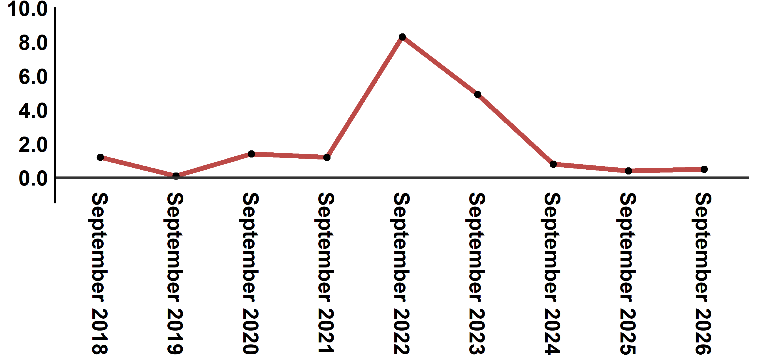
Reading: In September 2026, the consumer price index increased by 0,5% compared to September 2025
Evolution of the monthly variation (%) of the consumer price index
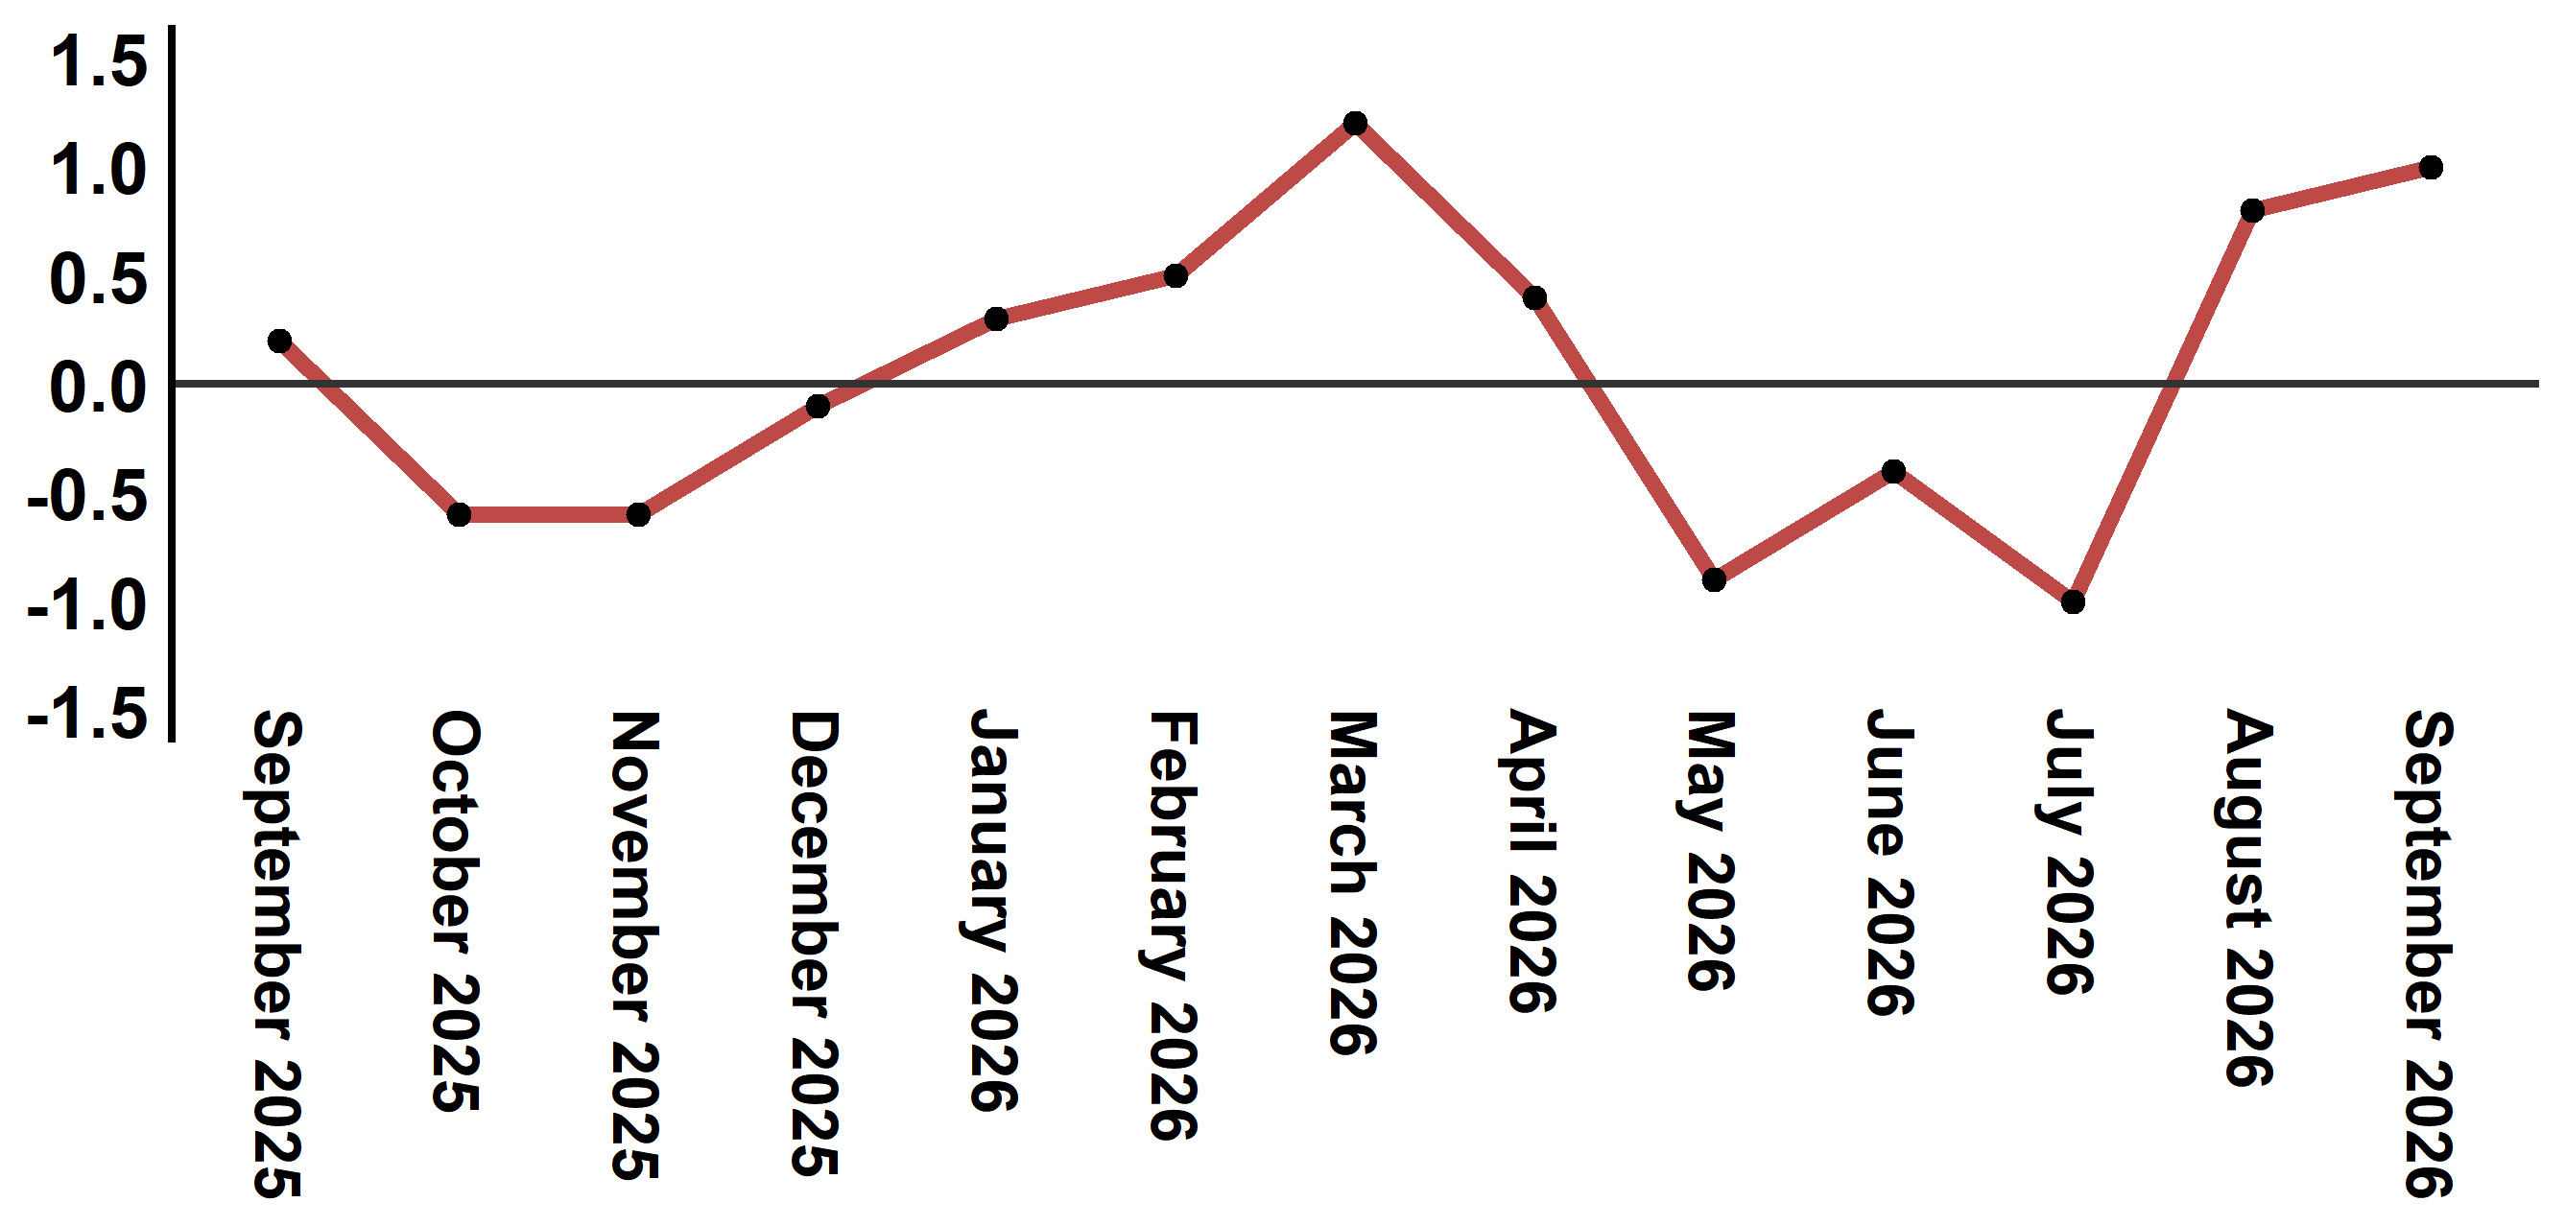
Reading: The level of price variation in September 2026 increased by 1,0% after being 0,8% in August 2026

Consumer price index for the city of : September 2026 (base 2017: 100)
Product Divisions | Weightings | Monthly index |  |  |  |  | Variation (%)
Product Divisions | Weightings | September 2025 | June 2026 | July 2026 | August 2026 | September 2026 | 1 month | 3 months | 12 months
Food products | 39,009 | 132,0 | 128,1 | 125,6 | 126,8 | 128,8 | 1,6 | 0,5 | -2,4
01 – Food products and non-alcoholic | 37,502 | 131,5 | 127,2 | 124,6 | 125,8 | 127,9 | 1,7 | 0,6 | -2,7
02 –Alcoholicbeverages and tobacco | 1,507 | 144,9 | 150,5 | 150,5 | 150,6 | 150,5 | -0,1 | 0,0 | 3,9
Non foodproducts | 60,991 | 112,5 | 114,6 | 114,3 | 115,1 | 115,6 | 0,4 | 0,9 | 2,8
03 – Clothing and shoes | 4,323 | 117,6 | 117,9 | 117,7 | 117,9 | 118,2 | 0,3 | 0,3 | 0,5
04 - Housing, water, gas, electricity and other fuel | 14,575 | 109,4 | 110,8 | 110,9 | 110,9 | 111,0 | 0,1 | 0,2 | 1,5
05- Furniture, household items and routine maintenance of the home | 4,407 | 113,1 | 113,9 | 114,0 | 114,3 | 114,5 | 0,2 | 0,5 | 1,2
06 –Health | 7,741 | 101,4 | 101,7 | 101,7 | 101,7 | 101,8 | 0,1 | 0,1 | 0,4
07 – Transport | 10,040 | 116,1 | 123,4 | 121,7 | 125,8 | 127,0 | 1,0 | 2,9 | 9,4
08 – Communication | 2,958 | 103,8 | 103,6 | 103,7 | 103,7 | 103,8 | 0,1 | 0,2 | 0,0
09 – Leisure and culture | 2,735 | 104,9 | 104,8 | 104,8 | 104,8 | 105,0 | 0,2 | 0,2 | 0,1
10 –Education | 5,636 | 124,3 | 124,4 | 124,4 | 124,4 | 125,9 | 1,2 | 1,2 | 1,3
11 - Restaurants and hotels | 1,461 | 122,5 | 123,9 | 124,7 | 125,4 | 126,0 | 0,5 | 1,7 | 2,9
12 – Variousgoods and services | 7,115 | 117,1 | 120,7 | 120,4 | 120,8 | 121,7 | 0,7 | 0,8 | 3,9
General index | 100,000 | 120,2 | 119,9 | 118,7 | 119,6 | 120,8 | 1,0 | 0,8 | 0,5
Source: High Commission for Planning, Department of Statistics - National consumer price survey
:::

