Information note from the regional directorate of Tangier-Tetouan-Al Hoceima
Consumer price index: city of Tétouan
In March 2026, the national consumer price index increased by 1% compared to the previous month, while the consumer price index increased by 2.2% over a full year.
The consumer price index experienced an increase of 1.4% during the month of March 2026 compared to the previous month. as a result of the rise in prices of «Vegetables» by 7.7%, «Meat» by 4.6% and «Fruits» by 1.6%
Similarly, the monthly variation in the non-food index increased by 0.6% due to price increases in the following divisions: «Transportation» by 5.1% and «Clothing and Shoes» by 0.7%
Over a year, the food product price index increased by 2.8% in March 2026 compared to March 2025 , due to the rise in the prices of «Vegetables» by 14.3%, «Fish and Seafood» by 9.5%, «Meat» by 7.1%, «Fruits» by 6.2%, «Cafe and Tea and Cocoa» by 4.6%, «Tobacco» by 3.7%, «Sugar, Jam, Honey and Chocolate and Confectionery» by 0.9%, «Milk and Cheese and Eggs» by 0.4% and «Mineral Waters, Soft Drinks and Fruit and Vegetable Juices (Nd)» by 0.2%. Moreover, the decrease in prices of «Oils and Fats» by 15.1%, «Bread and Cereals» and «Catering Services» by 0.7% and «Food Products N.C.A.» by 0.4% and the stagnation in prices for NA did not affect the general evolution.
Similarly, the annual variation in the non-food index increased by 1.6%. While the variation in prices of the divisions that make up non-food products fluctuated between a decrease of the division of «Communications» by 1% and the rise of the division of «Education» by 10.9%
5- Annual evolution (%) of the consumer price index for the month of March
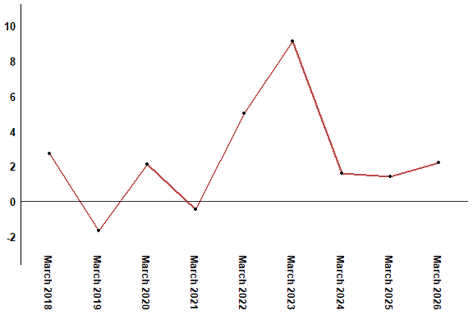
In March 2026, the consumer price index increased by 2.2% compared to March 2025
6- Annual evolution (%) of the consumer price index for the month of March
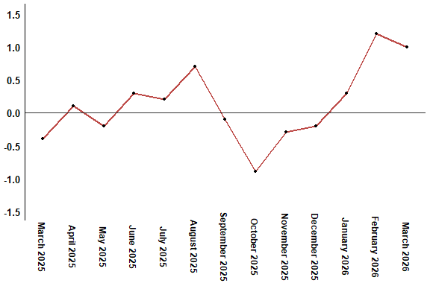
In March 2026, the consumer price index increased by 1% compared to February 2026
Table 3: Consumer price index for the city of Tétouan: March 2026 (2017 base: 100)
Product Divisions | Weightings | Monthly index |  |  |  |  | Variation (%)
 |  | March 2025 | December 2025 | January 2026 | February 2026 | March 2026 | 1 month | 3 months | 12 months
Food products | 40,725 | 132,6 | 130,1 | 131,4 | 134,4 | 136,3 | 1,4 | 4,8 | 2,8
01 – Food products and non-alcoholic | 38,964 | 132,0 | 129,4 | 130,5 | 133,7 | 135,7 | 1,5 | 4,9 | 2,8
02 –Alcoholicbeverages and tobacco | 1,761 | 145,1 | 146,1 | 150,5 | 150,5 | 150,5 | 0,0 | 3,0 | 3,7
Non foodproducts | 59,275 | 111,2 | 112,3 | 112,1 | 112,3 | 113,0 | 0,6 | 0,6 | 1,6
03 – Clothing and shoes | 5,835 | 114,5 | 114,3 | 114,5 | 113,9 | 114,7 | 0,7 | 0,3 | 0,2
04 - Housing, water, gas, electricity and other fuel | 14,202 | 109,2 | 109,4 | 109,5 | 109,5 | 109,5 | 0,0 | 0,1 | 0,3
05- Furniture, household items and routine maintenance of the home | 5,602 | 110,5 | 111,5 | 112,1 | 112,0 | 111,5 | -0,4 | 0,0 | 0,9
06 –Health | 6,594 | 103,5 | 103,5 | 103,5 | 103,4 | 103,4 | 0,0 | -0,1 | -0,1
07 – Transport | 7,416 | 113,5 | 111,2 | 108,1 | 109,4 | 115,0 | 5,1 | 3,4 | 1,3
08 – Communication | 2,560 | 97,8 | 97,1 | 97,1 | 96,8 | 96,8 | 0,0 | -0,3 | -1,0
09 – Leisure and culture | 2,432 | 106,1 | 106,4 | 106,4 | 106,4 | 106,3 | -0,1 | -0,1 | 0,2
10 –Education | 5,358 | 116,8 | 129,5 | 129,5 | 129,5 | 129,5 | 0,0 | 0,0 | 10,9
11 - Restaurants and hotels | 2,468 | 114,4 | 115,8 | 116,6 | 116,6 | 116,6 | 0,0 | 0,7 | 1,9
12 – Variousgoods and services | 6,808 | 119,3 | 119,8 | 120,8 | 121,6 | 121,2 | -0,3 | 1,2 | 1,6
General index | 100,000 | 120,0 | 119,6 | 120,0 | 121,4 | 122,6 | 1,0 | 2,5 | 2,2
High Commission for Planning, Department of Statistics - National consumer price survey

