Information note from the regional directorate of Tangier-Tetouan-Al Hoceima
Consumer price index: city of Tanger
In March 2026, the national consumer price index increased by 1.3% compared to the previous month, while the consumer price index increased by 2.1% over a full year.
The consumer price index experienced an increase of 2.7% during the month of March 2026 compared to the previous month. as a result of the rise in prices of «Vegetables» by 11.1%, «Meat» by 4.6%, «Fruits» by 3.6%, «Fish and Seafood» by 2%, «Cafe and Tea and Cocoa» by 0.7% and «Bread and Cereals» and «Catering Services» by 0.1%
Similarly, the monthly variation in the non-food index increased by 0.4% due to price increases in the following divisions: «Transportation» by 2.8% and «Housing, Water, Gas, Electricity and Other Fuels» and «Miscellaneous Goods and Services» by 0.1%
Over a year, the food product price index increased by 2.7% in March 2026 compared to March 2025 , due to the rise in the prices of «Fish and Seafood» by 25.2%, «Vegetables» by 11.6%, «Fruits», «Cafe and Tea and Cocoa» by 7%, «Tobacco» by 3.7%, «Meat» by 1.5%, «Milk and Cheese and Eggs» by 0.7%, «Bread and Cereals», «Catering Services», «Mineral Waters, Soft Drinks and Fruit and Vegetable Juices (Nd)» by 0.3% and «Sugar, Jam, Honey and Chocolate and Confectionery» by 0.2%. Moreover, the decrease in prices of «Oils and Fats» by 18% and «Food Products N.C.A.» by 0.9% and the stagnation in prices for NA did not affect the general evolution.
Similarly, the annual variation in the non-food index increased by 1.7%. While the variation in prices of the divisions that make up non-food products fluctuated between a decrease of the division of «Communications» by 1.3% and the rise of the division of «Miscellaneous Goods and Services» by 10.9%
3- Annual evolution (%) of the consumer price index for the month of March
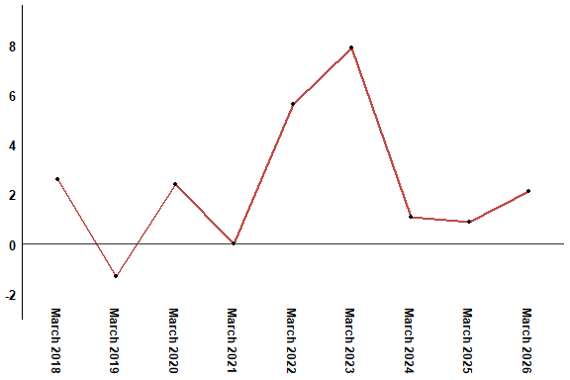
In March 2026, the consumer price index increased by 2.1% compared to March 2025
4- Annual evolution (%) of the consumer price index for the month of March
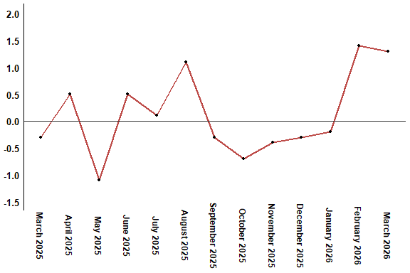
In March 2026, the consumer price index increased by 1.3% compared to February 2026
Table 4: Consumer price index for the city of Tanger: March 2026 (2017 base: 100)
Product Divisions | Weightings | Monthly index |  |  |  |  | Variation (%)
 |  | March 2025 | December 2025 | January 2026 | February 2026 | March 2026 | 1 month | 3 months | 12 months
Food products | 36,115 | 131,3 | 128,3 | 127,7 | 131,2 | 134,8 | 2,7 | 5,1 | 2,7
01 – Food products and non-alcoholic | 34,708 | 130,8 | 127,6 | 126,8 | 130,4 | 134,2 | 2,9 | 5,2 | 2,6
02 –Alcoholicbeverages and tobacco | 1,407 | 144,4 | 145,4 | 149,7 | 149,7 | 149,7 | 0,0 | 3,0 | 3,7
Non foodproducts | 63,885 | 112,0 | 112,8 | 112,8 | 113,4 | 113,9 | 0,4 | 1,0 | 1,7
03 – Clothing and shoes | 6,449 | 113,1 | 113,6 | 113,7 | 113,7 | 113,7 | 0,0 | 0,1 | 0,5
04 - Housing, water, gas, electricity and other fuel | 16,656 | 111,4 | 111,8 | 111,9 | 111,8 | 111,9 | 0,1 | 0,1 | 0,4
05- Furniture, household items and routine maintenance of the home | 4,100 | 108,8 | 112,5 | 112,5 | 112,1 | 112,1 | 0,0 | -0,4 | 3,0
06 –Health | 8,218 | 109,3 | 109,3 | 109,3 | 109,3 | 109,3 | 0,0 | 0,0 | 0,0
07 – Transport | 9,751 | 116,8 | 114,7 | 112,8 | 113,8 | 117,0 | 2,8 | 2,0 | 0,2
08 – Communication | 3,199 | 102,0 | 101,4 | 101,4 | 101,4 | 100,7 | -0,7 | -0,7 | -1,3
09 – Leisure and culture | 2,350 | 104,7 | 105,1 | 105,0 | 105,2 | 104,7 | -0,5 | -0,4 | 0,0
10 –Education | 5,047 | 110,9 | 113,4 | 113,4 | 113,4 | 113,4 | 0,0 | 0,0 | 2,3
11 - Restaurants and hotels | 1,280 | 125,7 | 126,6 | 127,1 | 127,1 | 127,1 | 0,0 | 0,4 | 1,1
12 – Variousgoods and services | 6,835 | 115,8 | 121,3 | 123,5 | 128,3 | 128,4 | 0,1 | 5,9 | 10,9
General index | 100,000 | 119,1 | 118,5 | 118,3 | 120,0 | 121,6 | 1,3 | 2,6 | 2,1
High Commission for Planning, Department of Statistics - National consumer price survey

