Information note from the regional directorate of Tangier-Tetouan-Al Hoceima
Consumer price index: city of Al Hoceima
In March 2026, the national consumer price index increased by 2.7% compared to the previous month, while the consumer price index increased by 1.5% over a full year.
The consumer price index experienced an increase of 4.1% during the month of March 2026 compared to the previous month. as a result of the rise in prices of «Vegetables» by 15.5%, «Fish and Seafood» by 5.5%, «Cafe and Tea and Cocoa» by 2.9%, «Fruits» by 2%, «Milk and Cheese and Eggs» by 1.2%, «Meat» by 0.7% and «Mineral Waters, Soft Drinks and Fruit and Vegetable Juices (Nd)» by 0.6%
Similarly, the monthly variation in the non-food index increased by 0.7% due to price increases in the following divisions: «Transportation» by 4.1% and «Clothing and Shoes» by 0.8%
Over a year, the food product price index increased by 2% in March 2026 compared to March 2025 , due to the rise in the prices of «Vegetables» by 20.3%, «Cafe and Tea and Cocoa» by 13.7%, «Fish and Seafood» by 11%, «Tobacco» by 4.7%, «Fruits» by 2.4% and «Sugar, Jam, Honey and Chocolate and Confectionery» by 0.3%. Moreover, the decrease in prices of «Oils and Fats» by 23.8%, «Food Products N.C.A.» by 5.2%, «Mineral Waters, Soft Drinks and Fruit and Vegetable Juices (Nd)» by 2%, «Bread and Cereals» and «Catering Services» by 1.6%, «Milk and Cheese and Eggs» by 0.9% and «Meat» by 0.7% and the stagnation in prices for NA did not affect the general evolution.
Similarly, the annual variation in the non-food index increased by 0.8%. While the variation in prices of the divisions that make up non-food products fluctuated between a decrease of the division of «Transportation» by 1.2% and the rise of the division of «Miscellaneous Goods and Services» by 3.7%
1- Annual evolution (%) of the consumer price index for the month of March
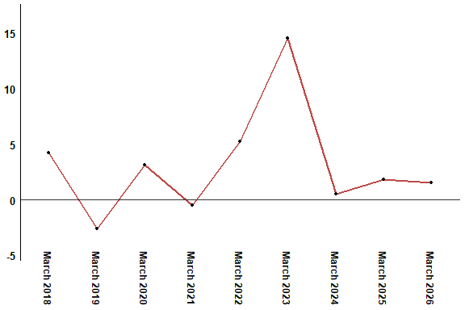
In March 2026, the consumer price index increased by 1.5% compared to March 2025
2- Annual evolution (%) of the consumer price index for the month of March
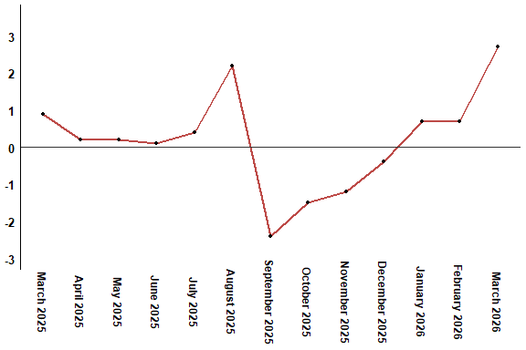
In March 2026, the consumer price index increased by 2.7% compared to February 2026
Table 2: Consumer price index for the city of Al Hoceima: March 2026 (2017 base: 100)
Product Divisions | Weightings | Monthly index |  |  |  |  | Variation (%)
 |  | March 2025 | December 2025 | January 2026 | February 2026 | March 2026 | 1 month | 3 months | 12 months
Food products | 49,716 | 140,6 | 134,1 | 136,2 | 137,7 | 143,4 | 4,1 | 6,9 | 2,0
01 – Food products and non-alcoholic | 48,371 | 140,4 | 133,6 | 135,6 | 137,2 | 143,0 | 4,2 | 7,0 | 1,9
02 –Alcoholicbeverages and tobacco | 1,345 | 148,9 | 150,8 | 156,3 | 156,3 | 156,3 | 0,0 | 3,6 | 5,0
Non foodproducts | 50,284 | 109,6 | 109,8 | 109,5 | 109,7 | 110,5 | 0,7 | 0,6 | 0,8
03 – Clothing and shoes | 5,155 | 117,3 | 117,5 | 117,5 | 117,4 | 118,3 | 0,8 | 0,7 | 0,9
04 - Housing, water, gas, electricity and other fuel | 11,732 | 105,8 | 106,9 | 107,1 | 107,1 | 107,1 | 0,0 | 0,2 | 1,2
05- Furniture, household items and routine maintenance of the home | 3,094 | 113,2 | 113,0 | 112,9 | 112,8 | 112,8 | 0,0 | -0,2 | -0,4
06 –Health | 6,413 | 98,8 | 98,8 | 99,1 | 99,1 | 99,1 | 0,0 | 0,3 | 0,3
07 – Transport | 7,704 | 120,4 | 116,8 | 113,9 | 114,3 | 119,0 | 4,1 | 1,9 | -1,2
08 – Communication | 2,892 | 101,6 | 101,4 | 101,4 | 101,4 | 101,4 | 0,0 | 0,0 | -0,2
09 – Leisure and culture | 1,933 | 95,0 | 96,4 | 97,0 | 97,0 | 97,0 | 0,0 | 0,6 | 2,1
10 –Education | 3,842 | 114,1 | 114,8 | 114,8 | 114,8 | 114,8 | 0,0 | 0,0 | 0,6
11 - Restaurants and hotels | 2,258 | 110,3 | 113,3 | 112,8 | 113,3 | 113,3 | 0,0 | 0,0 | 2,7
12 – Variousgoods and services | 5,261 | 112,1 | 114,4 | 115,1 | 116,3 | 116,3 | 0,0 | 1,7 | 3,7
General index | 100,000 | 125,3 | 122,1 | 123,0 | 123,9 | 127,2 | 2,7 | 4,2 | 1,5
High Commission for Planning, Department of Statistics - National consumer price survey

