Information note from the regional directorate of Tangier-Tetouan-Al Hoceima
Consumer price index: city of
In March 2026, the national consumer price index increased by 1.2% compared to the previous month, while the consumer price index increased by 0.9% over a full year.
The consumer price index experienced an increase of 1.8% during the month of March 2026 compared to the previous month. as a result of the rise in prices of «Vegetables» by 9.7%, «Fruits» by 2.6%, «Meat» by 2.4%, «Fish and Seafood» by 1.3%, «Cafe and Tea and Cocoa» by 0.3% and «Sugar, Jam, Honey and Chocolate and Confectionery» by 0.1%
Similarly, the monthly variation in the non-food index increased by 0.6% due to price increases in the following divisions: «Transportation» by 3%, «Clothing and Shoes» by 0.5%, «Housing, Water, Gas and Electricity and Other Fuels» by 0.2% and «Furniture, Household Items and Routine Home Maintenance» and «Miscellaneous Goods and Services» by 0.1%
Over a year, the food product price index increased by 0.6% in March 2026 compared to March 2025 , due to the rise in the prices of «Fish and Seafood» by 17.6%, «Vegetables» by 16.8%, «Cafe and Tea and Cocoa» by 5.5%, «Tobacco» by 3.8%, «Fruits» by 3.2%, «Sugar, Jam, Honey and Chocolate and Confectionery» by 0.5%, «Meat» by 0.4% and «Milk and Cheese and Eggs» by 0.3%. Moreover, the decrease in prices of «Oils and Fats» by 23.7%, «Bread and Cereals» and «Catering Services» by 1%, «Mineral Waters, Soft Drinks and Fruit and Vegetable Juices (Nd)» by 0.9% and «Food Products N.C.A.» by 0.7% and the stagnation in prices for NA did not affect the general evolution.
Similarly, the annual variation in the non-food index increased by 1.1%. While the variation in prices of the divisions that make up non-food products fluctuated between a decrease of the division of «Leisure and Culture» by 0.4% and the rise of the division of «Miscellaneous Goods and Services» by 3.5%
Annual evolution (%) of the consumer price index for the month of March
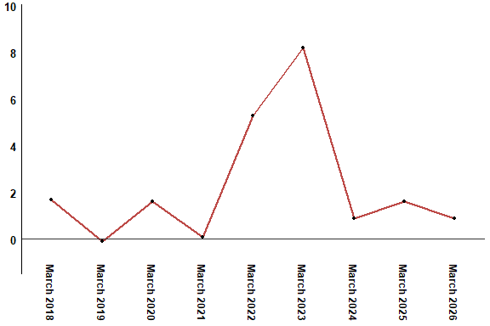
In March 2026, the consumer price index increased by 0.9% compared to March 2025
Annual evolution (%) of the consumer price index for the month of March
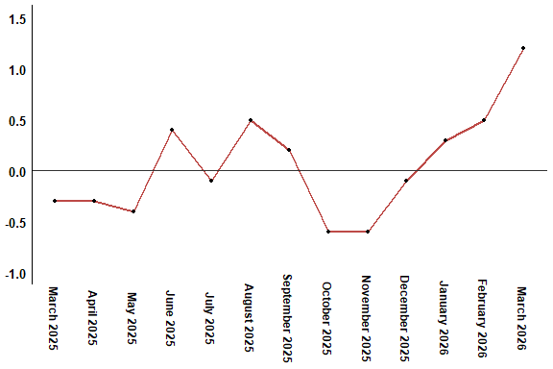
In March 2026, the consumer price index increased by 1.2% compared to February 2026
Consumer price index for the city of : March 2026 (2017 base: 100)
Product Divisions | Weightings | Monthly index |  |  |  |  | Variation (%)
 |  | March 2025 | December 2025 | January 2026 | February 2026 | March 2026 | 1 month | 3 months | 12 months
Food products | 39,009 | 131,9 | 128,2 | 129,2 | 130,3 | 132,7 | 1,8 | 3,5 | 0,6
01 – Food products and non-alcoholic | 37,502 | 131,4 | 127,5 | 128,4 | 129,5 | 132,0 | 1,9 | 3,5 | 0,5
02 –Alcoholicbeverages and tobacco | 1,507 | 144,0 | 145,0 | 149,3 | 149,3 | 149,3 | 0,0 | 3,0 | 3,7
Non foodproducts | 60,991 | 112,2 | 112,6 | 112,4 | 112,7 | 113,4 | 0,6 | 0,7 | 1,1
03 – Clothing and shoes | 4,323 | 116,9 | 117,5 | 117,5 | 117,5 | 118,1 | 0,5 | 0,5 | 1,0
04 - Housing, water, gas, electricity and other fuel | 14,575 | 109,1 | 109,6 | 109,6 | 109,6 | 109,8 | 0,2 | 0,2 | 0,6
05- Furniture, household items and routine maintenance of the home | 4,407 | 112,6 | 113,2 | 113,2 | 113,2 | 113,3 | 0,1 | 0,1 | 0,6
06 –Health | 7,741 | 101,4 | 101,5 | 101,5 | 101,5 | 101,5 | 0,0 | 0,0 | 0,1
07 – Transport | 10,040 | 117,5 | 115,7 | 113,9 | 115,0 | 118,4 | 3,0 | 2,3 | 0,8
08 – Communication | 2,958 | 104,0 | 103,8 | 103,7 | 103,7 | 103,7 | 0,0 | -0,1 | -0,3
09 – Leisure and culture | 2,735 | 105,1 | 104,9 | 104,9 | 105,0 | 104,7 | -0,3 | -0,2 | -0,4
10 –Education | 5,636 | 121,8 | 124,4 | 124,4 | 124,4 | 124,4 | 0,0 | 0,0 | 2,1
11 - Restaurants and hotels | 1,461 | 120,1 | 122,8 | 122,5 | 122,5 | 122,5 | 0,0 | -0,2 | 2,0
12 – Variousgoods and services | 7,115 | 116,4 | 117,9 | 119,1 | 120,4 | 120,5 | 0,1 | 2,2 | 3,5
General index | 100,000 | 119,9 | 118,7 | 119,0 | 119,6 | 121,0 | 1,2 | 1,9 | 0,9
High Commission for Planning, Department of Statistics - National consumer price survey

