Information note from the regional directorate of Tangier-Tetouan-Al Hoceima
Consumer price index: city of Tétouan
In April 2026, the national consumer price index increased by 0.9% compared to the previous month, while the consumer price index increased by 3% over a full year.
The consumer price index experienced an increase of 0.1% during the month of April 2026 compared to the previous month. as a result of the rise in prices of «Fruits» by 12.2%, «Meat» by 3.4%, «Food Products N.C.A.» by 2.8%, «Mineral Waters, Soft Drinks, Fruit and Vegetable Juices (Nd)» by 1.4%, «Tobacco» by 1%, «Sugar, Jam, Honey, Chocolate and Confectionery» by 0.7% and «Fish and Seafood» by 0.1%
Similarly, the monthly variation in the non-food index increased by 1.6% due to price increases in the following divisions: «Transportation» by 10.5%, «Restaurants and Hotels» by 5.9%, «Miscellaneous Goods and Services» by 0.7%, «Furniture, Household Items and Routine Home Maintenance» by 0.4%, «Communications» by 0.3% and «Leisure and Culture» by 0.2%
Over a year, the food product price index increased by 2.4% in April 2026 compared to April 2025 , due to the rise in the prices of «Fruits» by 13.5%, «Meat» by 13%, «Vegetables» by 8.8%, «Fish and Seafood» by 5.7%, «Tobacco» by 4%, «Food Products N.C.A.» by 2.2%, «Sugar, Jam, Honey, Chocolate and Confectionery» by 1.5%, «Mineral Waters, Soft Drinks, Fruit and Vegetable Juices (Nd)» by 1.2% and «Cafe, Tea and Cocoa» by 1.1%. Moreover, the decrease in prices of «Oils and Fats» by 23.6%, «Milk, Cheese and Eggs» by 2.6% and «Bread and Cereals» and «Catering Services» by 0.8% and the stagnation in prices for NA did not affect the general evolution.
Similarly, the annual variation in the non-food index increased by 3.5%. While the variation in prices of the divisions that make up non-food products fluctuated between a decrease of the division of «Communications» by 0.6% and the rise of the division of «Transportation» by 13.6%
3- Annual evolution (%) of the consumer price index for the month of April
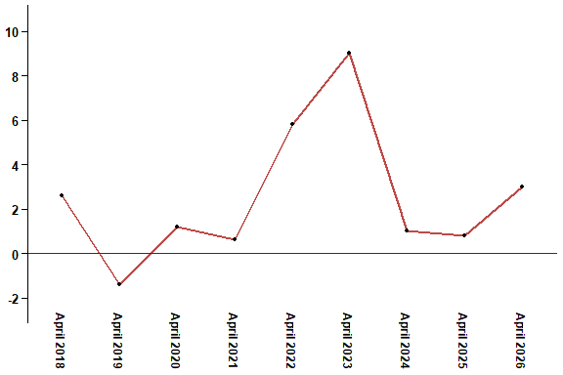
In April 2026, the consumer price index increased by 3% compared to April 2025
4- Annual evolution (%) of the consumer price index for the month of April
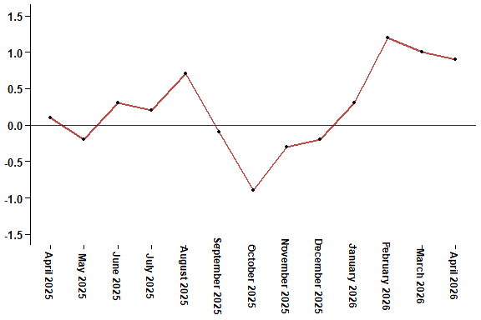
In April 2026, the consumer price index increased by 0.9% compared to March 2026
Table 3: Consumer price index for the city of Tétouan: April 2026 (2017 base: 100)
Product Divisions | Weightings | Monthly index |  |  |  |  | Variation (%)
 |  | April 2025 | January 2026 | February 2026 | March 2026 | April 2026 | 1 month | 3 months | 12 months
Food products | 40,725 | 133,3 | 131,4 | 134,4 | 136,3 | 136,5 | 0,1 | 3,9 | 2,4
01 – Food products and non-alcoholic | 38,964 | 132,7 | 130,5 | 133,7 | 135,7 | 135,8 | 0,1 | 4,1 | 2,3
02 –Alcoholicbeverages and tobacco | 1,761 | 146,1 | 150,5 | 150,5 | 150,5 | 152,0 | 1,0 | 1,0 | 4,0
Non foodproducts | 59,275 | 110,9 | 112,1 | 112,3 | 113,0 | 114,8 | 1,6 | 2,4 | 3,5
03 – Clothing and shoes | 5,835 | 114,3 | 114,5 | 113,9 | 114,7 | 114,0 | -0,6 | -0,4 | -0,3
04 - Housing, water, gas, electricity and other fuel | 14,202 | 109,2 | 109,5 | 109,5 | 109,5 | 109,5 | 0,0 | 0,0 | 0,3
05- Furniture, household items and routine maintenance of the home | 5,602 | 109,4 | 112,1 | 112,0 | 111,5 | 111,9 | 0,4 | -0,2 | 2,3
06 –Health | 6,594 | 103,5 | 103,5 | 103,4 | 103,4 | 103,0 | -0,4 | -0,5 | -0,5
07 – Transport | 7,416 | 111,9 | 108,1 | 109,4 | 115,0 | 127,1 | 10,5 | 17,6 | 13,6
08 – Communication | 2,560 | 97,7 | 97,1 | 96,8 | 96,8 | 97,1 | 0,3 | 0,0 | -0,6
09 – Leisure and culture | 2,432 | 106,1 | 106,4 | 106,4 | 106,3 | 106,5 | 0,2 | 0,1 | 0,4
10 –Education | 5,358 | 116,8 | 129,5 | 129,5 | 129,5 | 129,5 | 0,0 | 0,0 | 10,9
11 - Restaurants and hotels | 2,468 | 114,4 | 116,6 | 116,6 | 116,6 | 123,5 | 5,9 | 5,9 | 8,0
12 – Variousgoods and services | 6,808 | 119,3 | 120,8 | 121,6 | 121,2 | 122,1 | 0,7 | 1,1 | 2,3
General index | 100,000 | 120,1 | 120,0 | 121,4 | 122,6 | 123,7 | 0,9 | 3,1 | 3,0
High Commission for Planning, Department of Statistics - National consumer price survey

