Information note from the regional directorate of Tangier-Tetouan-Al Hoceima
Consumer price index: city of Tanger
In April 2026, the national consumer price index increased by 0.2% compared to the previous month, while the consumer price index increased by 1.8% over a full year.
The consumer price index experienced a decrease of 1% during the month of April 2026 compared to the previous month. as a result of the decline in prices of «Fish and Seafood» by 11.3%, «Oils and Fats» by 4.1%, «Milk, Cheese and Eggs» by 3.6% and «Cafe, Tea and Cocoa» by 1.7%
On the other hand, the monthly variation in the non-food index increased by 1.1% due to price increases in the following divisions: «Transportation» by 6.1%, «Restaurants and Hotels» by 0.9%, «Miscellaneous Goods and Services» by 0.7%, «Leisure and Culture» by 0.5% and «Furniture, Household Items and Routine Home Maintenance» by 0.1%
Over a year, the food product price index increased by 0.2% in April 2026 compared to April 2025 , due to the rise in the prices of «Fish and Seafood» by 10%, «Vegetables» by 6.9%, «Cafe, Tea and Cocoa» by 4.7%, «Tobacco» by 4%, «Meat» by 3.6%, «Fruits» by 1%, «Bread and Cereals», «Catering Services», «Mineral Waters, Soft Drinks and Fruit and Vegetable Juices (Nd)» by 0.9% and «Sugar, Jam, Honey, Chocolate and Confectionery» by 0.4%. Moreover, the decrease in prices of «Oils and Fats» by 21.2%, «Food Products N.C.A.» by 0.7% and «Milk, Cheese and Eggs» by 0.2% and the stagnation in prices for NA did not affect the general evolution.
Similarly, the annual variation in the non-food index increased by 2.9%. While the variation in prices of the divisions that make up non-food products fluctuated between a decrease of the division of «Communications» by 1.5% and the rise of the division of «Miscellaneous Goods and Services» by 11.7%
1- Annual evolution (%) of the consumer price index for the month of April
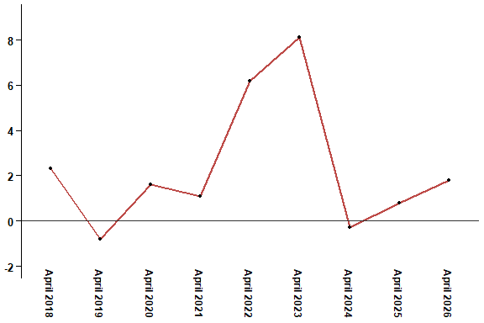
In April 2026, the consumer price index increased by 1.8% compared to April 2025
2- Annual evolution (%) of the consumer price index for the month of April
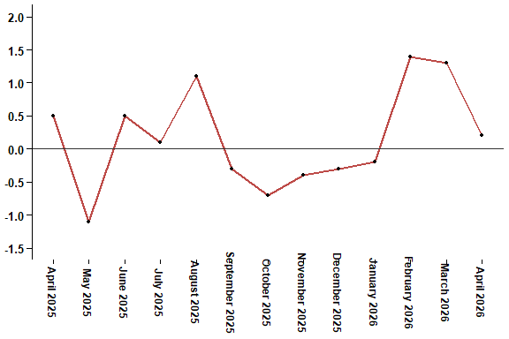
In April 2026, the consumer price index increased by 0.2% compared to March 2026
Table 4: Consumer price index for the city of Tanger: April 2026 (2017 base: 100)
Product Divisions | Weightings | Monthly index |  |  |  |  | Variation (%)
 |  | April 2025 | January 2026 | February 2026 | March 2026 | April 2026 | 1 month | 3 months | 12 months
Food products | 36,115 | 133,2 | 127,7 | 131,2 | 134,8 | 133,5 | -1,0 | 4,5 | 0,2
01 – Food products and non-alcoholic | 34,708 | 132,7 | 126,8 | 130,4 | 134,2 | 132,8 | -1,0 | 4,7 | 0,1
02 –Alcoholicbeverages and tobacco | 1,407 | 145,4 | 149,7 | 149,7 | 149,7 | 151,1 | 0,9 | 0,9 | 3,9
Non foodproducts | 63,885 | 111,9 | 112,8 | 113,4 | 113,9 | 115,1 | 1,1 | 2,0 | 2,9
03 – Clothing and shoes | 6,449 | 113,0 | 113,7 | 113,7 | 113,7 | 113,2 | -0,4 | -0,4 | 0,2
04 - Housing, water, gas, electricity and other fuel | 16,656 | 111,4 | 111,9 | 111,8 | 111,9 | 111,9 | 0,0 | 0,0 | 0,4
05- Furniture, household items and routine maintenance of the home | 4,100 | 108,9 | 112,5 | 112,1 | 112,1 | 112,2 | 0,1 | -0,3 | 3,0
06 –Health | 8,218 | 109,3 | 109,3 | 109,3 | 109,3 | 109,3 | 0,0 | 0,0 | 0,0
07 – Transport | 9,751 | 116,3 | 112,8 | 113,8 | 117,0 | 124,1 | 6,1 | 10,0 | 6,7
08 – Communication | 3,199 | 101,8 | 101,4 | 101,4 | 100,7 | 100,3 | -0,4 | -1,1 | -1,5
09 – Leisure and culture | 2,350 | 104,5 | 105,0 | 105,2 | 104,7 | 105,2 | 0,5 | 0,2 | 0,7
10 –Education | 5,047 | 110,9 | 113,4 | 113,4 | 113,4 | 113,4 | 0,0 | 0,0 | 2,3
11 - Restaurants and hotels | 1,280 | 127,2 | 127,1 | 127,1 | 127,1 | 128,3 | 0,9 | 0,9 | 0,9
12 – Variousgoods and services | 6,835 | 115,8 | 123,5 | 128,3 | 128,4 | 129,3 | 0,7 | 4,7 | 11,7
General index | 100,000 | 119,7 | 118,3 | 120,0 | 121,6 | 121,8 | 0,2 | 3,0 | 1,8
High Commission for Planning, Department of Statistics - National consumer price survey

