Information note from the regional directorate of Tangier-Tetouan-Al Hoceima
Consumer price index: city of Al Hoceima
In April 2026, the national consumer price index increased by 0.9% compared to the previous month, while the consumer price index increased by 2.2% over a full year.
The consumer price index experienced an increase of 0.2% during the month of April 2026 compared to the previous month. as a result of the rise in prices of «Fruits» by 9.7%, «Meat» by 3.5%, «Mineral Waters, Soft Drinks, Fruit and Vegetable Juices (Nd)» by 2.2%, «Tobacco» by 1.2%, «Food Products N.C.A.» by 1% and «Cafe, Tea and Cocoa» by 0.2%
Similarly, the monthly variation in the non-food index increased by 1.8% due to price increases in the following divisions: «Transportation» by 10.6%, «Housing, Water, Gas, Electricity and Other Fuels» by 0.3% and «Clothing and Shoes» by 0.2%
Over a year, the food product price index increased by 1.8% in April 2026 compared to April 2025 , due to the rise in the prices of «Fish and Seafood» by 19%, «Cafe, Tea and Cocoa» by 13.6%, «Vegetables» by 12.5%, «Tobacco» by 5%, «Meat» by 4%, «Fruits» by 2.4%, «Mineral Waters, Soft Drinks, Fruit and Vegetable Juices (Nd)» by 1% and «Sugar, Jam, Honey, Chocolate and Confectionery» by 0.3%. Moreover, the decrease in prices of «Oils and Fats» by 27.5%, «Food Products N.C.A.» by 4.4% and «Bread and Cereals», «Catering Services», «Milk and Cheese and Eggs» by 1.5% and the stagnation in prices for NA did not affect the general evolution.
Similarly, the annual variation in the non-food index increased by 2.7%. While the variation in prices of the divisions that make up non-food products fluctuated between a decrease of the division of «Furniture, Household Items and Routine Home Maintenance» by 0.4% and the rise of the division of «Transportation» by 11.2%
4- Annual evolution (%) of the consumer price index for the month of April
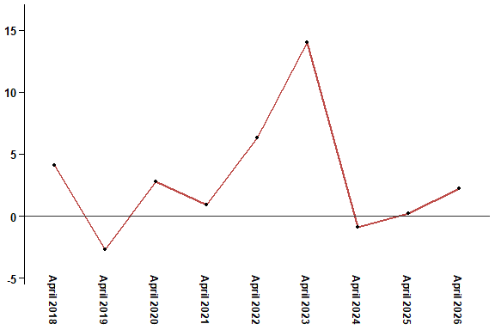
In April 2026, the consumer price index increased by 2.2% compared to April 2025
6- Annual evolution (%) of the consumer price index for the month of April
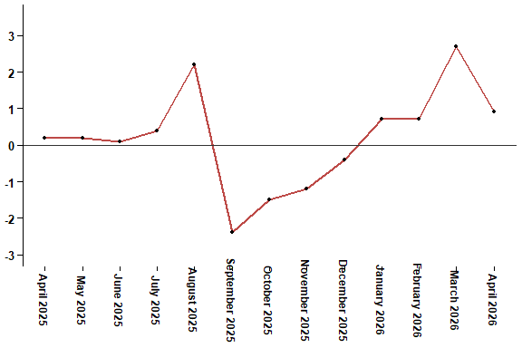
In April 2026, the consumer price index increased by 0.9% compared to March 2026
Table 2: Consumer price index for the city of Al Hoceima: April 2026 (2017 base: 100)
Product Divisions | Weightings | Monthly index |  |  |  |  | Variation (%)
 |  | April 2025 | January 2026 | February 2026 | March 2026 | April 2026 | 1 month | 3 months | 12 months
Food products | 49,716 | 141,1 | 136,2 | 137,7 | 143,4 | 143,7 | 0,2 | 5,5 | 1,8
01 – Food products and non-alcoholic | 48,371 | 140,9 | 135,6 | 137,2 | 143,0 | 143,3 | 0,2 | 5,7 | 1,7
02 –Alcoholicbeverages and tobacco | 1,345 | 150,1 | 156,3 | 156,3 | 156,3 | 158,1 | 1,2 | 1,2 | 5,3
Non foodproducts | 50,284 | 109,5 | 109,5 | 109,7 | 110,5 | 112,5 | 1,8 | 2,7 | 2,7
03 – Clothing and shoes | 5,155 | 117,5 | 117,5 | 117,4 | 118,3 | 118,5 | 0,2 | 0,9 | 0,9
04 - Housing, water, gas, electricity and other fuel | 11,732 | 106,2 | 107,1 | 107,1 | 107,1 | 107,4 | 0,3 | 0,3 | 1,1
05- Furniture, household items and routine maintenance of the home | 3,094 | 113,2 | 112,9 | 112,8 | 112,8 | 112,7 | -0,1 | -0,2 | -0,4
06 –Health | 6,413 | 98,8 | 99,1 | 99,1 | 99,1 | 99,1 | 0,0 | 0,0 | 0,3
07 – Transport | 7,704 | 118,3 | 113,9 | 114,3 | 119,0 | 131,6 | 10,6 | 15,5 | 11,2
08 – Communication | 2,892 | 101,6 | 101,4 | 101,4 | 101,4 | 101,4 | 0,0 | 0,0 | -0,2
09 – Leisure and culture | 1,933 | 95,0 | 97,0 | 97,0 | 97,0 | 96,5 | -0,5 | -0,5 | 1,6
10 –Education | 3,842 | 114,1 | 114,8 | 114,8 | 114,8 | 114,8 | 0,0 | 0,0 | 0,6
11 - Restaurants and hotels | 2,258 | 111,6 | 112,8 | 113,3 | 113,3 | 113,3 | 0,0 | 0,4 | 1,5
12 – Variousgoods and services | 5,261 | 112,4 | 115,1 | 116,3 | 116,3 | 115,9 | -0,3 | 0,7 | 3,1
General index | 100,000 | 125,5 | 123,0 | 123,9 | 127,2 | 128,3 | 0,9 | 4,3 | 2,2
High Commission for Planning, Department of Statistics - National consumer price survey

