Information note from the regional directorate of Tangier-Tetouan-Al Hoceima
Consumer price index: city of
In April 2026, the national consumer price index increased by 0.4% compared to the previous month, while the consumer price index increased by 1.7% over a full year.
The consumer price index experienced a decrease of 0.7% during the month of April 2026 compared to the previous month. as a result of the decline in prices of «Fish and Seafood» by 11.1%, «Milk, Cheese and Eggs» by 3.2%, «Vegetables» by 1.8%, «Oils and Fats» by 1.6% and «Bread and Cereals» and «Catering Services» by 0.2%
On the other hand, the monthly variation in the non-food index increased by 1.2% due to price increases in the following divisions: «Transportation» by 6.5%, «Restaurants and Hotels» by 0.6%, «Leisure and Culture» by 0.4%, «Housing, Water, Gas, Electricity and Other Fuels» and «Miscellaneous Goods and Services» by 0.2% and «Clothing and Shoes», «Furniture, Household Items and Routine Home Maintenance» and «Health» by 0.1%
Over a year, the food product price index increased by 0.5% in April 2026 compared to April 2025 , due to the rise in the prices of «Vegetables» by 14%, «Fish and Seafood» by 9.4%, «Cafe, Tea and Cocoa» by 5.3%, «Meat» by 4.8%, «Tobacco» by 4%, «Fruits» by 3% and «Sugar, Jam, Honey, Chocolate and Confectionery» by 0.6%. Moreover, the decrease in prices of «Oils and Fats» by 24.2%, «Bread and Cereals» and «Catering Services» by 0.9%, «Mineral Waters, Soft Drinks, Fruit and Vegetable Juices (Nd)» by 0.8%, «Food Products N.C.A.» by 0.4% and «Milk, Cheese and Eggs» by 0.3% and the stagnation in prices for NA did not affect the general evolution.
Similarly, the annual variation in the non-food index increased by 2.5%. While the variation in prices of the divisions that make up non-food products fluctuated between a decrease of the division of «Communications» by 0.3% and the rise of the division of «Transportation» by 8.4%
Annual evolution (%) of the consumer price index for the month of April
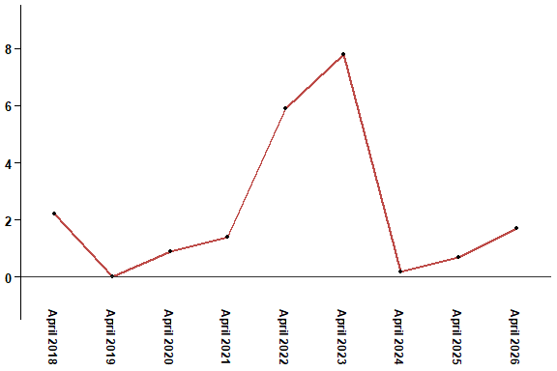
In April 2026, the consumer price index increased by 1.7% compared to April 2025
Annual evolution (%) of the consumer price index for the month of April
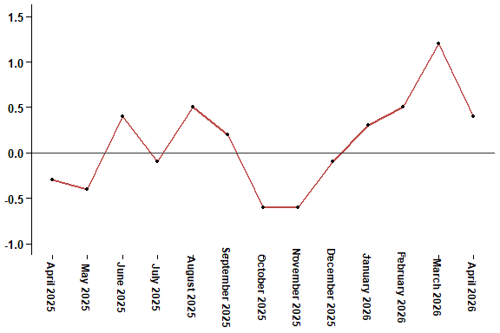
In April 2026, the consumer price index increased by 0.4% compared to March 2026
Consumer price index for the city of : April 2026 (2017 base: 100)
Product Divisions | Weightings | Monthly index |  |  |  |  | Variation (%)
 |  | April 2025 | January 2026 | February 2026 | March 2026 | April 2026 | 1 month | 3 months | 12 months
Food products | 39,009 | 131,1 | 129,2 | 130,3 | 132,7 | 131,8 | -0,7 | 2,0 | 0,5
01 – Food products and non-alcoholic | 37,502 | 130,5 | 128,4 | 129,5 | 132,0 | 131,1 | -0,7 | 2,1 | 0,5
02 –Alcoholicbeverages and tobacco | 1,507 | 145,0 | 149,3 | 149,3 | 149,3 | 150,5 | 0,8 | 0,8 | 3,8
Non foodproducts | 60,991 | 112,0 | 112,4 | 112,7 | 113,4 | 114,8 | 1,2 | 2,1 | 2,5
03 – Clothing and shoes | 4,323 | 117,0 | 117,5 | 117,5 | 118,1 | 118,2 | 0,1 | 0,6 | 1,0
04 - Housing, water, gas, electricity and other fuel | 14,575 | 109,2 | 109,6 | 109,6 | 109,8 | 110,0 | 0,2 | 0,4 | 0,7
05- Furniture, household items and routine maintenance of the home | 4,407 | 112,7 | 113,2 | 113,2 | 113,3 | 113,4 | 0,1 | 0,2 | 0,6
06 –Health | 7,741 | 101,4 | 101,5 | 101,5 | 101,5 | 101,6 | 0,1 | 0,1 | 0,2
07 – Transport | 10,040 | 116,3 | 113,9 | 115,0 | 118,4 | 126,1 | 6,5 | 10,7 | 8,4
08 – Communication | 2,958 | 104,0 | 103,7 | 103,7 | 103,7 | 103,7 | 0,0 | 0,0 | -0,3
09 – Leisure and culture | 2,735 | 104,9 | 104,9 | 105,0 | 104,7 | 105,1 | 0,4 | 0,2 | 0,2
10 –Education | 5,636 | 121,8 | 124,4 | 124,4 | 124,4 | 124,4 | 0,0 | 0,0 | 2,1
11 - Restaurants and hotels | 1,461 | 120,7 | 122,5 | 122,5 | 122,5 | 123,2 | 0,6 | 0,6 | 2,1
12 – Variousgoods and services | 7,115 | 116,5 | 119,1 | 120,4 | 120,5 | 120,8 | 0,2 | 1,4 | 3,7
General index | 100,000 | 119,5 | 119,0 | 119,6 | 121,0 | 121,5 | 0,4 | 2,1 | 1,7
High Commission for Planning, Department of Statistics - National consumer price survey

