Information note from the regional directorate of Tangier-Tetouan-Al Hoceima
Consumer price index: city of Tétouan
In May 2026, the national consumer price index decreased by 0.7% compared to the previous month, while the consumer price index increased by 2.4% over a full year.
The consumer price index experienced a decrease of 1.7% during the month of May 2026 compared to the previous month. as a result of the decline in prices of «Vegetables» by 7.8%, «Fruits» by 2.7%, «Fish and Seafood» by 1.2%, «Milk, Cheese and Eggs» by 1%, «Meat» by 0.9%, «Mineral Waters, Soft Drinks, Fruit and Vegetable Juices (Nd)» by 0.7%, «Cafe, Tea and Cocoa» by 0.3% and «Food Products N.C.A.» by 0.2%
On the other hand, the monthly variation in the non-food index increased by 0.1% due to price increases in the following divisions: «Housing, Water, Gas, Electricity and Other Fuels» by 1.4%, «Miscellaneous Goods and Services» by 0.5% and «Communications» by 0.2%
Over a year, the food product price index increased by 0.8% in May 2026 compared to May 2025 , due to the rise in the prices of «Meat» by 12%, «Fruits» by 6.3%, «Fish and Seafood» by 5.2%, «Tobacco» by 4%, «Vegetables» by 3%, «Food Products N.C.A.» by 2.1%, «Sugar, Jam, Honey, Chocolate and Confectionery» by 1.6%, «Cafe, Tea and Cocoa» by 0.8% and «Mineral Waters, Soft Drinks, Fruit and Vegetable Juices (Nd)» by 0.6%. Moreover, the decrease in prices of «Oils and Fats» by 22.6%, «Milk, Cheese and Eggs» by 3% and «Bread and Cereals» and «Catering Services» by 0.2% and the stagnation in prices for NA did not affect the general evolution.
Similarly, the annual variation in the non-food index increased by 3.9%. While the variation in prices of the divisions that make up non-food products fluctuated between a decrease of the division of «Leisure and Culture» by 1.1% and the rise of the division of «Transportation» by 13.6%
3- Annual evolution (%) of the consumer price index for the month of May
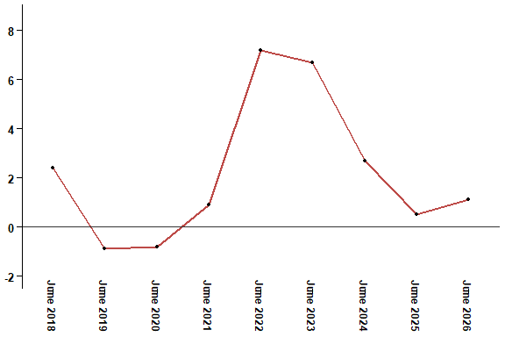
In May 2026, the consumer price index increased by 2.4% compared to May 2025
4- Annual evolution (%) of the consumer price index for the month of May
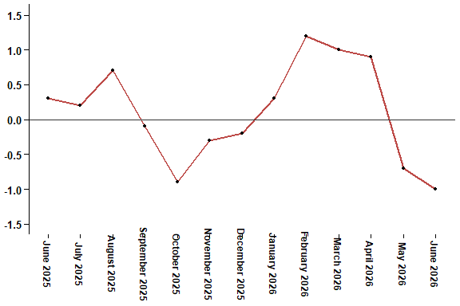
In May 2026, the consumer price index decreased by 0.7% compared to April 2026
Table 3: Consumer price index for the city of Tétouan: May 2026 (2017 base: 100)
Product Divisions | Weightings | Monthly index |  |  |  |  | Variation (%)
 |  | June 2025 | March 2026 | April 2026 | May 2026 | June 2026 | 1 month | 3 months | 12 months
Food products | 40,725 | 133,9 | 136,3 | 136,5 | 134,2 | 132,1 | -1,6 | -3,1 | -1,3
01 – Food products and non-alcoholic | 38,964 | 133,3 | 135,7 | 135,8 | 133,4 | 131,2 | -1,6 | -3,3 | -1,6
02 –Alcoholicbeverages and tobacco | 1,761 | 146,1 | 150,5 | 152,0 | 152,0 | 152,0 | 0,0 | 1,0 | 4,0
Non foodproducts | 59,275 | 110,8 | 113,0 | 114,8 | 114,9 | 114,3 | -0,5 | 1,2 | 3,2
03 – Clothing and shoes | 5,835 | 113,2 | 114,7 | 114,0 | 113,2 | 112,2 | -0,9 | -2,2 | -0,9
04 - Housing, water, gas, electricity and other fuel | 14,202 | 109,2 | 109,5 | 109,5 | 111,0 | 110,8 | -0,2 | 1,2 | 1,5
05- Furniture, household items and routine maintenance of the home | 5,602 | 110,6 | 111,5 | 111,9 | 111,2 | 111,6 | 0,4 | 0,1 | 0,9
06 –Health | 6,594 | 103,5 | 103,4 | 103,0 | 103,0 | 103,0 | 0,0 | -0,4 | -0,5
07 – Transport | 7,416 | 110,6 | 115,0 | 127,1 | 125,6 | 121,8 | -3,0 | 5,9 | 10,1
08 – Communication | 2,560 | 97,6 | 96,8 | 97,1 | 97,3 | 97,3 | 0,0 | 0,5 | -0,3
09 – Leisure and culture | 2,432 | 106,8 | 106,3 | 106,5 | 105,6 | 105,6 | 0,0 | -0,7 | -1,1
10 –Education | 5,358 | 116,8 | 129,5 | 129,5 | 129,5 | 129,5 | 0,0 | 0,0 | 10,9
11 - Restaurants and hotels | 2,468 | 115,8 | 116,6 | 123,5 | 122,9 | 123,1 | 0,2 | 5,6 | 6,3
12 – Variousgoods and services | 6,808 | 119,3 | 121,2 | 122,1 | 122,7 | 122,4 | -0,2 | 1,0 | 2,6
General index | 100,000 | 120,3 | 122,6 | 123,7 | 122,8 | 121,6 | -1,0 | -0,8 | 1,1
High Commission for Planning, Department of Statistics - National consumer price survey

