Information note from the regional directorate of Tangier-Tetouan-Al Hoceima
Consumer price index: city of Tanger
In May 2026, the national consumer price index decreased by 1.2% compared to the previous month, while the consumer price index increased by 1.6% over a full year.
The consumer price index experienced a decrease of 3.1% during the month of May 2026 compared to the previous month. as a result of the decline in prices of «Vegetables» by 11.6%, «Meat» by 3.7%, «Fruits» by 3.4%, «Milk, Cheese and Eggs» by 2.3%, «Oils and Fats» by 1.8%, «Cafe, Tea and Cocoa» by 0.8% and «Fish and Seafood» by 0.3%
Similarly, the monthly variation in the non-food index decreased by abs(evol_non_alim_1mois)% due to price decreases in the following divisions: «Communications» by 1%, «Transportation» by 0.7%, «Leisure and Culture» by 0.5%, «Miscellaneous Goods and Services» by 0.3% and «Furniture, Household Items and Routine Home Maintenance» by 0.1%.
Over a year, the food product price index decreased by -0.3% in May 2026 compared to May 2025 , due to the decrease in the prices of «Oils and Fats» by 21.2%, «Milk, Cheese and Eggs» by 1.2% and «Food Products N.C.A.» by 0.8%. Moreover, the rise in prices of «Fish and Seafood» by 13.6%, «Tobacco» by 4%, «Meat» and «Fruits» by 2.4%, «Bread and Cereals» and «Catering Services» by 2.1%, «Vegetables» by 1.9%, «Cafe, Tea and Cocoa» by 1.2%, «Mineral Waters, Soft Drinks, Fruit and Vegetable Juices (Nd)» by 0.7% and «Sugar, Jam, Honey, Chocolate and Confectionery» by 0.5% and the stagnation in prices for NA did not affect the general evolution.
On the other hand, the annual variation in the non-food index increased by 2.9%. While the variation in prices of the divisions that make up non-food products fluctuated between a decrease of the division of «Communications» by 2.2% and the rise of the division of «Miscellaneous Goods and Services» by 10.7%
1- Annual evolution (%) of the consumer price index for the month of May
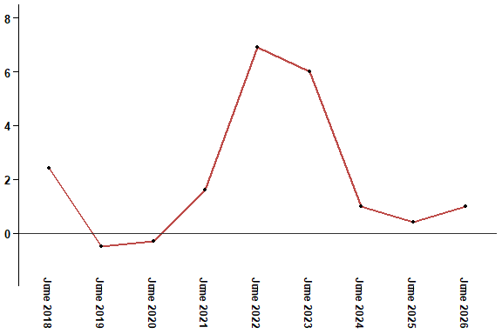
In May 2026, the consumer price index increased by 1.6% compared to May 2025
2- Annual evolution (%) of the consumer price index for the month of May
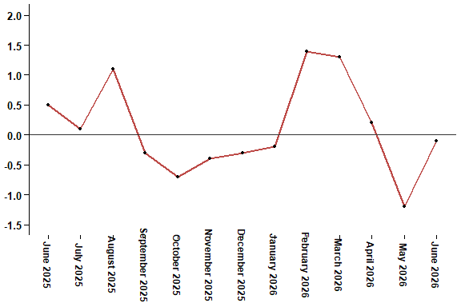
In May 2026, the consumer price index decreased by 1.2% compared to April 2026
Table 4: Consumer price index for the city of Tanger: May 2026 (2017 base: 100)
Product Divisions | Weightings | Monthly index |  |  |  |  | Variation (%)
 |  | June 2025 | March 2026 | April 2026 | May 2026 | June 2026 | 1 month | 3 months | 12 months
Food products | 36,115 | 131,3 | 134,8 | 133,5 | 129,3 | 129,3 | 0,0 | -4,1 | -1,5
01 – Food products and non-alcoholic | 34,708 | 130,7 | 134,2 | 132,8 | 128,4 | 128,4 | 0,0 | -4,3 | -1,8
02 –Alcoholicbeverages and tobacco | 1,407 | 145,4 | 149,7 | 151,1 | 151,1 | 151,1 | 0,0 | 0,9 | 3,9
Non foodproducts | 63,885 | 111,9 | 113,9 | 115,1 | 115,0 | 114,9 | -0,1 | 0,9 | 2,7
03 – Clothing and shoes | 6,449 | 113,2 | 113,7 | 113,2 | 113,3 | 113,3 | 0,0 | -0,4 | 0,1
04 - Housing, water, gas, electricity and other fuel | 16,656 | 111,6 | 111,9 | 111,9 | 112,7 | 112,8 | 0,1 | 0,8 | 1,1
05- Furniture, household items and routine maintenance of the home | 4,100 | 108,8 | 112,1 | 112,2 | 112,1 | 112,1 | 0,0 | 0,0 | 3,0
06 –Health | 8,218 | 109,3 | 109,3 | 109,3 | 109,3 | 109,4 | 0,1 | 0,1 | 0,1
07 – Transport | 9,751 | 115,4 | 117,0 | 124,1 | 123,2 | 121,5 | -1,4 | 3,8 | 5,3
08 – Communication | 3,199 | 101,5 | 100,7 | 100,3 | 99,3 | 99,3 | 0,0 | -1,4 | -2,2
09 – Leisure and culture | 2,350 | 104,4 | 104,7 | 105,2 | 104,7 | 104,7 | 0,0 | 0,0 | 0,3
10 –Education | 5,047 | 110,9 | 113,4 | 113,4 | 113,4 | 113,4 | 0,0 | 0,0 | 2,3
11 - Restaurants and hotels | 1,280 | 127,2 | 127,1 | 128,3 | 128,3 | 129,9 | 1,2 | 2,2 | 2,1
12 – Variousgoods and services | 6,835 | 116,4 | 128,4 | 129,3 | 128,9 | 129,1 | 0,2 | 0,5 | 10,9
General index | 100,000 | 119,0 | 121,6 | 121,8 | 120,3 | 120,2 | -0,1 | -1,2 | 1,0
High Commission for Planning, Department of Statistics - National consumer price survey

