Information note from the regional directorate of Tangier-Tetouan-Al Hoceima
Consumer price index: city of Al Hoceima
In May 2026, the national consumer price index decreased by 1.2% compared to the previous month, while the consumer price index increased by 0.9% over a full year.
The consumer price index experienced a decrease of 2.4% during the month of May 2026 compared to the previous month. as a result of the decline in prices of «Oils and Fats» by 5.8%, «Vegetables» by 5%, «Fish and Seafood», «Milk and Cheese and Eggs» by 3%, «Fruits» by 1.2%, «Mineral Waters, Soft Drinks, Fruit and Vegetable Juices (Nd)» by 0.8%, «Meat» by 0.7% and «Cafe, Tea and Cocoa» by 0.3%
On the other hand, the monthly variation in the non-food index increased by 0.5% due to price increases in the following divisions: «Housing, Water, Gas, Electricity and Other Fuels» by 2.3%, «Restaurants and Hotels» by 0.4%, «Clothing and Shoes» by 0.3% and «Transportation» by 0.2%
Over a year, the food product price index decreased by -0.9% in May 2026 compared to May 2025 , due to the decrease in the prices of «Oils and Fats» by 32.6%, «Milk, Cheese and Eggs» by 3.4%, «Bread and Cereals» and «Catering Services» by 1.1% and «Food Products N.C.A.» by 0.7%. Moreover, the rise in prices of «Cafe, Tea and Cocoa» by 13.6%, «Fish and Seafood» by 7.9%, «Meat» by 6.7%, «Tobacco» by 5%, «Fruits» by 4.6%, «Vegetables» by 3.8% and «Sugar, Jam, Honey, Chocolate and Confectionery» by 0.5% and the stagnation in prices for «Mineral Waters, Soft Drinks, Fruit and Vegetable Juices (Nd)» by 0% did not affect the general evolution.
On the other hand, the annual variation in the non-food index increased by 3.4%. While the variation in prices of the divisions that make up non-food products fluctuated between a decrease of the division of «Furniture, Household Items and Routine Home Maintenance» by 0.5% and the rise of the division of «Transportation» by 12.6%
4- Annual evolution (%) of the consumer price index for the month of May
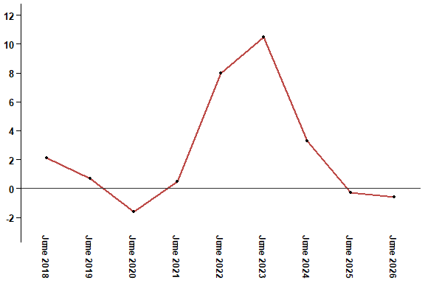
In May 2026, the consumer price index increased by 0.9% compared to May 2025
6- Annual evolution (%) of the consumer price index for the month of May
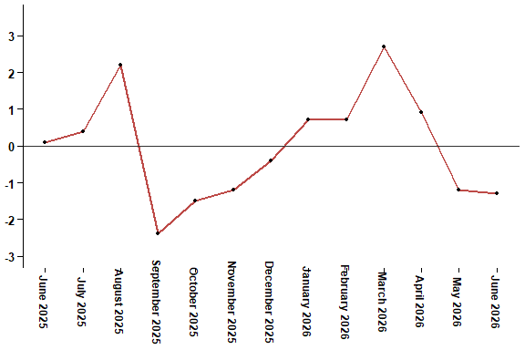
In May 2026, the consumer price index decreased by 1.2% compared to April 2026
Table 2: Consumer price index for the city of Al Hoceima: May 2026 (2017 base: 100)
Product Divisions | Weightings | Monthly index |  |  |  |  | Variation (%)
 |  | June 2025 | March 2026 | April 2026 | May 2026 | June 2026 | 1 month | 3 months | 12 months
Food products | 49,716 | 141,6 | 143,4 | 143,7 | 140,2 | 137,1 | -2,2 | -4,4 | -3,2
01 – Food products and non-alcoholic | 48,371 | 141,4 | 143,0 | 143,3 | 139,7 | 136,5 | -2,3 | -4,5 | -3,5
02 –Alcoholicbeverages and tobacco | 1,345 | 150,1 | 156,3 | 158,1 | 158,1 | 158,1 | 0,0 | 1,2 | 5,3
Non foodproducts | 50,284 | 109,5 | 110,5 | 112,5 | 113,1 | 112,9 | -0,2 | 2,2 | 3,1
03 – Clothing and shoes | 5,155 | 117,4 | 118,3 | 118,5 | 118,8 | 118,8 | 0,0 | 0,4 | 1,2
04 - Housing, water, gas, electricity and other fuel | 11,732 | 106,2 | 107,1 | 107,4 | 109,9 | 109,9 | 0,0 | 2,6 | 3,5
05- Furniture, household items and routine maintenance of the home | 3,094 | 113,1 | 112,8 | 112,7 | 112,7 | 112,7 | 0,0 | -0,1 | -0,4
06 –Health | 6,413 | 98,8 | 99,1 | 99,1 | 99,1 | 99,1 | 0,0 | 0,0 | 0,3
07 – Transport | 7,704 | 117,4 | 119,0 | 131,6 | 131,9 | 129,6 | -1,7 | 8,9 | 10,4
08 – Communication | 2,892 | 101,6 | 101,4 | 101,4 | 101,4 | 101,4 | 0,0 | 0,0 | -0,2
09 – Leisure and culture | 1,933 | 94,9 | 97,0 | 96,5 | 96,5 | 96,5 | 0,0 | -0,5 | 1,7
10 –Education | 3,842 | 114,1 | 114,8 | 114,8 | 114,8 | 114,8 | 0,0 | 0,0 | 0,6
11 - Restaurants and hotels | 2,258 | 113,3 | 113,3 | 113,3 | 113,7 | 116,6 | 2,6 | 2,9 | 2,9
12 – Variousgoods and services | 5,261 | 113,2 | 116,3 | 115,9 | 115,7 | 115,2 | -0,4 | -0,9 | 1,8
General index | 100,000 | 125,8 | 127,2 | 128,3 | 126,8 | 125,1 | -1,3 | -1,7 | -0,6
High Commission for Planning, Department of Statistics - National consumer price survey

