Consumer Price Index - June 2026 | City of Tetouan
In June 2026, the national consumer price index decreased by 1% compared to the previous month, while the consumer price index increased by 1.1% over a full year.

Over a month, The consumer price index experienced a decrease of 1.6% during the month of June 2026 compared to the previous month. as a result of the decline in prices of «Fish and Seafood» by 5,1%, «Vegetables» by 4,0%, «Fruits» by 2,8%, «Meat» by 2,4%, «Food Productsnot elsewhere classified» by 1,7% and «Milk, Cheese and Eggs» by 0,2%
Similarly, the monthly variation in the non-food index decreased by abs(evol_non_alim_1mois)% due to price decreases in the following divisions: «Transportation» by 3,0%, «Clothing and Shoes» by 0,9% and «Housing, Water, Gas, Electricity and Other Fuels» and «Various Goods and Services» by 0,2%.
Over a year, the food product price index decreased by -1.3% in June 2026 compared to June 2025 , due to the decrease in the prices of «Oils and Fats» by 18,9%, «Milk, Cheese and Eggs» by 3,1%, «Vegetables» by 1,9%, «Fish and Seafood» by 0,7% and «Bread and Cereals» and «Catering Services» by 0,1%. Moreover, the rise in prices of «Meat» by 5,5%, «Tobacco» by 4,0%, «Sugar, Jam, Honey, Chocolate and Confectionery» by 1,8%, «Fruits», «Cafe and Tea and Cocoa» by 0,9% and «Mineral Waters, Soft Drinks, Fruit and Vegetable Juices (Nd)» by 0,7% and the stagnation in prices for «Food Productsnot elsewhere classified» by 0,0% did not affect the general evolution.
On the other hand, the annual variation in the non-food index increased by 3.2%. While the variation in prices of the divisions that make up non-food products fluctuated between a decrease of the division of «Leisure and Culture» by 1,1% and the rise of the division of «Education» by 10,9%
3- Annual evolution (%) of the consumer price index for the month of June
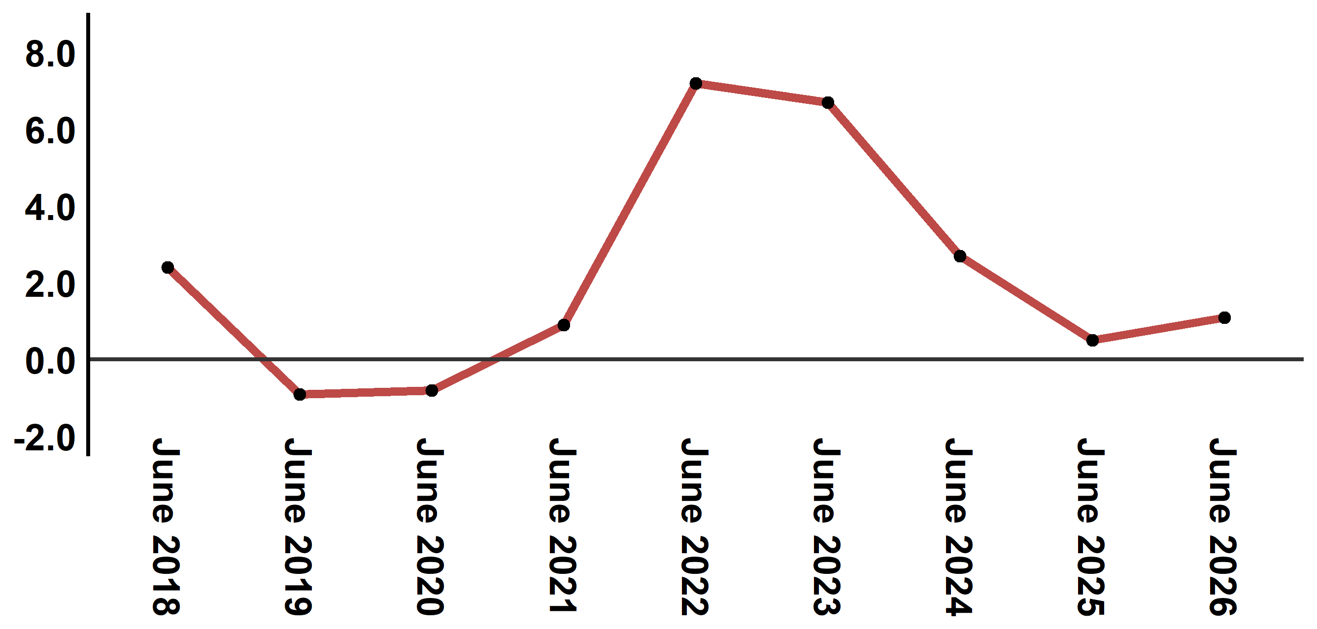
Reading: In June 2026, the consumer price index increased by 1.1% compared to June 2025
4- Annual evolution (%) of the consumer price index for the month of June
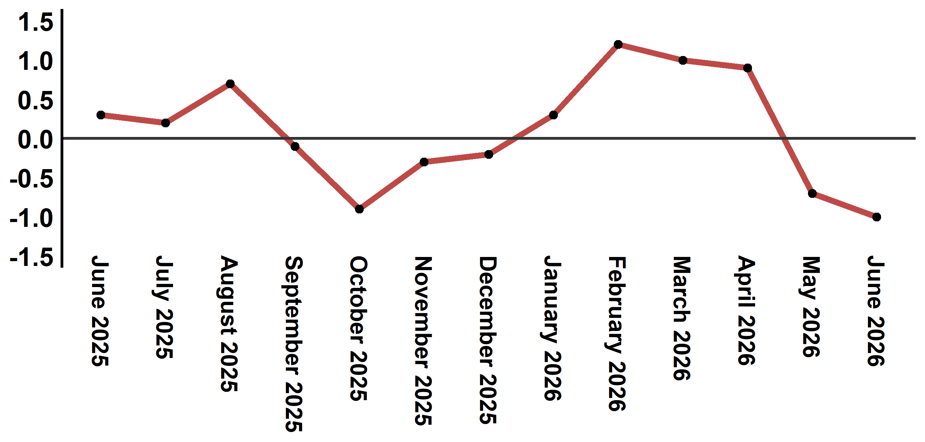
Reading: In June 2026, the consumer price index decreased by 1% compared to May 2026

Table 3: Consumer price index for the city of Tetouan: June 2026 (2017 base: 100)
Product Divisions | Weightings | Monthly index |  |  |  |  | Variation (%)
 |  | June 2025 | March 2026 | April 2026 | May 2026 | June 2026 | 1 month | 3 months | 12 months
Food products | 40,725 | 133,9 | 136,3 | 136,5 | 134,2 | 132,1 | -1,6 | -3,1 | -1,3
01 – Food products and non-alcoholic | 38,964 | 133,3 | 135,7 | 135,8 | 133,4 | 131,2 | -1,6 | -3,3 | -1,6
02 –Alcoholicbeverages and tobacco | 1,761 | 146,1 | 150,5 | 152,0 | 152,0 | 152,0 | 0,0 | 1,0 | 4,0
Non foodproducts | 59,275 | 110,8 | 113,0 | 114,8 | 114,9 | 114,3 | -0,5 | 1,2 | 3,2
03 – Clothing and shoes | 5,835 | 113,2 | 114,7 | 114,0 | 113,2 | 112,2 | -0,9 | -2,2 | -0,9
04 - Housing, water, gas, electricity and other fuel | 14,202 | 109,2 | 109,5 | 109,5 | 111,0 | 110,8 | -0,2 | 1,2 | 1,5
05- Furniture, household items and routine maintenance of the home | 5,602 | 110,6 | 111,5 | 111,9 | 111,2 | 111,6 | 0,4 | 0,1 | 0,9
06 –Health | 6,594 | 103,5 | 103,4 | 103,0 | 103,0 | 103,0 | 0,0 | -0,4 | -0,5
07 – Transport | 7,416 | 110,6 | 115,0 | 127,1 | 125,6 | 121,8 | -3,0 | 5,9 | 10,1
08 – Communication | 2,560 | 97,6 | 96,8 | 97,1 | 97,3 | 97,3 | 0,0 | 0,5 | -0,3
09 – Leisure and culture | 2,432 | 106,8 | 106,3 | 106,5 | 105,6 | 105,6 | 0,0 | -0,7 | -1,1
10 –Education | 5,358 | 116,8 | 129,5 | 129,5 | 129,5 | 129,5 | 0,0 | 0,0 | 10,9
11 - Restaurants and hotels | 2,468 | 115,8 | 116,6 | 123,5 | 122,9 | 123,1 | 0,2 | 5,6 | 6,3
12 – Variousgoods and services | 6,808 | 119,3 | 121,2 | 122,1 | 122,7 | 122,4 | -0,2 | 1,0 | 2,6
General index | 100,000 | 120,3 | 122,6 | 123,7 | 122,8 | 121,6 | -1,0 | -0,8 | 1,1
Source: High Commission for Planning, Department of Statistics - National consumer price survey
Angle Avenue Ibn Tachafine et Avenue Ibn Toumart B.P.104 Tanger
****Tél:0539940698****Fax:0539940364 Site Web: www.hcp.ma/region-tanger Email:hcp.dr.tanger@hcp.ma
:::

