Consumer Price Index - June 2026 | City of Tangier
In June 2026, the consumer price index for households decreased by -0,1% compared to the previous month. On an annual level, the consumer price index increased by 1,0% over a full year.

Over a month, the food price index remained unchanged in June 2026 compared to May 2026. as a result of the rise in prices of «Fruits» by 6,2%, «Fish and Seafood» by 2,2%, «Cafe, Tea and Cocoa» by 0,8% and «Sugar, Jam, Honey, Chocolate and Confectionery» by 0,2% and the decline in prices of «Vegetables» by 3,8%, «Milk, Cheese and Eggs» by 1,7%, «Food Productsnot elsewhere classified» by 1,0%, «Oils and Fats» by 0,7%, «Bread and Cereals», «Catering Services», «Mineral Waters, Soft Drinks and Fruit and Vegetable Juices (Nd)» by 0,2% and «Meat» by 0,1%.
Moreover, the monthly variation of the index for the non-food products decreased by 0,1% due to drop in prices in the following divisions: «Transportation» by 1,4%. Also, the increase in prices of the following divisions: «Restaurants and Hotels» by 1,2%, «Various Goods and Services» by 0,2% and «Housing, Water, Gas, Electricity and Other Fuels» and «Health» by 0,1%. Thus, the stagnation of the indices of the other divisions did not impact the general evolution.
Over a year, the food product price index decreased by 1,5% in June 2026 compared to June 2025 , due to the decrease in the prices of «Oils and Fats» by 21,3%, «Milk, Cheese and Eggs» by 3,1%, «Meat» by 2,5% and «Food Productsnot elsewhere classified» by 0,2%. Moreover, the rise in prices of «Fish and Seafood» by 5,5%, «Fruits» by 5,3%, «Tobacco» by 4,0%, «Bread and Cereals» and «Catering Services» by 2,8%, «Vegetables» by 1,1%, «Sugar, Jam, Honey, Chocolate and Confectionery» by 0,7%, «Cafe, Tea and Cocoa» by 0,6% and «Mineral Waters, Soft Drinks, Fruit and Vegetable Juices (Nd)» by 0,2% and the stagnation in prices for NA did not affect the general evolution.
On the other hand, the annual variation in the non-food index increased by 2,7%. While the variation in prices of the divisions that make up non-food products fluctuated between a decrease of the division of «Communications» by 2,2% and the rise of the division of «Various Goods and Services» by 10,9%
1- Annual evolution (%) of the consumer price index for the month of June
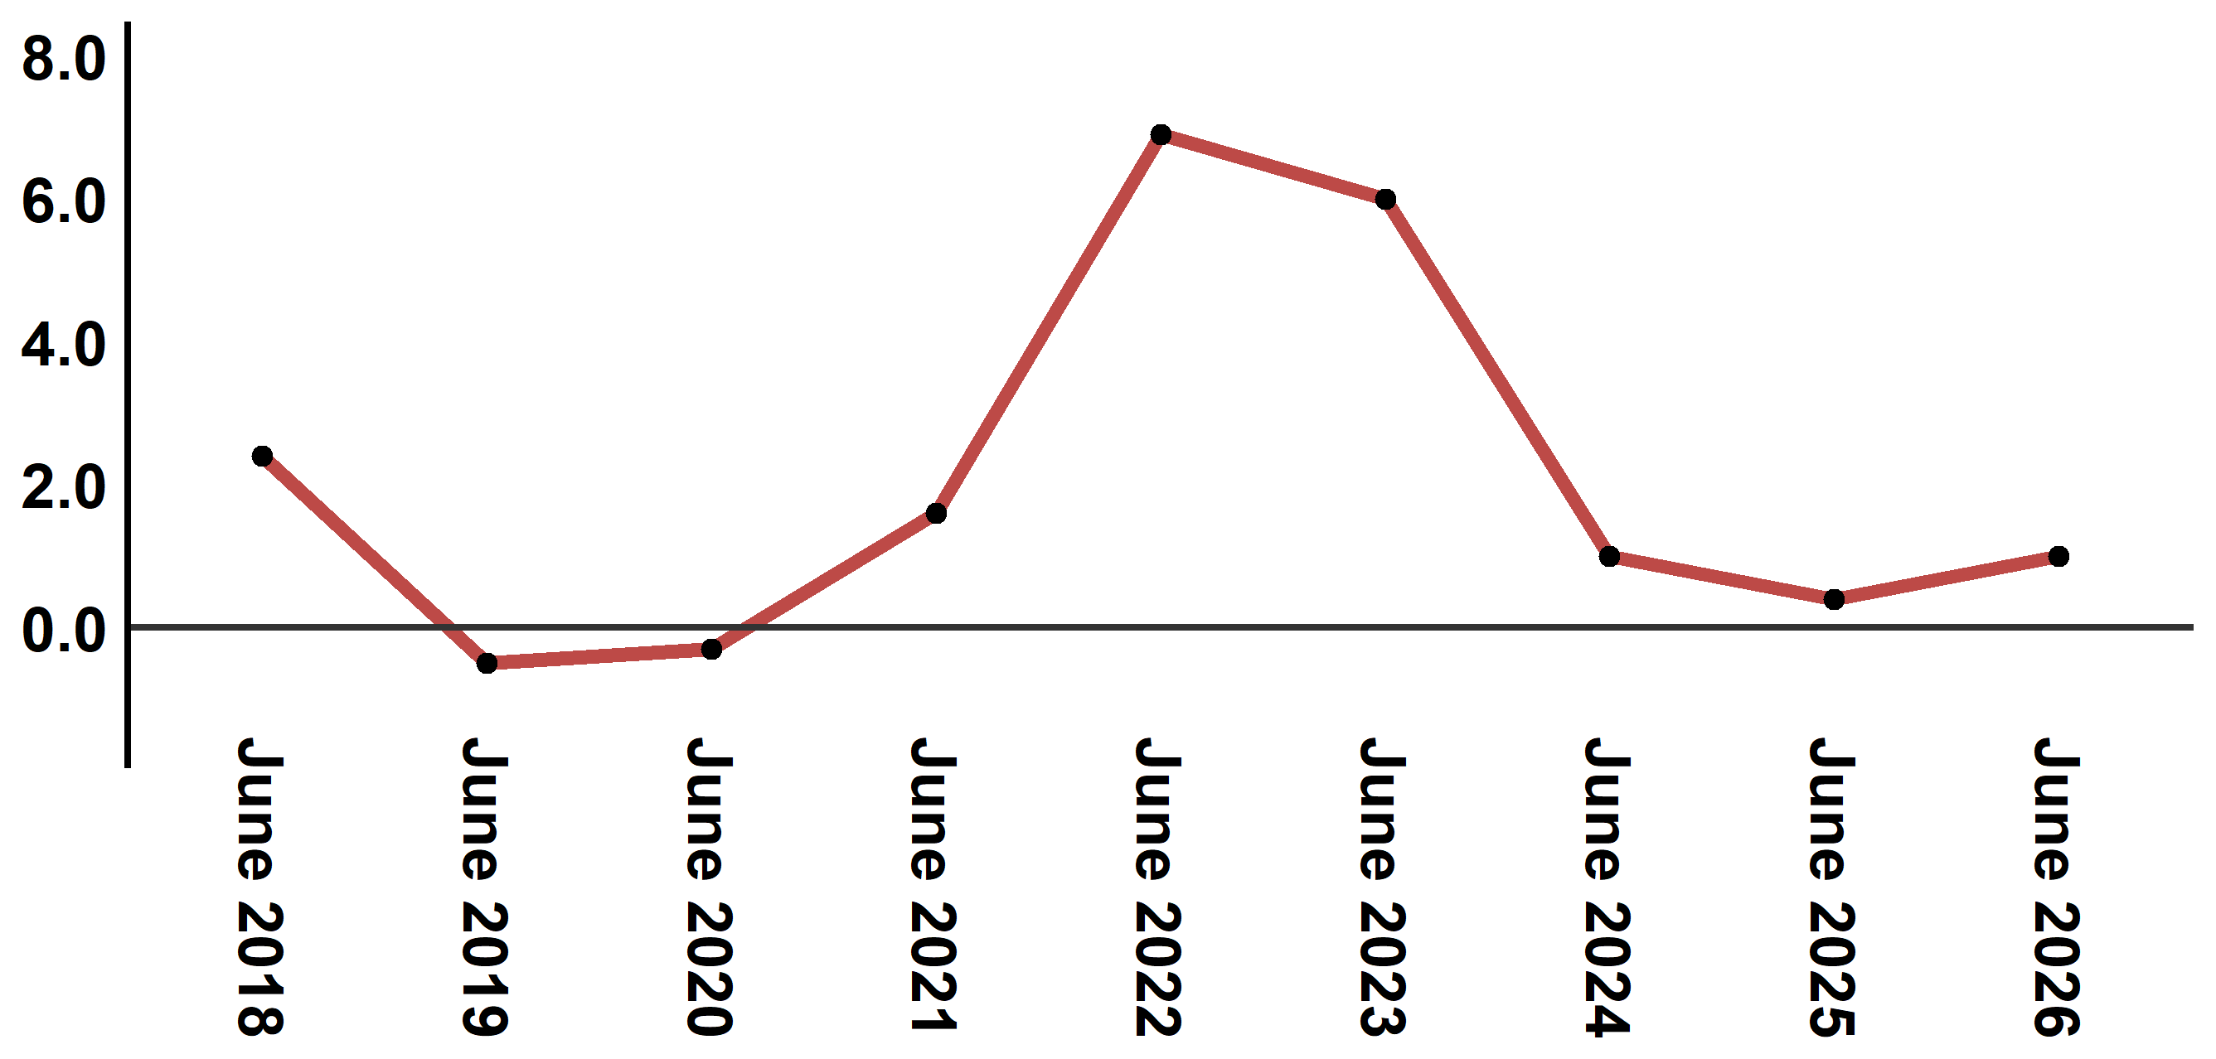
Reading: In June 2026, the consumer price index increased by 1,0% compared to June 2025
2- Annual evolution (%) of the consumer price index for the month of June
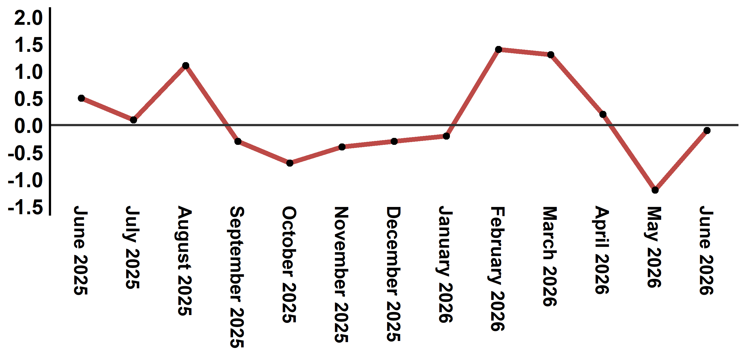
Reading: The level of price variation in June 2026 decreased by 0,1% after being 1,2% in April 2026

Table 4: Consumer price index for the city of Tangier: June 2026 (2017 base: 100)
Product Divisions | Weightings | Monthly index |  |  |  |  | Variation (%)
 |  | June 2025 | March 2026 | April 2026 | May 2026 | June 2026 | 1 month | 3 months | 12 months
Food products | 36,115 | 131,3 | 134,8 | 133,5 | 129,3 | 129,3 | 0,0 | -4,1 | -1,5
01 – Food products and non-alcoholic | 34,708 | 130,7 | 134,2 | 132,8 | 128,4 | 128,4 | 0,0 | -4,3 | -1,8
02 –Alcoholicbeverages and tobacco | 1,407 | 145,4 | 149,7 | 151,1 | 151,1 | 151,1 | 0,0 | 0,9 | 3,9
Non foodproducts | 63,885 | 111,9 | 113,9 | 115,1 | 115,0 | 114,9 | -0,1 | 0,9 | 2,7
03 – Clothing and shoes | 6,449 | 113,2 | 113,7 | 113,2 | 113,3 | 113,3 | 0,0 | -0,4 | 0,1
04 - Housing, water, gas, electricity and other fuel | 16,656 | 111,6 | 111,9 | 111,9 | 112,7 | 112,8 | 0,1 | 0,8 | 1,1
05- Furniture, household items and routine maintenance of the home | 4,100 | 108,8 | 112,1 | 112,2 | 112,1 | 112,1 | 0,0 | 0,0 | 3,0
06 –Health | 8,218 | 109,3 | 109,3 | 109,3 | 109,3 | 109,4 | 0,1 | 0,1 | 0,1
07 – Transport | 9,751 | 115,4 | 117,0 | 124,1 | 123,2 | 121,5 | -1,4 | 3,8 | 5,3
08 – Communication | 3,199 | 101,5 | 100,7 | 100,3 | 99,3 | 99,3 | 0,0 | -1,4 | -2,2
09 – Leisure and culture | 2,350 | 104,4 | 104,7 | 105,2 | 104,7 | 104,7 | 0,0 | 0,0 | 0,3
10 –Education | 5,047 | 110,9 | 113,4 | 113,4 | 113,4 | 113,4 | 0,0 | 0,0 | 2,3
11 - Restaurants and hotels | 1,280 | 127,2 | 127,1 | 128,3 | 128,3 | 129,9 | 1,2 | 2,2 | 2,1
12 – Variousgoods and services | 6,835 | 116,4 | 128,4 | 129,3 | 128,9 | 129,1 | 0,2 | 0,5 | 10,9
General index | 100,000 | 119,0 | 121,6 | 121,8 | 120,3 | 120,2 | -0,1 | -1,2 | 1,0
Source: High Commission for Planning, Department of Statistics - National consumer price survey
Angle Avenue Ibn Tachafine et Avenue Ibn Toumart B.P.104 Tanger
****Tél:0539940698****Fax:0539940364 Site Web: www.hcp.ma/region-tanger Email:hcp.dr.tanger@hcp.ma
:::

