Consumer Price Index - June 2026 | City of Al Hoceima
In June 2026, the national consumer price index decreased by 1.3% compared to the previous month, while the consumer price index decreased by 0.6% over a full year.

Over a month, The consumer price index experienced a decrease of 2.2% during the month of June 2026 compared to the previous month. as a result of the decline in prices of «Vegetables» by 11,6%, «Fruits» by 2,3%, «Fish and Seafood» by 2,2% and «Milk, Cheese and Eggs» by 1,4%
Similarly, the monthly variation in the non-food index decreased by abs(evol_non_alim_1mois)% due to price decreases in the following divisions: «Transportation» by 1,7% and «Various Goods and Services» by 0,4%.
Over a year, the food product price index decreased by -3.2% in June 2026 compared to June 2025 , due to the decrease in the prices of «Oils and Fats» by 31,6%, «Milk, Cheese and Eggs» by 4,5%, «Vegetables» by 3,1%, «Fruits» by 1,6%, «Bread and Cereals» and «Catering Services» by 0,8% and «Food Productsnot elsewhere classified» by 0,2%. Moreover, the rise in prices of «Cafe, Tea and Cocoa» by 13,7%, «Meat» by 6,7%, «Fish and Seafood» by 5,1%, «Tobacco» by 5,0%, «Mineral Waters, Soft Drinks, Fruit and Vegetable Juices (Nd)» by 1,0% and «Sugar, Jam, Honey, Chocolate and Confectionery» by 0,6% and the stagnation in prices for NA did not affect the general evolution.
On the other hand, the annual variation in the non-food index increased by 3.1%. While the variation in prices of the divisions that make up non-food products fluctuated between a decrease of the division of «Furniture, Household Items and Routine Home Maintenance» by 0,4% and the rise of the division of «Transportation» by 10,4%
4- Annual evolution (%) of the consumer price index for the month of June
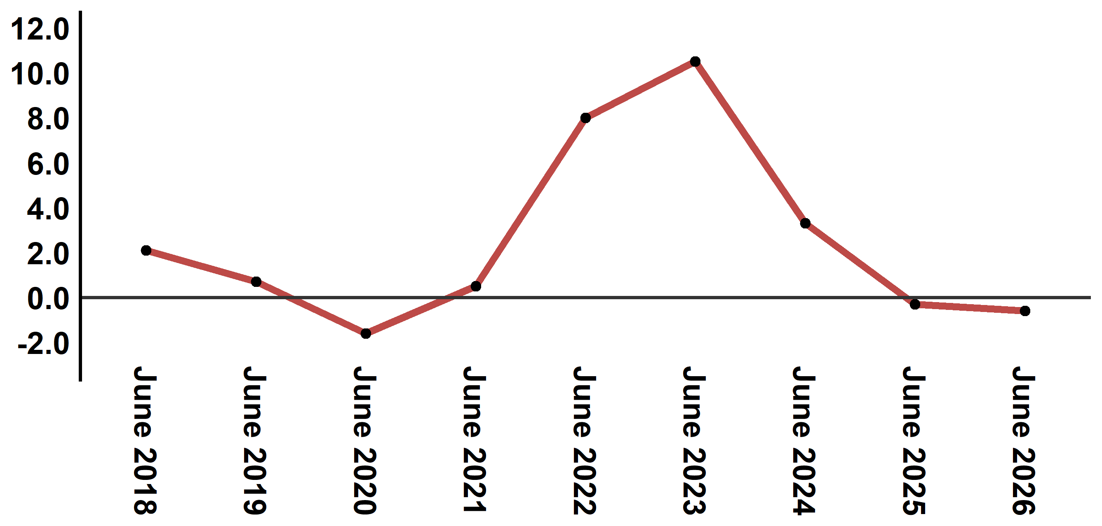
Reading: In June 2026, the consumer price index decreased by 0.6% compared to June 2025
6- Annual evolution (%) of the consumer price index for the month of June
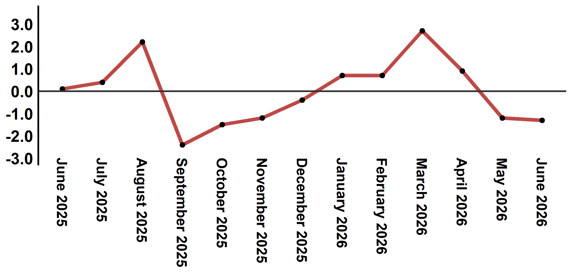
Reading: In June 2026, the consumer price index decreased by 1.3% compared to May 2026

Table 2: Consumer price index for the city of Al Hoceima: June 2026 (2017 base: 100)
Product Divisions | Weightings | Monthly index |  |  |  |  | Variation (%)
 |  | June 2025 | March 2026 | April 2026 | May 2026 | June 2026 | 1 month | 3 months | 12 months
Food products | 49,716 | 141,6 | 143,4 | 143,7 | 140,2 | 137,1 | -2,2 | -4,4 | -3,2
01 – Food products and non-alcoholic | 48,371 | 141,4 | 143,0 | 143,3 | 139,7 | 136,5 | -2,3 | -4,5 | -3,5
02 –Alcoholicbeverages and tobacco | 1,345 | 150,1 | 156,3 | 158,1 | 158,1 | 158,1 | 0,0 | 1,2 | 5,3
Non foodproducts | 50,284 | 109,5 | 110,5 | 112,5 | 113,1 | 112,9 | -0,2 | 2,2 | 3,1
03 – Clothing and shoes | 5,155 | 117,4 | 118,3 | 118,5 | 118,8 | 118,8 | 0,0 | 0,4 | 1,2
04 - Housing, water, gas, electricity and other fuel | 11,732 | 106,2 | 107,1 | 107,4 | 109,9 | 109,9 | 0,0 | 2,6 | 3,5
05- Furniture, household items and routine maintenance of the home | 3,094 | 113,1 | 112,8 | 112,7 | 112,7 | 112,7 | 0,0 | -0,1 | -0,4
06 –Health | 6,413 | 98,8 | 99,1 | 99,1 | 99,1 | 99,1 | 0,0 | 0,0 | 0,3
07 – Transport | 7,704 | 117,4 | 119,0 | 131,6 | 131,9 | 129,6 | -1,7 | 8,9 | 10,4
08 – Communication | 2,892 | 101,6 | 101,4 | 101,4 | 101,4 | 101,4 | 0,0 | 0,0 | -0,2
09 – Leisure and culture | 1,933 | 94,9 | 97,0 | 96,5 | 96,5 | 96,5 | 0,0 | -0,5 | 1,7
10 –Education | 3,842 | 114,1 | 114,8 | 114,8 | 114,8 | 114,8 | 0,0 | 0,0 | 0,6
11 - Restaurants and hotels | 2,258 | 113,3 | 113,3 | 113,3 | 113,7 | 116,6 | 2,6 | 2,9 | 2,9
12 – Variousgoods and services | 5,261 | 113,2 | 116,3 | 115,9 | 115,7 | 115,2 | -0,4 | -0,9 | 1,8
General index | 100,000 | 125,8 | 127,2 | 128,3 | 126,8 | 125,1 | -1,3 | -1,7 | -0,6
Source: High Commission for Planning, Department of Statistics - National consumer price survey
Angle Avenue Ibn Tachafine et Avenue Ibn Toumart B.P.104 Tanger
****Tél:0539940698****Fax:0539940364 Site Web: www.hcp.ma/region-tanger Email:hcp.dr.tanger@hcp.ma
:::

