Indice des prix à la consommation - June 2026 | city of
In June 2026, the national consumer price index decreased by 0.4% compared to the previous month, while the consumer price index increased by 0.3% over a full year.

On a month, The consumer price index experienced a decrease of 0.8% during the month of June 2026 compared to the previous month. as a result of the decline in prices of «Vegetables» by 5,2%, «Milk, Cheese and Eggs» by 1,9%, «Food Productsnot elsewhere classified» by 0,4%, «Bread and Cereals», «Catering Services» and «Meat» by 0,3% and «Oils and Fats» by 0,1%
Similarly, the monthly variation in the non-food index decreased by abs(evol_non_alim_1mois)% due to price decreases in the following divisions: «Transportation» by 1,0% and «Clothing and Shoes», «Housing, Water, Gas, Electricity and Other Fuels» and «Leisure and Culture» by 0,1%.
Sur un an, the food product price index decreased by -2.3% in June 2026 compared to June 2025 , due to the decrease in the prices of «Oils and Fats» by 23,3%, «Milk, Cheese and Eggs» by 3,1%, «Food Productsnot elsewhere classified» by 1,6% and «Bread and Cereals» and «Catering Services» by 0,5%. Moreover, the rise in prices of «Fish and Seafood» by 6,7%, «Tobacco» by 4,0%, «Fruits» by 3,1%, «Cafe, Tea and Cocoa» by 2,3%, «Vegetables» by 1,5% and «Sugar, Jam, Honey, Chocolate and Confectionery» by 0,8% and the stagnation in prices for «Meat», «Mineral Waters, Soft Drinks and Fruit and Vegetable Juices (Nd)» by 0,0% did not affect the general evolution.
On the other hand, the annual variation in the non-food index increased by 2.3%. While the variation in prices of the divisions that make up non-food products fluctuated between a decrease of the division of «Communications» by 0,3% and the rise of the division of «Transportation» by 6,7%
Annual evolution (%) of the consumer price index for the month of June
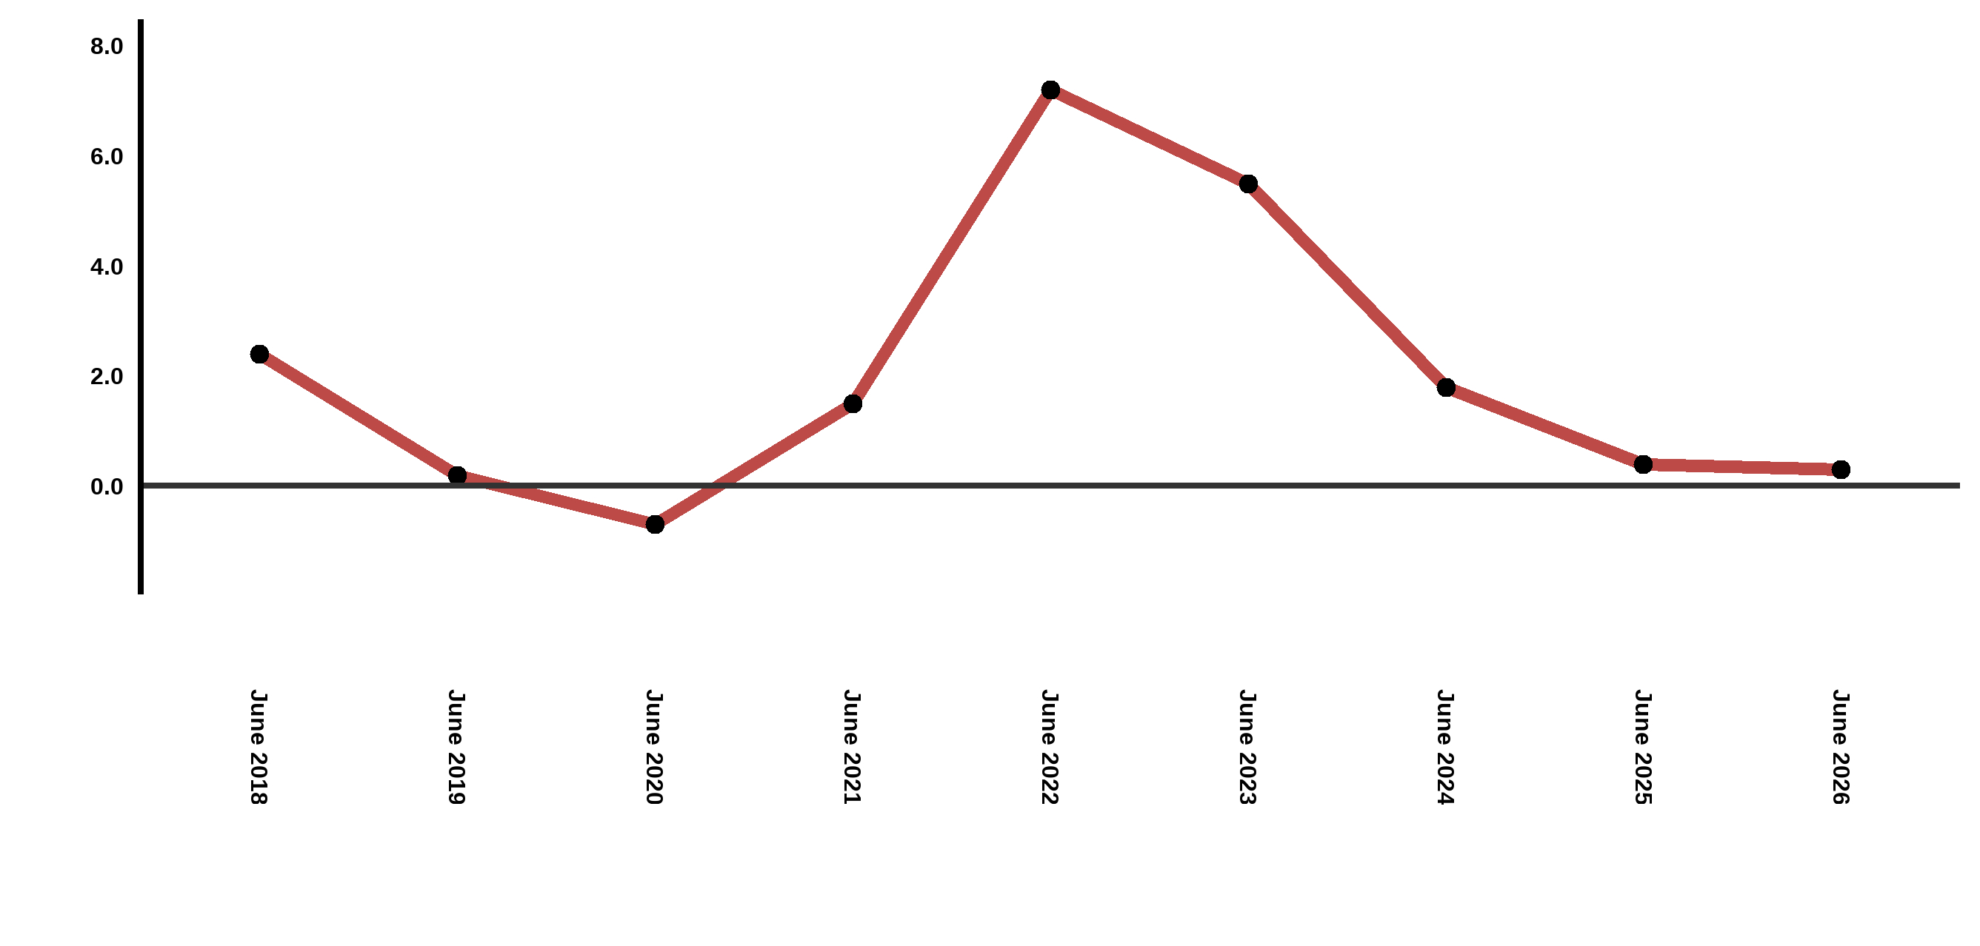
Reading: In June 2026, the consumer price index increased by 0.3% compared to June 2025
Annual evolution (%) of the consumer price index for the month of June
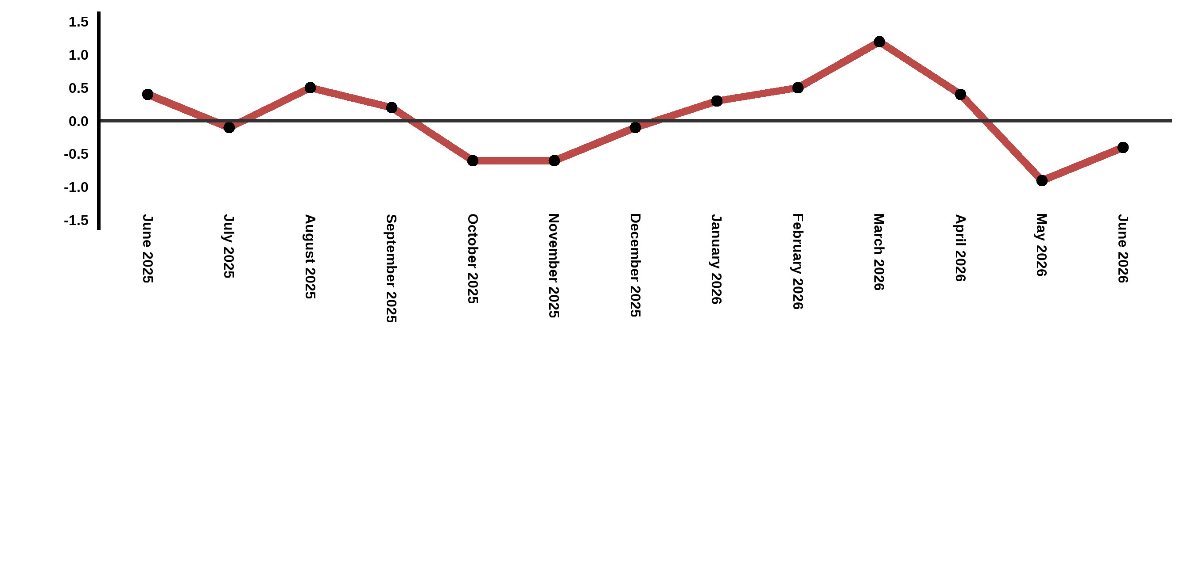
Reading: In June 2026, the consumer price index decreased by 0.4% compared to May 2026

Consumer price index for the city of : June 2026 (2017 base: 100)
Product Divisions | Weightings | Monthly index |  |  |  |  | Variation (%)
 |  | June 2025 | March 2026 | April 2026 | May 2026 | June 2026 | 1 month | 3 months | 12 months
Food products | 39,009 | 131,1 | 132,7 | 131,8 | 129,1 | 128,1 | -0,8 | -3,5 | -2,3
01 – Food products and non-alcoholic | 37,502 | 130,5 | 132,0 | 131,1 | 128,2 | 127,2 | -0,8 | -3,6 | -2,5
02 –Alcoholicbeverages and tobacco | 1,507 | 144,9 | 149,3 | 150,5 | 150,5 | 150,5 | 0,0 | 0,8 | 3,9
Non foodproducts | 60,991 | 112,0 | 113,4 | 114,8 | 114,8 | 114,6 | -0,2 | 1,1 | 2,3
03 – Clothing and shoes | 4,323 | 117,0 | 118,1 | 118,2 | 118,0 | 117,9 | -0,1 | -0,2 | 0,8
04 - Housing, water, gas, electricity and other fuel | 14,575 | 109,3 | 109,8 | 110,0 | 110,9 | 110,8 | -0,1 | 0,9 | 1,4
05- Furniture, household items and routine maintenance of the home | 4,407 | 112,6 | 113,3 | 113,4 | 113,9 | 113,9 | 0,0 | 0,5 | 1,2
06 –Health | 7,741 | 101,4 | 101,5 | 101,6 | 101,6 | 101,7 | 0,1 | 0,2 | 0,3
07 – Transport | 10,040 | 115,7 | 118,4 | 126,1 | 124,7 | 123,4 | -1,0 | 4,2 | 6,7
08 – Communication | 2,958 | 103,9 | 103,7 | 103,7 | 103,6 | 103,6 | 0,0 | -0,1 | -0,3
09 – Leisure and culture | 2,735 | 105,0 | 104,7 | 105,1 | 104,9 | 104,8 | -0,1 | 0,1 | -0,2
10 –Education | 5,636 | 121,8 | 124,4 | 124,4 | 124,4 | 124,4 | 0,0 | 0,0 | 2,1
11 - Restaurants and hotels | 1,461 | 121,4 | 122,5 | 123,2 | 123,5 | 123,9 | 0,3 | 1,1 | 2,1
12 – Variousgoods and services | 7,115 | 116,7 | 120,5 | 120,8 | 120,7 | 120,7 | 0,0 | 0,2 | 3,4
General index | 100,000 | 119,5 | 121,0 | 121,5 | 120,4 | 119,9 | -0,4 | -0,9 | 0,3
Source: High Commission for Planning, Department of Statistics - National consumer price survey
Angle Avenue Ibn Tachafine et Avenue Ibn Toumart B.P.104 Tanger
****Tél:0539940698****Fax:0539940364 Site Web: www.hcp.ma/region-tanger Email:hcp.dr.tanger@hcp.ma
:::

