Consumer Price Index - July 2026 | City of Tetouan
In July 2026, the national consumer price index decreased by 0.7% compared to the previous month, while the consumer price index increased by 0.1% over a full year.

Over a month, The consumer price index experienced a decrease of 1.5% during the month of July 2026 compared to the previous month. as a result of the decline in prices of «Vegetables» by 7,1%, «Fruits» by 4,4%, «Milk, Cheese and Eggs» by 0,8%, «Bread and Cereals», «Catering Services», «Cafe and Tea and Cocoa» by 0,6%, «Meat» by 0,5%, «Food Productsnot elsewhere classified» by 0,4%, «Oils and Fats» by 0,2% and «Mineral Waters, Soft Drinks, Fruit and Vegetable Juices (Nd)» by 0,1%
Similarly, the monthly variation in the non-food index decreased by abs(evol_non_alim_1mois)% due to price decreases in the following divisions: «Transportation» by 1,9%, «Clothing and Shoes» by 0,4% and «Furniture, Household Items and Routine Home Maintenance» and «Leisure and Culture» by 0,2%.
Over a year, the food product price index decreased by -2.9% in July 2026 compared to July 2025 , due to the decrease in the prices of «Oils and Fats» by 19,0%, «Milk, Cheese and Eggs» by 5,6%, «Vegetables» by 4,3%, «Fish and Seafood» by 4,1%, «Fruits» by 3,5% and «Food Productsnot elsewhere classified» by 0,3%. Moreover, the rise in prices of «Tobacco» by 4,0%, «Meat» by 3,6%, «Sugar, Jam, Honey, Chocolate and Confectionery» by 2,1% and «Cafe, Tea and Cocoa», «Mineral Waters, Soft Drinks and Fruit and Vegetable Juices (Nd)» by 0,4% and the stagnation in prices for «Bread and Cereals» and «Catering Services» by 0,0% did not affect the general evolution.
On the other hand, the annual variation in the non-food index increased by 2.8%. While the variation in prices of the divisions that make up non-food products fluctuated between a decrease of the division of «Leisure and Culture» by 1,2% and the rise of the division of «Education» by 10,9%
3- Annual evolution (%) of the consumer price index for the month of July
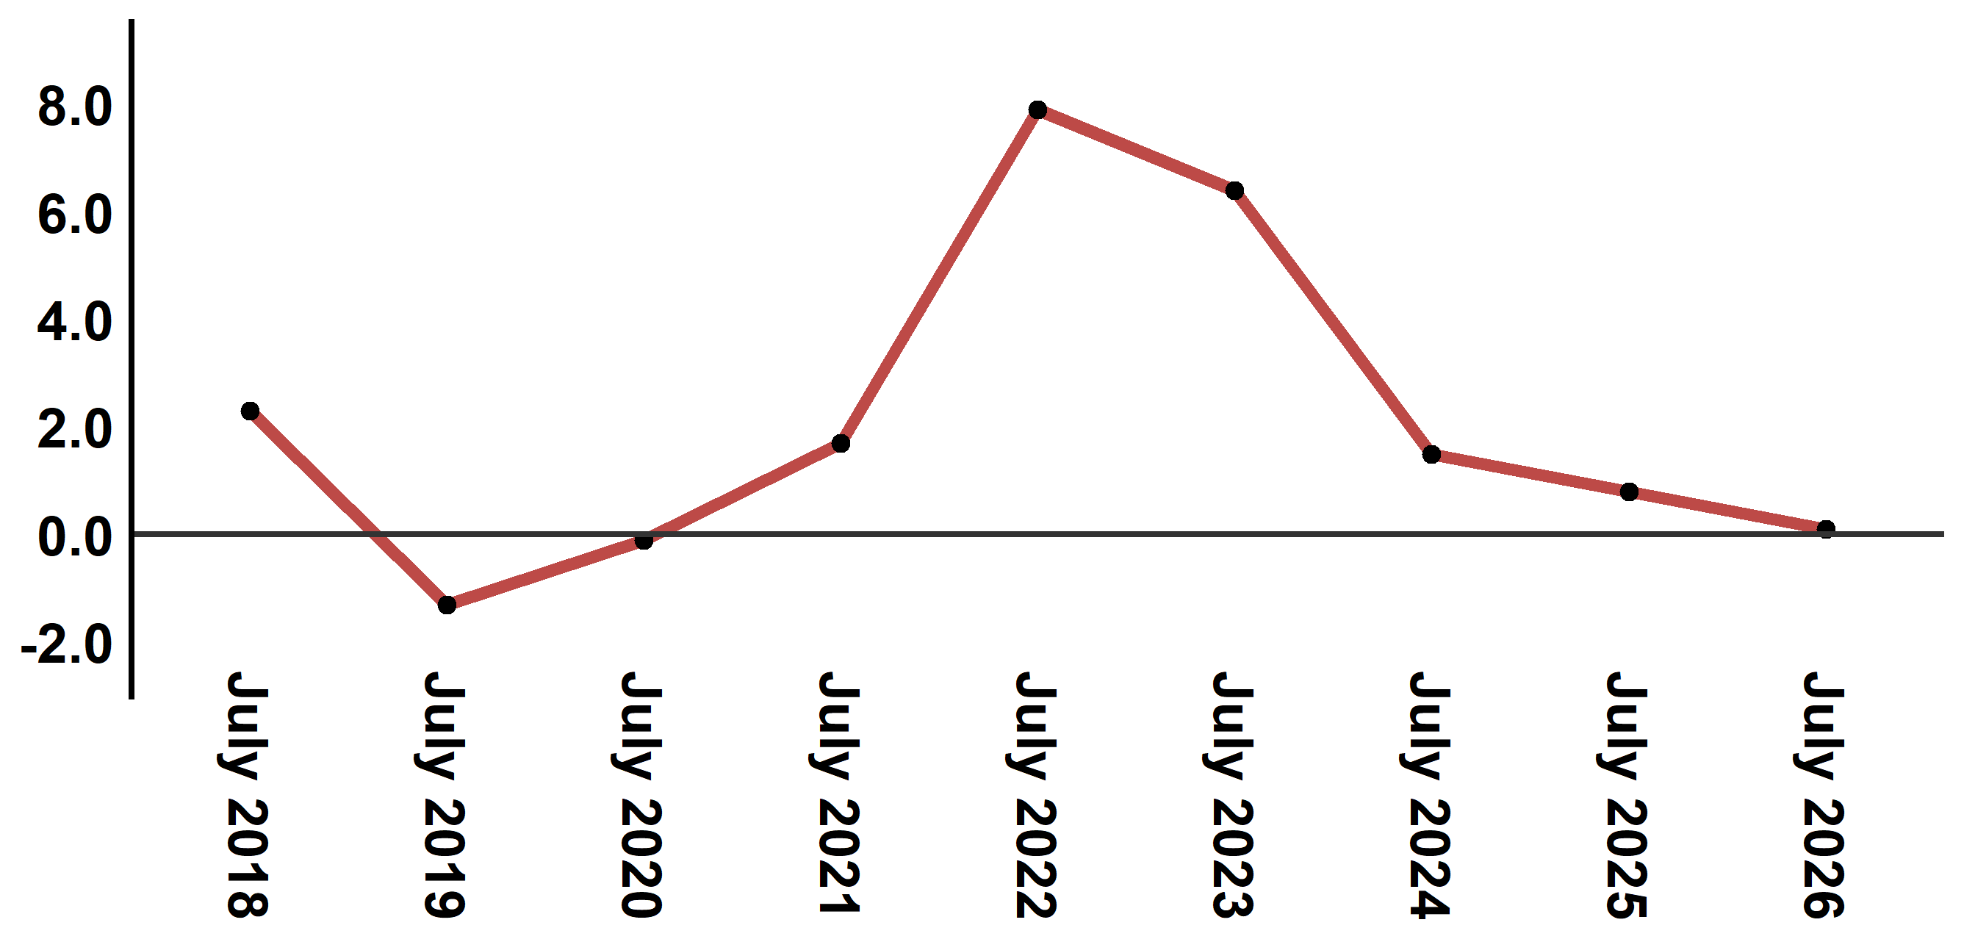
Reading: In July 2026, the consumer price index increased by 0.1% compared to July 2025
4- Annual evolution (%) of the consumer price index for the month of July
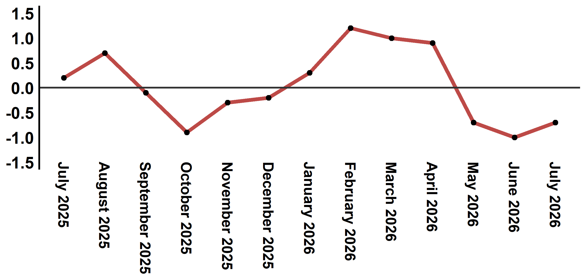
Reading: In July 2026, the consumer price index decreased by 0.7% compared to June 2026

Table 3: Consumer price index for the city of Tetouan: July 2026 (2017 base: 100)
Product Divisions | Weightings | Monthly index |  |  |  |  | Variation (%)
 |  | July 2025 | April 2026 | May 2026 | June 2026 | July 2026 | 1 month | 3 months | 12 months
Food products | 40,725 | 134,0 | 136,5 | 134,2 | 132,1 | 130,1 | -1,5 | -4,7 | -2,9
01 – Food products and non-alcoholic | 38,964 | 133,5 | 135,8 | 133,4 | 131,2 | 129,1 | -1,6 | -4,9 | -3,3
02 –Alcoholicbeverages and tobacco | 1,761 | 146,1 | 152,0 | 152,0 | 152,0 | 152,0 | 0,0 | 0,0 | 4,0
Non foodproducts | 59,275 | 111,1 | 114,8 | 114,9 | 114,3 | 114,2 | -0,1 | -0,5 | 2,8
03 – Clothing and shoes | 5,835 | 113,1 | 114,0 | 113,2 | 112,2 | 111,8 | -0,4 | -1,9 | -1,1
04 - Housing, water, gas, electricity and other fuel | 14,202 | 109,2 | 109,5 | 111,0 | 110,8 | 110,9 | 0,1 | 1,3 | 1,6
05- Furniture, household items and routine maintenance of the home | 5,602 | 110,7 | 111,9 | 111,2 | 111,6 | 111,4 | -0,2 | -0,4 | 0,6
06 –Health | 6,594 | 103,5 | 103,0 | 103,0 | 103,0 | 103,0 | 0,0 | 0,0 | -0,5
07 – Transport | 7,416 | 112,6 | 127,1 | 125,6 | 121,8 | 119,5 | -1,9 | -6,0 | 6,1
08 – Communication | 2,560 | 97,6 | 97,1 | 97,3 | 97,3 | 97,6 | 0,3 | 0,5 | 0,0
09 – Leisure and culture | 2,432 | 106,7 | 106,5 | 105,6 | 105,6 | 105,4 | -0,2 | -1,0 | -1,2
10 –Education | 5,358 | 116,8 | 129,5 | 129,5 | 129,5 | 129,5 | 0,0 | 0,0 | 10,9
11 - Restaurants and hotels | 2,468 | 117,7 | 123,5 | 122,9 | 123,1 | 129,1 | 4,9 | 4,5 | 9,7
12 – Variousgoods and services | 6,808 | 119,4 | 122,1 | 122,7 | 122,4 | 122,5 | 0,1 | 0,3 | 2,6
General index | 100,000 | 120,6 | 123,7 | 122,8 | 121,6 | 120,7 | -0,7 | -2,4 | 0,1
Source: High Commission for Planning, Department of Statistics - National consumer price survey

