Consumer Price Index - July 2026 | City of Tangier
In July 2026, the consumer price index for households decreased by -1,1% compared to the previous month. On an annual level, the consumer price index decreased by 0,2% over a full year.

Over a month, The food product price index decreased by 1,9% in July 2026 compared to June 2026, as a result of the decline in prices of «Vegetables» by 6,5%, «Fruits» by 5,4%, «Fish and Seafood» by 2,1%, «Meat» by 1,2%, «Bread and Cereals» and «Catering Services» by 0,3%, «Oils and Fats», «Cafe and Tea and Cocoa» by 0,2% and «Milk, Cheese and Eggs» by 0,1%.
Similarly, the monthly variation of the index for the non-food products decreased by 0,4% due to drop in prices in the following divisions: «Transportation» by 1,7%, «Various Goods and Services» by 1,5% and «Leisure and Culture» by 0,1%. Also, the increase in prices of the following divisions: «Communications» by 0,3% and «Clothing and Shoes», «Furniture, Household Items and Routine Home Maintenance» and «Health» by 0,1%. Thus, the stagnation of the indices of the other divisions did not impact the general evolution.
Over a year, the food product price index decreased by 3,1% in July 2026 compared to July 2025 , due to the decrease in the prices of «Oils and Fats» by 21,1%, «Milk, Cheese and Eggs» by 6,3%, «Meat» by 3,4%, «Vegetables» by 1,4%, «Fruits» by 1,1% and «Food Productsnot elsewhere classified» by 0,8%. Moreover, the rise in prices of «Fish and Seafood» by 5,9%, «Tobacco» by 4,0%, «Bread and Cereals» and «Catering Services» by 2,5%, «Mineral Waters, Soft Drinks, Fruit and Vegetable Juices (Nd)» by 1,0%, «Sugar, Jam, Honey, Chocolate and Confectionery» by 0,6% and «Cafe, Tea and Cocoa» by 0,4% and the stagnation in prices for NA did not affect the general evolution.
On the other hand, the annual variation in the non-food index increased by 1,9%. While the variation in prices of the divisions that make up non-food products fluctuated between a decrease of the division of «Communications» by 1,1% and the rise of the division of «Various Goods and Services» by 8,5%
1- Annual evolution (%) of the consumer price index for the month of July
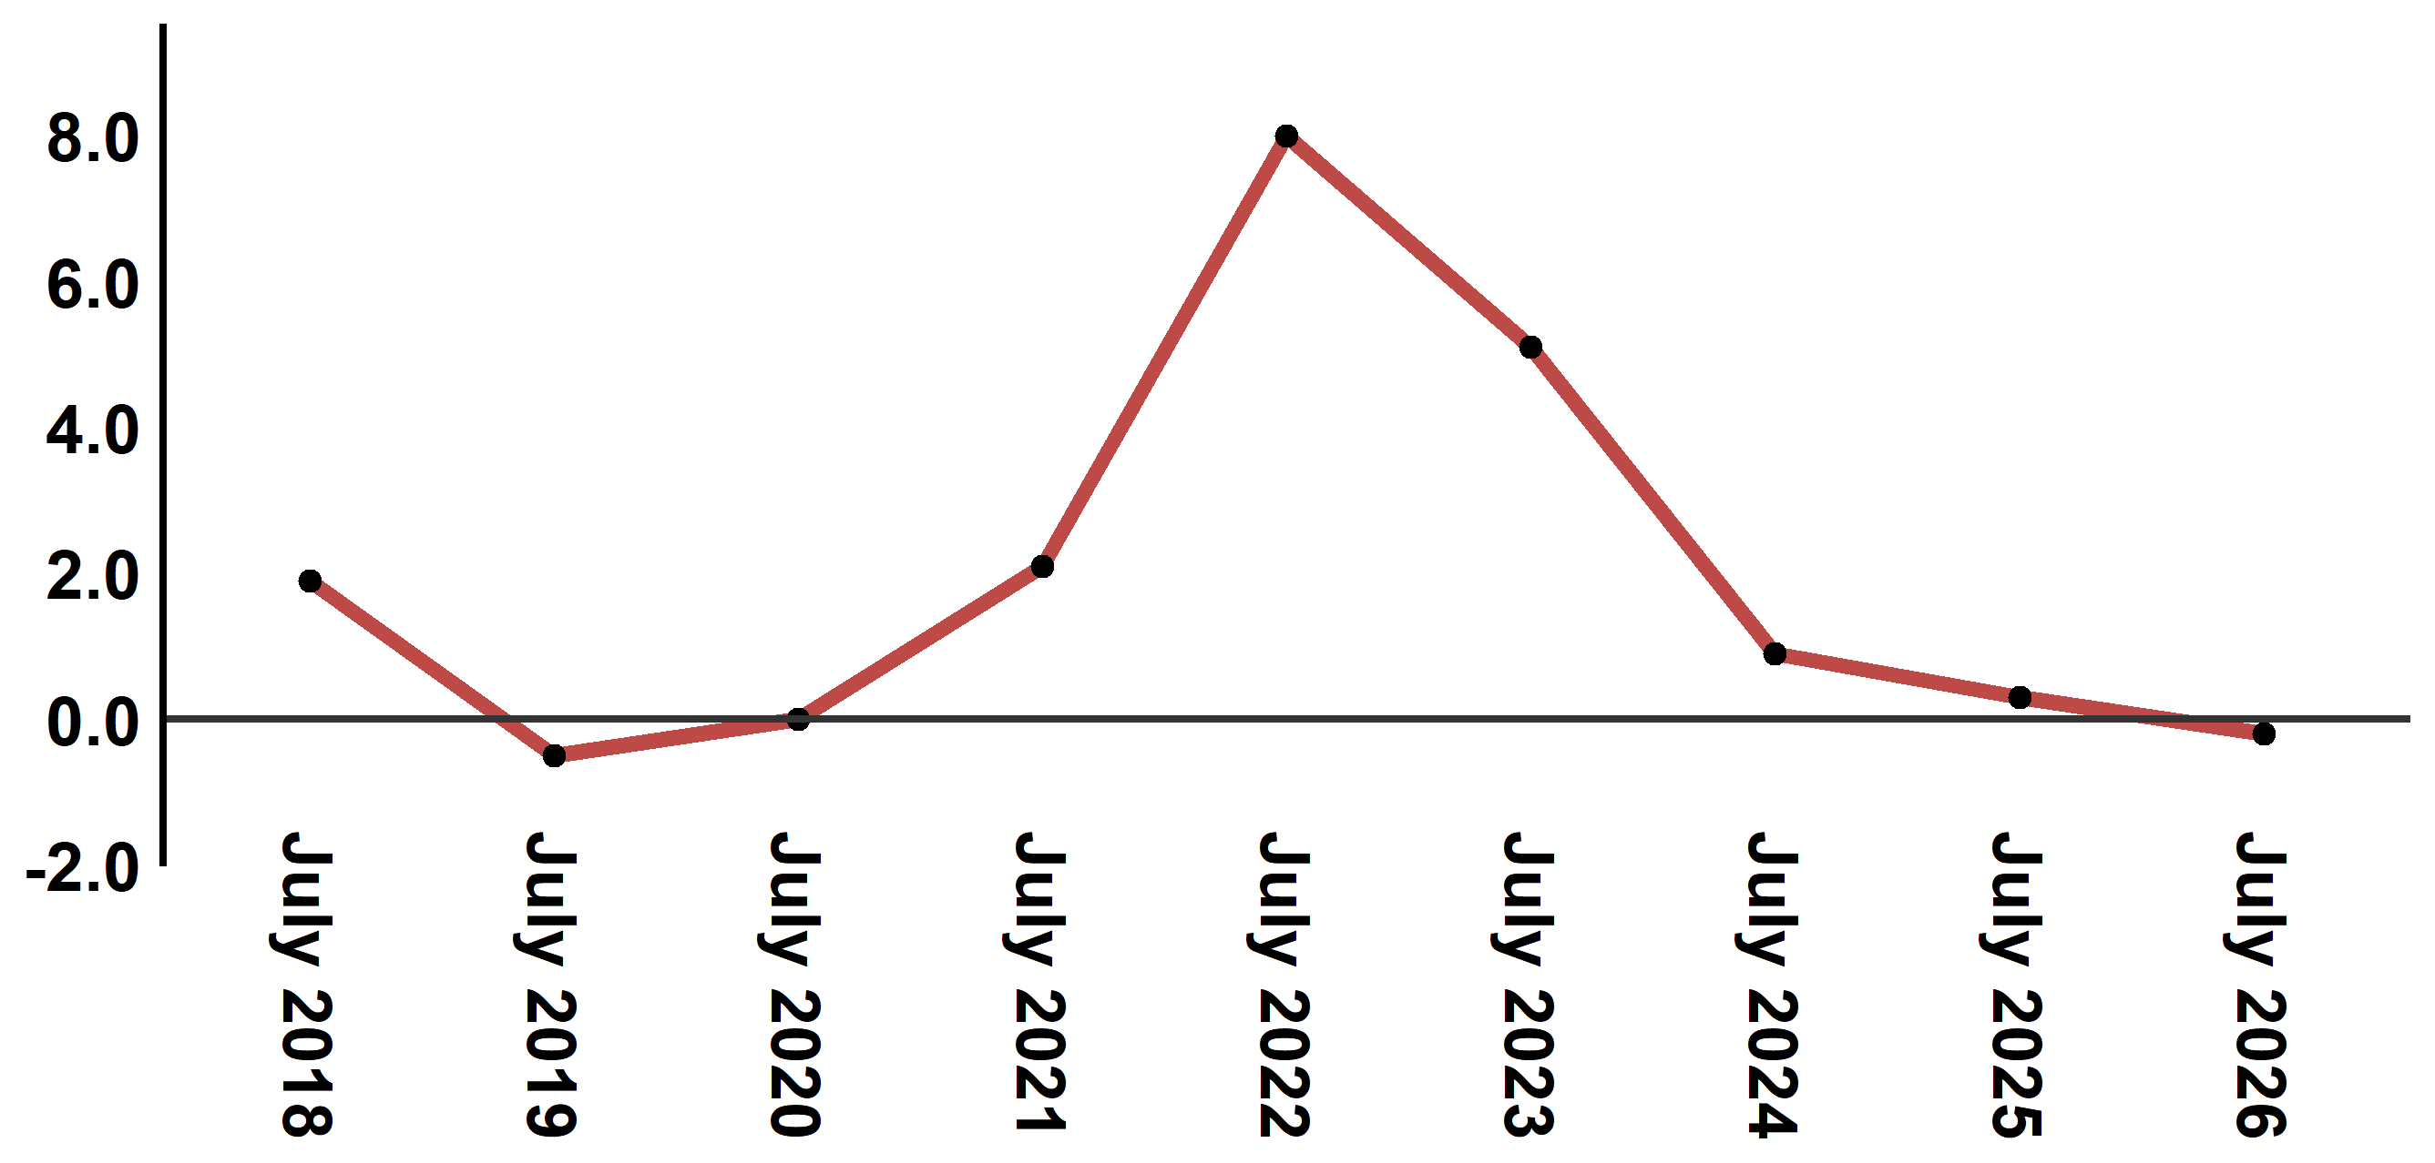
Reading: In July 2026, the consumer price index decreased by 0,2% compared to July 2025
2- Annual evolution (%) of the consumer price index for the month of July
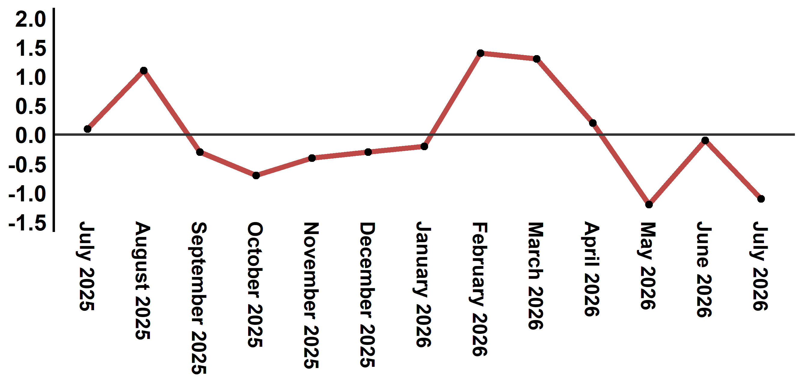
Reading: The level of price variation in July 2026 decreased by 1,1% after being 0,1% in May 2026

Table 4: Consumer price index for the city of Tangier: July 2026 (2017 base: 100)
Product Divisions | Weightings | Monthly index |  |  |  |  | Variation (%)
 |  | July 2025 | April 2026 | May 2026 | June 2026 | July 2026 | 1 month | 3 months | 12 months
Food products | 36,115 | 130,8 | 133,5 | 129,3 | 129,3 | 126,8 | -1,9 | -5,0 | -3,1
01 – Food products and non-alcoholic | 34,708 | 130,2 | 132,8 | 128,4 | 128,4 | 125,8 | -2,0 | -5,3 | -3,4
02 –Alcoholicbeverages and tobacco | 1,407 | 145,4 | 151,1 | 151,1 | 151,1 | 151,1 | 0,0 | 0,0 | 3,9
Non foodproducts | 63,885 | 112,3 | 115,1 | 115,0 | 114,9 | 114,4 | -0,4 | -0,6 | 1,9
03 – Clothing and shoes | 6,449 | 113,5 | 113,2 | 113,3 | 113,3 | 113,4 | 0,1 | 0,2 | -0,1
04 - Housing, water, gas, electricity and other fuel | 16,656 | 111,6 | 111,9 | 112,7 | 112,8 | 112,8 | 0,0 | 0,8 | 1,1
05- Furniture, household items and routine maintenance of the home | 4,100 | 111,9 | 112,2 | 112,1 | 112,1 | 112,2 | 0,1 | 0,0 | 0,3
06 –Health | 8,218 | 109,3 | 109,3 | 109,3 | 109,4 | 109,5 | 0,1 | 0,2 | 0,2
07 – Transport | 9,751 | 116,4 | 124,1 | 123,2 | 121,5 | 119,4 | -1,7 | -3,8 | 2,6
08 – Communication | 3,199 | 100,7 | 100,3 | 99,3 | 99,3 | 99,6 | 0,3 | -0,7 | -1,1
09 – Leisure and culture | 2,350 | 104,4 | 105,2 | 104,7 | 104,7 | 104,6 | -0,1 | -0,6 | 0,2
10 –Education | 5,047 | 110,9 | 113,4 | 113,4 | 113,4 | 113,4 | 0,0 | 0,0 | 2,3
11 - Restaurants and hotels | 1,280 | 128,3 | 128,3 | 128,3 | 129,9 | 129,9 | 0,0 | 1,2 | 1,2
12 – Variousgoods and services | 6,835 | 117,2 | 129,3 | 128,9 | 129,1 | 127,2 | -1,5 | -1,6 | 8,5
General index | 100,000 | 119,1 | 121,8 | 120,3 | 120,2 | 118,9 | -1,1 | -2,4 | -0,2
Source: High Commission for Planning, Department of Statistics - National consumer price survey

