Consumer Price Index - July 2026 | City of Al Hoceima
In July 2026, the national consumer price index decreased by 0.6% compared to the previous month, while the consumer price index decreased by 1.5% over a full year.

Over a month, The consumer price index experienced a decrease of 1.2% during the month of July 2026 compared to the previous month. as a result of the decline in prices of «Fruits» by 4,9%, «Vegetables» by 2,4%, «Fish and Seafood» by 0,6%, «Oils and Fats» by 0,4%, «Meat», «Sugar, Jam, Honey, Chocolate and Confectionery» and «Food Productsnot elsewhere classified» by 0,2% and «Bread and Cereals», «Catering Services», «Mineral Waters, Soft Drinks and Fruit and Vegetable Juices (Nd)» by 0,1%
On the other hand, the monthly variation in the non-food index increased by 0.2% due to price increases in the following divisions: «Restaurants and Hotels» by 17,8%, «Various Goods and Services» by 0,7% and «Clothing and Shoes» and «Communications» by 0,1%
Over a year, the food product price index decreased by -4.5% in July 2026 compared to July 2025 , due to the decrease in the prices of «Oils and Fats» by 27,6%, «Milk, Cheese and Eggs» by 7,6%, «Vegetables» by 5,7%, «Fruits» by 5,3%, «Fish and Seafood» by 3,3% and «Bread and Cereals» and «Catering Services» by 0,9%. Moreover, the rise in prices of «Cafe, Tea and Cocoa» by 10,7%, «Meat» by 7,9%, «Tobacco» by 5,0%, «Food Productsnot elsewhere classified» by 0,8%, «Sugar, Jam, Honey, Chocolate and Confectionery» by 0,2% and «Mineral Waters, Soft Drinks, Fruit and Vegetable Juices (Nd)» by 0,1% and the stagnation in prices for NA did not affect the general evolution.
On the other hand, the annual variation in the non-food index increased by 2.5%. While the variation in prices of the divisions that make up non-food products fluctuated between a decrease of the division of «Furniture, Household Items and Routine Home Maintenance» by 0,8% and the rise of the division of «Restaurants and Hotels» by 6,7%
4- Annual evolution (%) of the consumer price index for the month of July
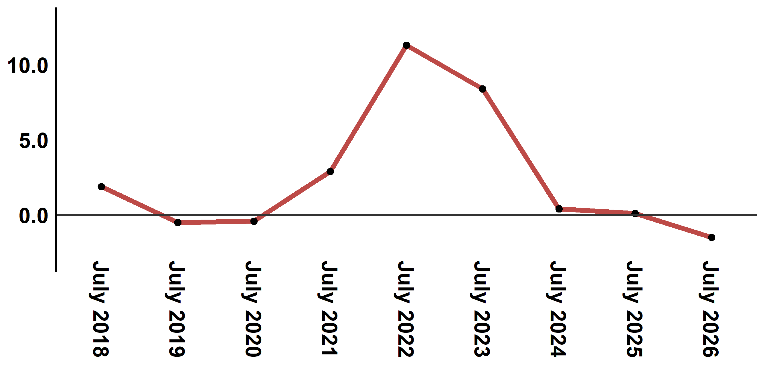
Reading: In July 2026, the consumer price index decreased by 1.5% compared to July 2025
6- Annual evolution (%) of the consumer price index for the month of July
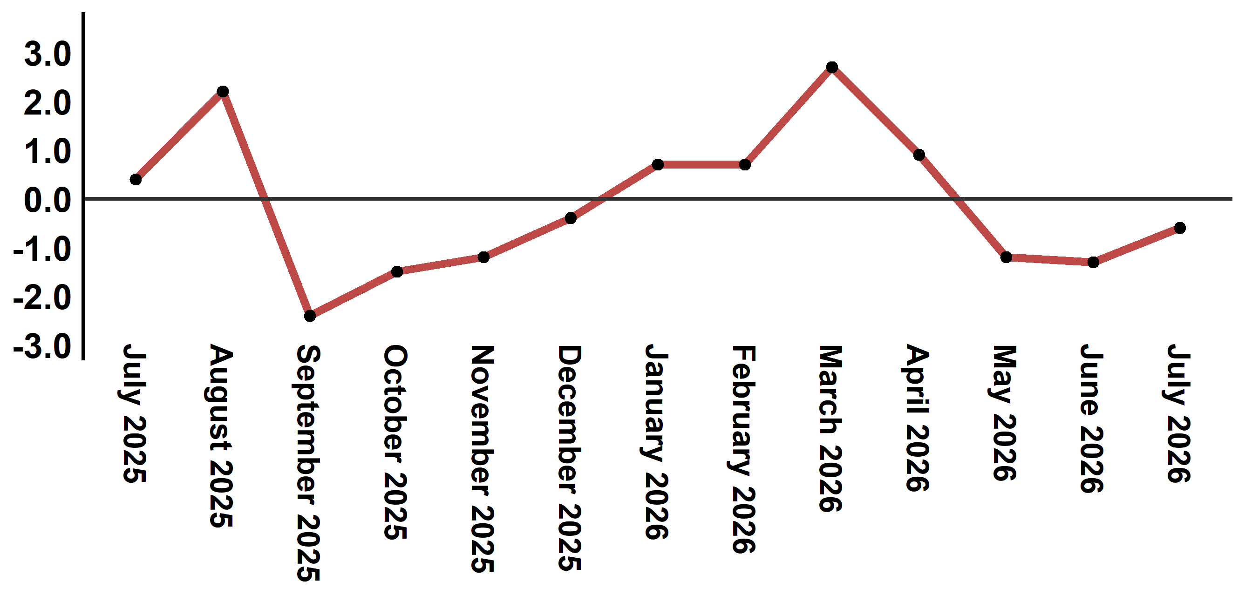
Reading: In July 2026, the consumer price index decreased by 0.6% compared to June 2026

Table 2: Consumer price index for the city of Al Hoceima: July 2026 (2017 base: 100)
Product Divisions | Weightings | Monthly index |  |  |  |  | Variation (%)
 |  | July 2025 | April 2026 | May 2026 | June 2026 | July 2026 | 1 month | 3 months | 12 months
Food products | 49,716 | 141,8 | 143,7 | 140,2 | 137,1 | 135,4 | -1,2 | -5,8 | -4,5
01 – Food products and non-alcoholic | 48,371 | 141,6 | 143,3 | 139,7 | 136,5 | 134,8 | -1,2 | -5,9 | -4,8
02 –Alcoholicbeverages and tobacco | 1,345 | 150,1 | 158,1 | 158,1 | 158,1 | 158,1 | 0,0 | 0,0 | 5,3
Non foodproducts | 50,284 | 110,3 | 112,5 | 113,1 | 112,9 | 113,1 | 0,2 | 0,5 | 2,5
03 – Clothing and shoes | 5,155 | 117,4 | 118,5 | 118,8 | 118,8 | 118,9 | 0,1 | 0,3 | 1,3
04 - Housing, water, gas, electricity and other fuel | 11,732 | 106,2 | 107,4 | 109,9 | 109,9 | 109,3 | -0,5 | 1,8 | 2,9
05- Furniture, household items and routine maintenance of the home | 3,094 | 113,2 | 112,7 | 112,7 | 112,7 | 112,3 | -0,4 | -0,4 | -0,8
06 –Health | 6,413 | 98,8 | 99,1 | 99,1 | 99,1 | 99,1 | 0,0 | 0,0 | 0,3
07 – Transport | 7,704 | 118,3 | 131,6 | 131,9 | 129,6 | 125,3 | -3,3 | -4,8 | 5,9
08 – Communication | 2,892 | 101,6 | 101,4 | 101,4 | 101,4 | 101,5 | 0,1 | 0,1 | -0,1
09 – Leisure and culture | 1,933 | 95,0 | 96,5 | 96,5 | 96,5 | 96,4 | -0,1 | -0,1 | 1,5
10 –Education | 3,842 | 114,1 | 114,8 | 114,8 | 114,8 | 114,8 | 0,0 | 0,0 | 0,6
11 - Restaurants and hotels | 2,258 | 128,8 | 113,3 | 113,7 | 116,6 | 137,4 | 17,8 | 21,3 | 6,7
12 – Variousgoods and services | 5,261 | 113,2 | 115,9 | 115,7 | 115,2 | 116,0 | 0,7 | 0,1 | 2,5
General index | 100,000 | 126,3 | 128,3 | 126,8 | 125,1 | 124,4 | -0,6 | -3,0 | -1,5
Source: High Commission for Planning, Department of Statistics - National consumer price survey

