Consumer Price Index - July 2026 | City of
In July 2026, the national consumer price index decreased by 1% compared to the previous month, while the consumer price index decreased by 0.6% over a full year.

Over a month, The consumer price index experienced a decrease of 2% during the month of July 2026 compared to the previous month. as a result of the decline in prices of «Vegetables» by 7,6%, «Fish and Seafood» by 3,9%, «Fruits» by 3,7%, «Meat» by 1,2% and «Bread and Cereals», «Catering Services», «Milk and Cheese and Eggs» by 0,3%
Similarly, the monthly variation in the non-food index decreased by abs(evol_non_alim_1mois)% due to price decreases in the following divisions: «Transportation» by 1,4% and «Clothing and Shoes» and «Various Goods and Services» by 0,2%.
Over a year, the food product price index decreased by -3.7% in July 2026 compared to July 2025 , due to the decrease in the prices of «Oils and Fats» by 22,9%, «Milk, Cheese and Eggs» by 5,9%, «Vegetables» by 1,6%, «Food Productsnot elsewhere classified» by 1,5%, «Meat» by 1,1% and «Bread and Cereals» and «Catering Services» by 0,5%. Moreover, the rise in prices of «Tobacco» by 4,0%, «Fish and Seafood» by 2,1%, «Cafe, Tea and Cocoa» by 1,9%, «Sugar, Jam, Honey, Chocolate and Confectionery» by 0,8%, «Mineral Waters, Soft Drinks, Fruit and Vegetable Juices (Nd)» by 0,2% and «Fruits» by 0,1% and the stagnation in prices for NA did not affect the general evolution.
On the other hand, the annual variation in the non-food index increased by 1.9%. While the variation in prices of the divisions that make up non-food products fluctuated between a decrease of the division of «Communications» by 0,2% and the rise of the division of «Transportation» by 4,1%
Annual evolution (%) of the consumer price index for the month of July
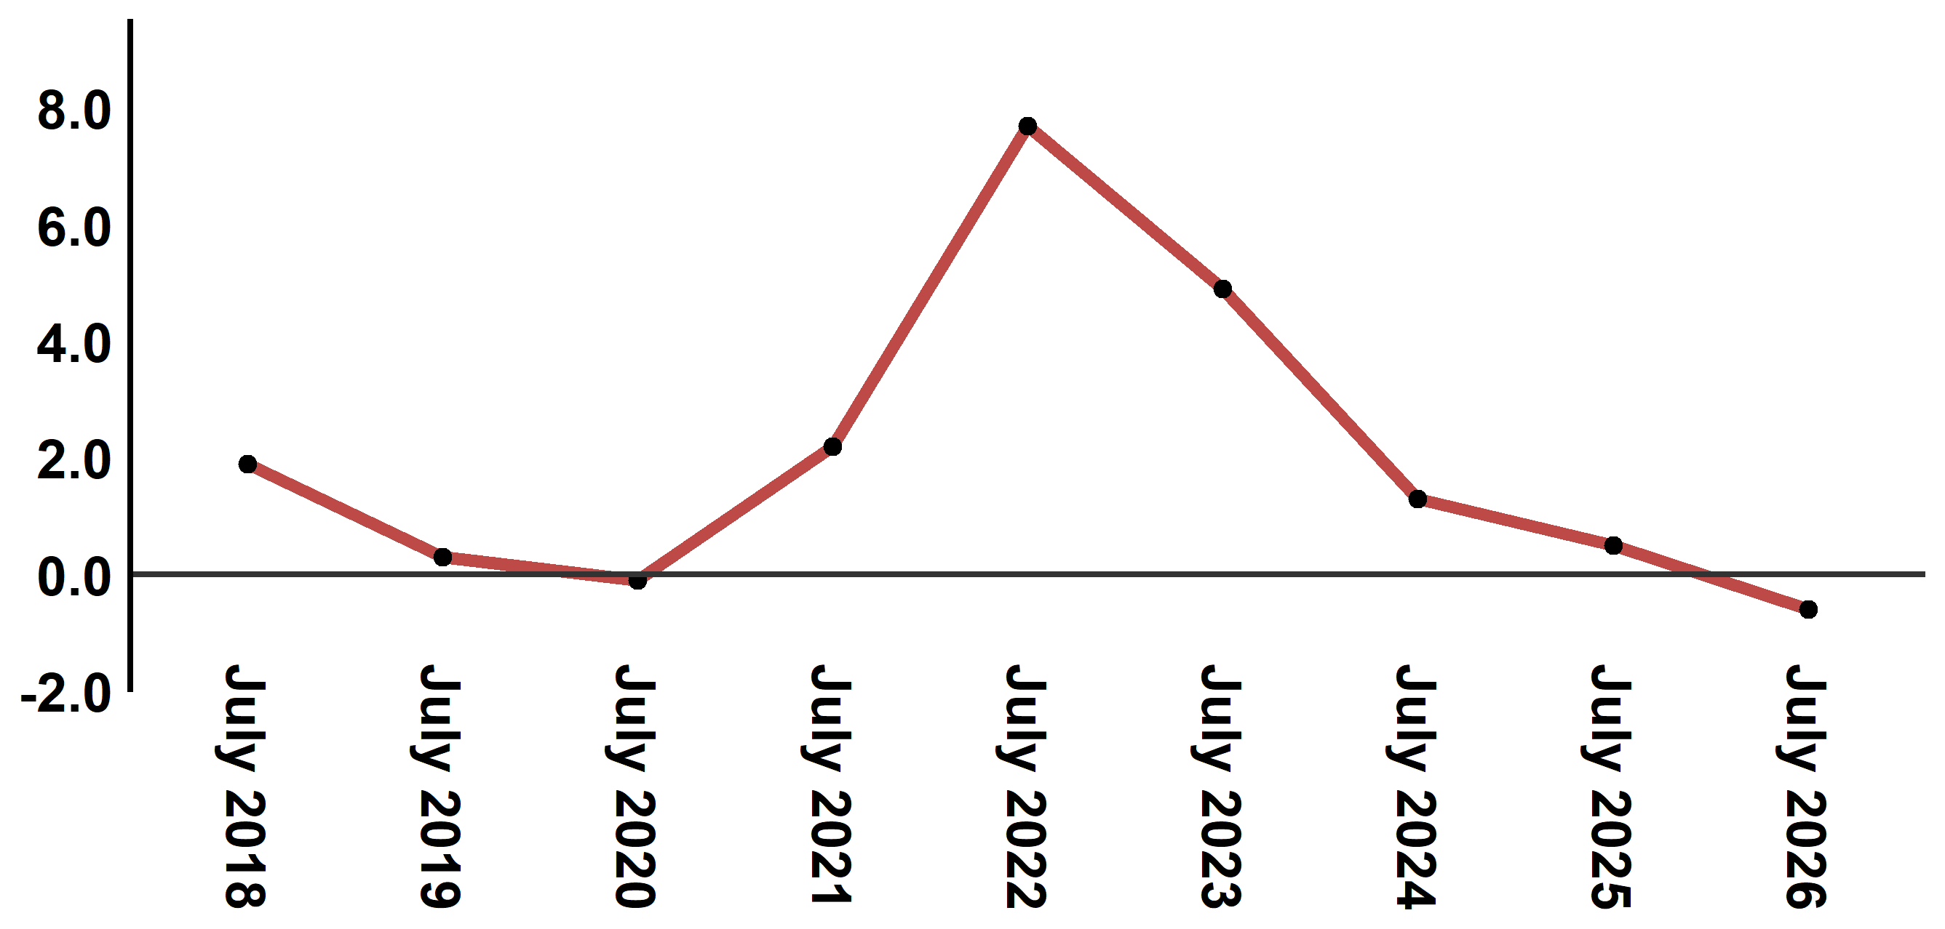
Reading: In July 2026, the consumer price index decreased by 0.6% compared to July 2025
Annual evolution (%) of the consumer price index for the month of July
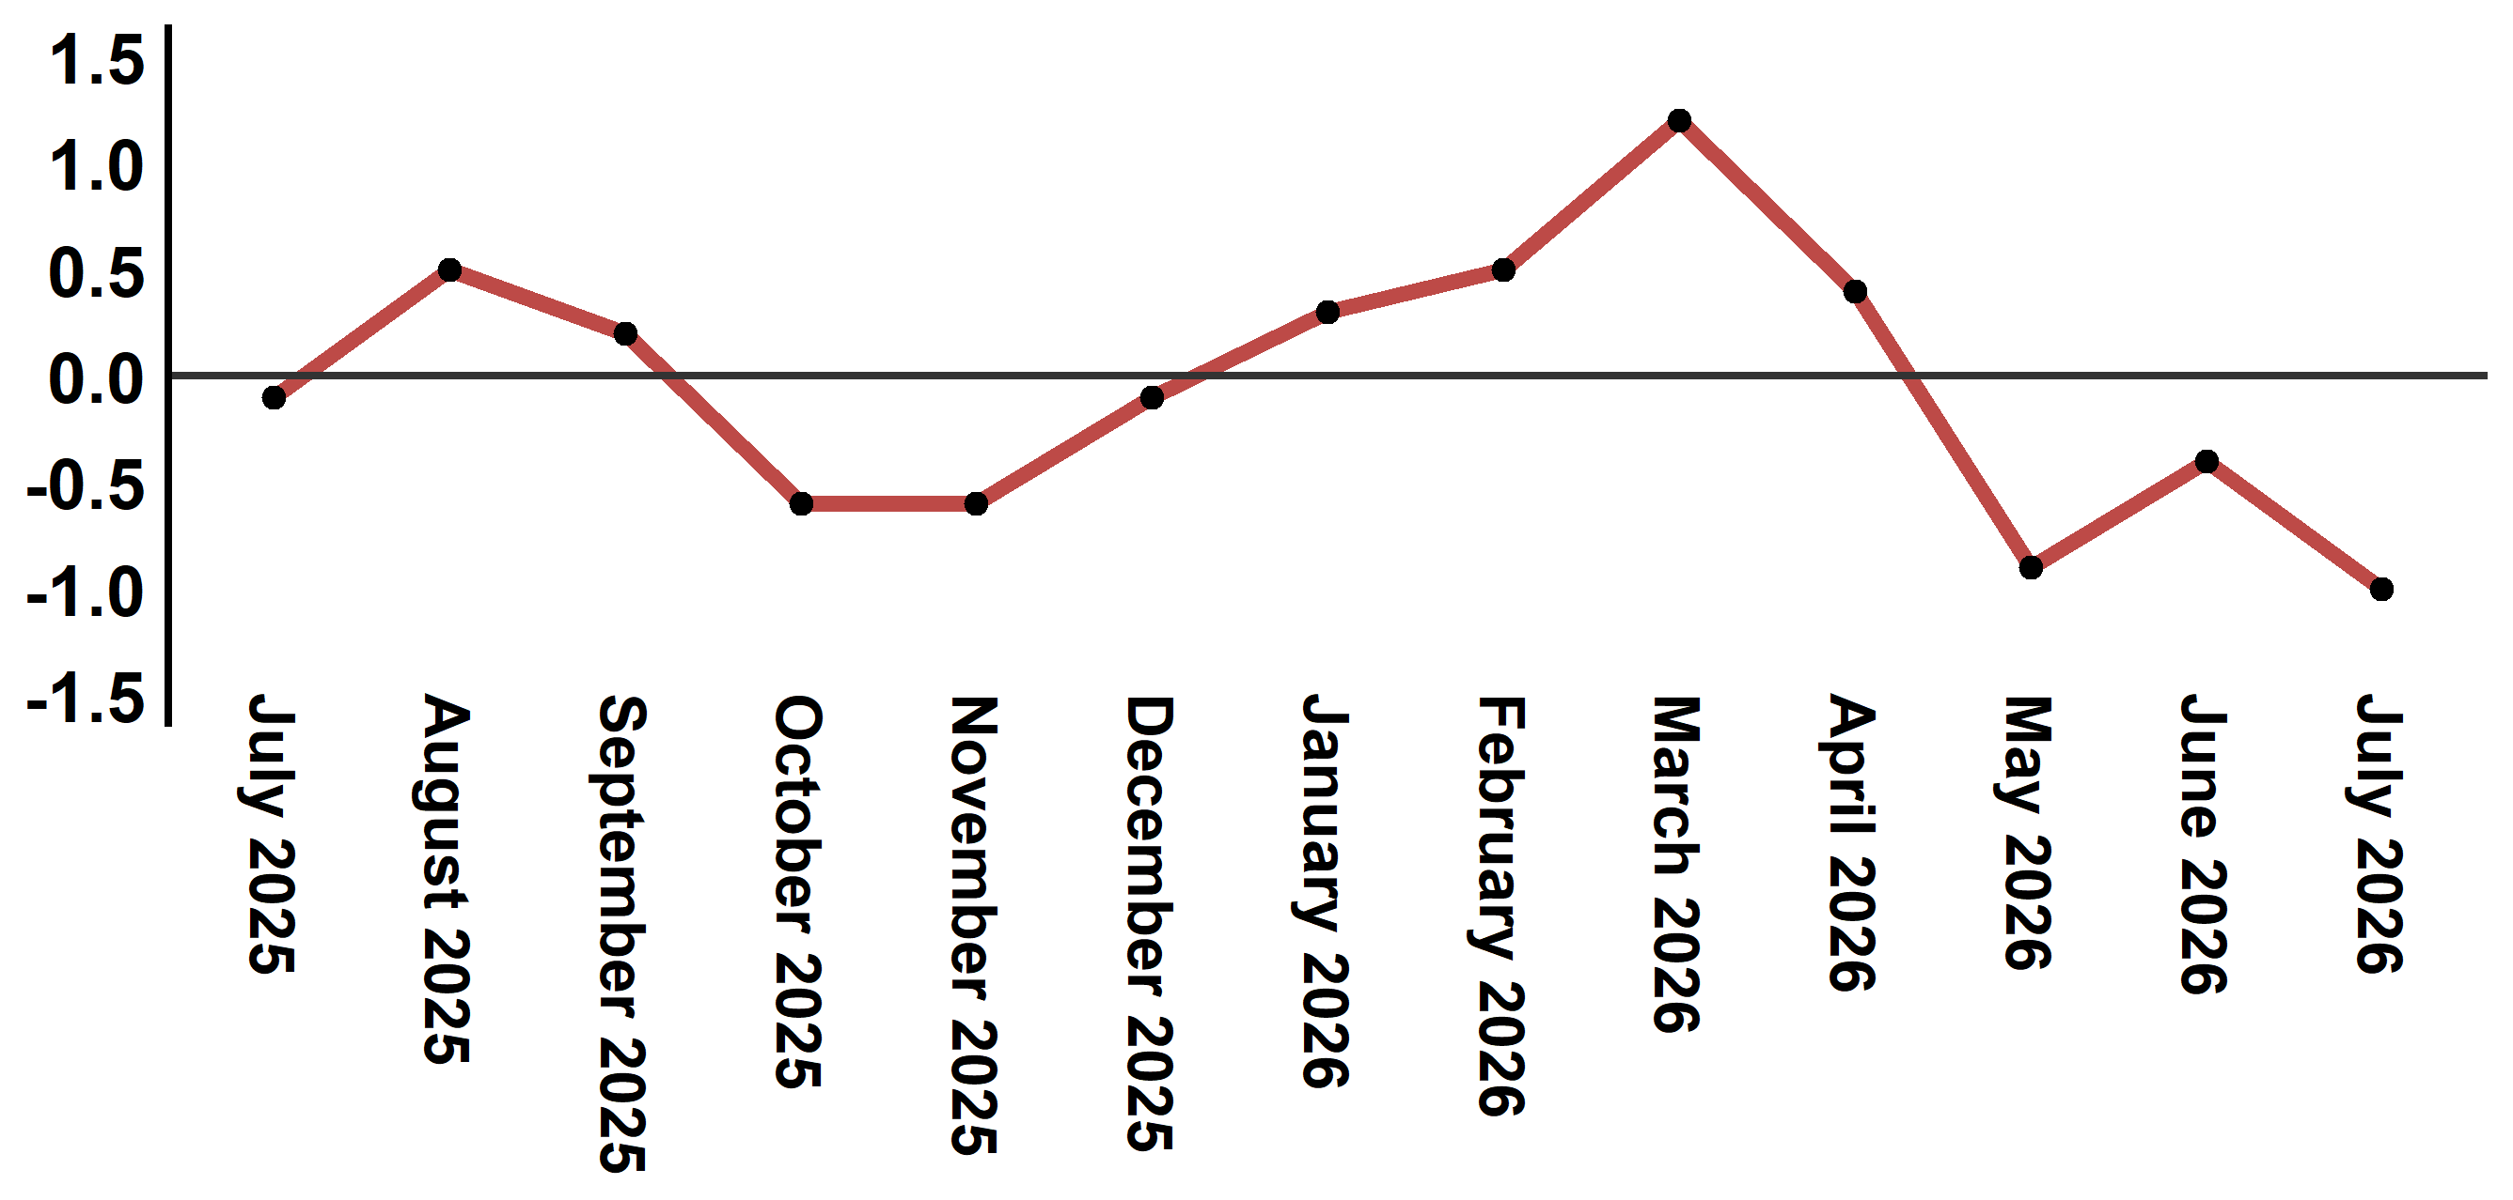
Reading: In July 2026, the consumer price index decreased by 1% compared to June 2026

Consumer price index for the city of : July 2026 (2017 base: 100)
Product Divisions | Weightings | Monthly index |  |  |  |  | Variation (%)
 |  | July 2025 | April 2026 | May 2026 | June 2026 | July 2026 | 1 month | 3 months | 12 months
Food products | 39,009 | 130,4 | 131,8 | 129,1 | 128,1 | 125,6 | -2,0 | -4,7 | -3,7
01 – Food products and non-alcoholic | 37,502 | 129,8 | 131,1 | 128,2 | 127,2 | 124,6 | -2,0 | -5,0 | -4,0
02 –Alcoholicbeverages and tobacco | 1,507 | 145,0 | 150,5 | 150,5 | 150,5 | 150,5 | 0,0 | 0,0 | 3,8
Non foodproducts | 60,991 | 112,2 | 114,8 | 114,8 | 114,6 | 114,3 | -0,3 | -0,4 | 1,9
03 – Clothing and shoes | 4,323 | 116,9 | 118,2 | 118,0 | 117,9 | 117,7 | -0,2 | -0,4 | 0,7
04 - Housing, water, gas, electricity and other fuel | 14,575 | 109,3 | 110,0 | 110,9 | 110,8 | 110,9 | 0,1 | 0,8 | 1,5
05- Furniture, household items and routine maintenance of the home | 4,407 | 113,0 | 113,4 | 113,9 | 113,9 | 114,0 | 0,1 | 0,5 | 0,9
06 –Health | 7,741 | 101,4 | 101,6 | 101,6 | 101,7 | 101,7 | 0,0 | 0,1 | 0,3
07 – Transport | 10,040 | 116,9 | 126,1 | 124,7 | 123,4 | 121,7 | -1,4 | -3,5 | 4,1
08 – Communication | 2,958 | 103,9 | 103,7 | 103,6 | 103,6 | 103,7 | 0,1 | 0,0 | -0,2
09 – Leisure and culture | 2,735 | 104,8 | 105,1 | 104,9 | 104,8 | 104,8 | 0,0 | -0,3 | 0,0
10 –Education | 5,636 | 121,8 | 124,4 | 124,4 | 124,4 | 124,4 | 0,0 | 0,0 | 2,1
11 - Restaurants and hotels | 1,461 | 121,8 | 123,2 | 123,5 | 123,9 | 124,7 | 0,6 | 1,2 | 2,4
12 – Variousgoods and services | 7,115 | 116,9 | 120,8 | 120,7 | 120,7 | 120,4 | -0,2 | -0,3 | 3,0
General index | 100,000 | 119,4 | 121,5 | 120,4 | 119,9 | 118,7 | -1,0 | -2,3 | -0,6
Source: High Commission for Planning, Department of Statistics - National consumer price survey

