Consumer Price Index - August 2026 | City of
In August 2026, the national consumer price index increased by 0.8% compared to the previous month, while the consumer price index decreased by 0.3% over a full year.

Over a month, The consumer price index experienced an increase of 1% during the month of August 2026 compared to the previous month. as a result of the rise in prices of «Fish and Seafood», «Milk and Cheese and Eggs» by 2,8%, «Meat» by 2,2%, «Vegetables» by 1,0%, «Cafe, Tea and Cocoa» by 0,3%, «Food Productsnot elsewhere classified» by 0,2% and «Oils and Fats» by 0,1%
Similarly, the monthly variation in the non-food index increased by 0.7% due to price increases in the following divisions: «Transportation» by 3,4%, «Restaurants and Hotels» by 0,6%, «Furniture, Household Items and Routine Home Maintenance» and «Various Goods and Services» by 0,3% and «Clothing and Shoes» by 0,2%
Over a year, the food product price index decreased by -3.8% in August 2026 compared to August 2025 , due to the decrease in the prices of «Oils and Fats» by 22,4%, «Fruits» by 4,4%, «Vegetables» by 3,8%, «Milk, Cheese and Eggs» by 3,7%, «Food Productsnot elsewhere classified» by 1,3%, «Meat» by 0,7% and «Bread and Cereals» by 0,6%. Moreover, the rise in prices of «Tobacco» by 4,0%, «Fish and Seafood» by 3,0%, «Cafe, Tea and Cocoa» by 1,6%, «Sugar, Jam, Honey, Chocolate and Confectionery» by 0,8% and «Mineral Waters, Soft Drinks, Fruit and Vegetable Juices (Nd)» by 0,6% and the stagnation in prices for NA did not affect the general evolution.
On the other hand, the annual variation in the non-food index increased by 2.4%. While the variation in prices of the divisions that make up non-food products fluctuated between a decrease of the division of «Communications» by 0,2% and the rise of the division of «Transportation» by 7,3%
Annual evolution (%) of the consumer price index for the month of August
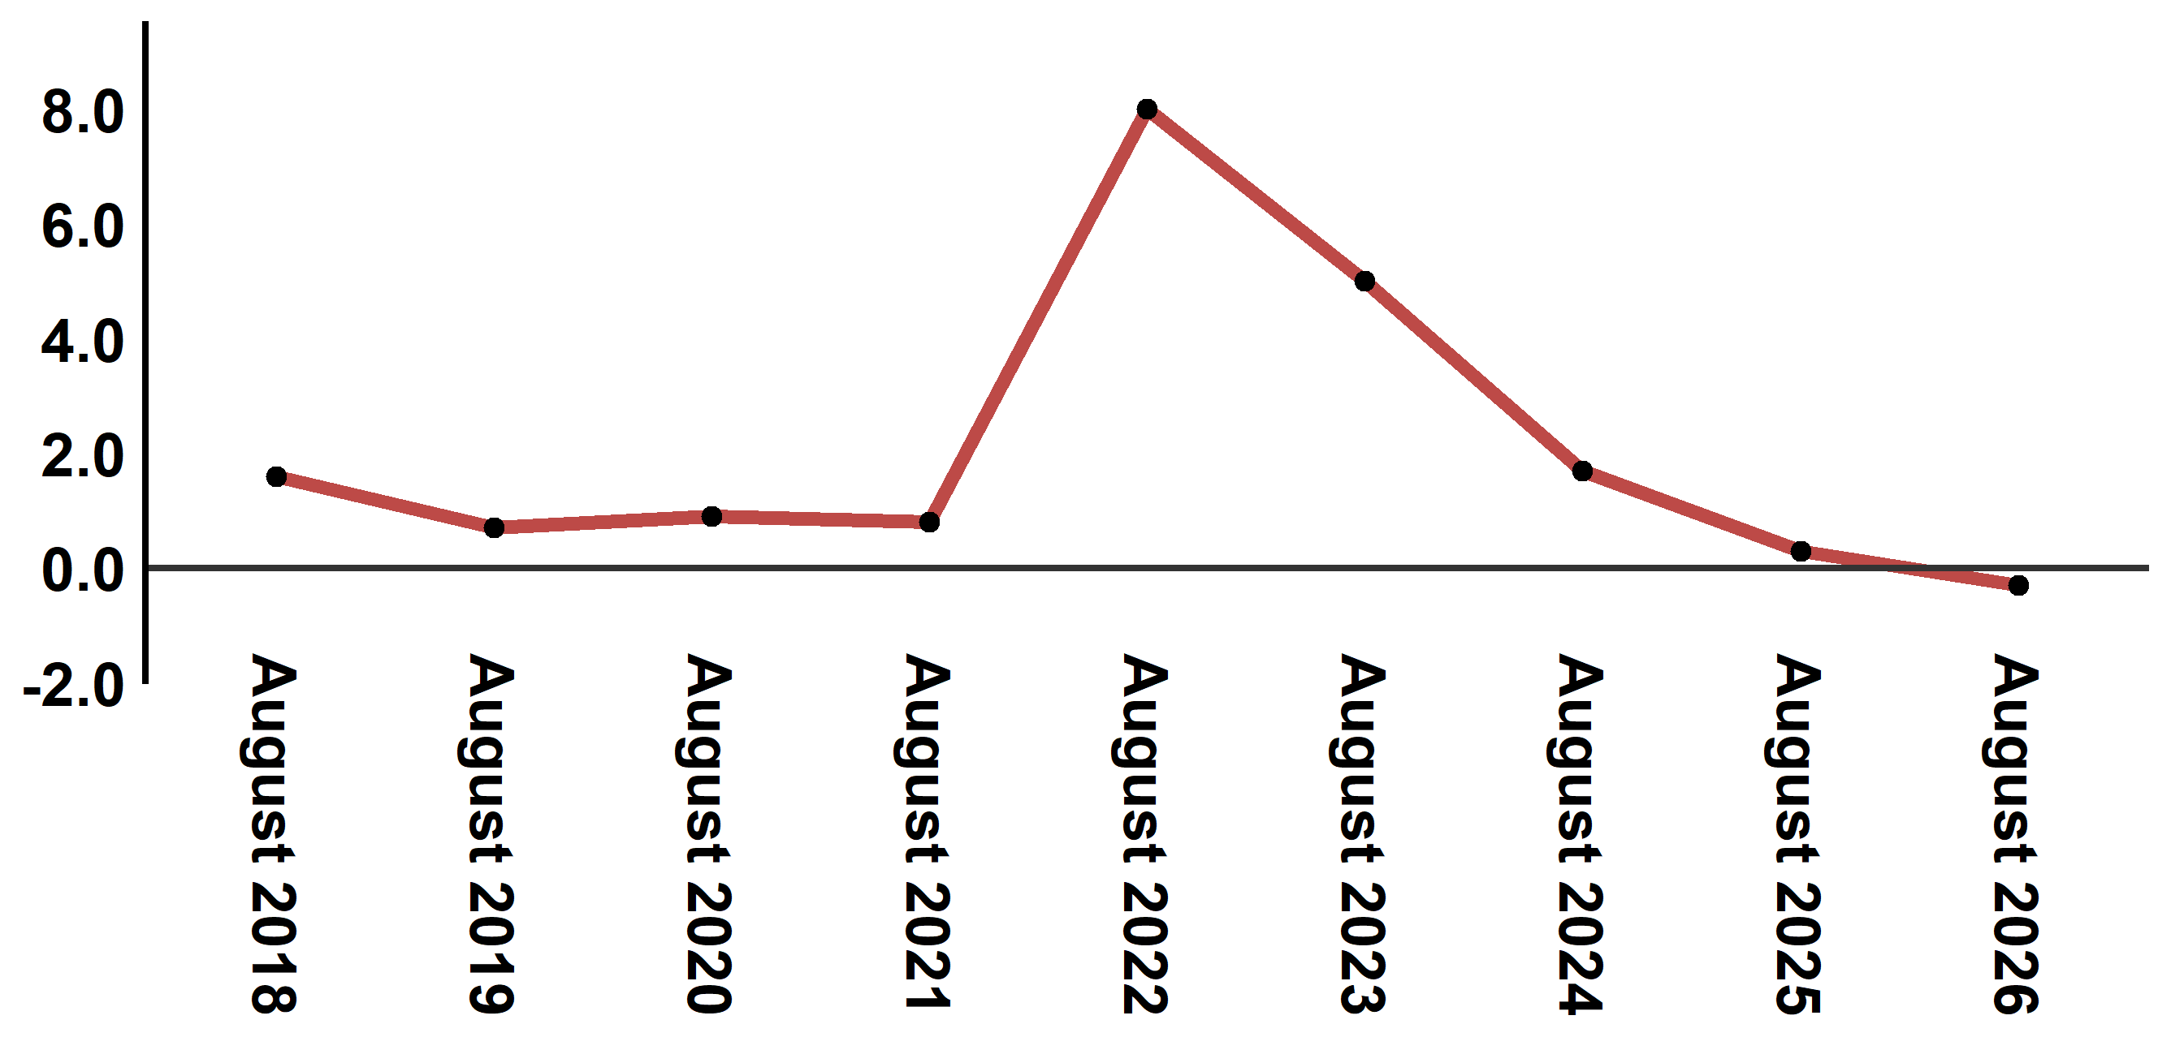
Reading: In August 2026, the consumer price index decreased by 0.3% compared to August 2025
Annual evolution (%) of the consumer price index for the month of August
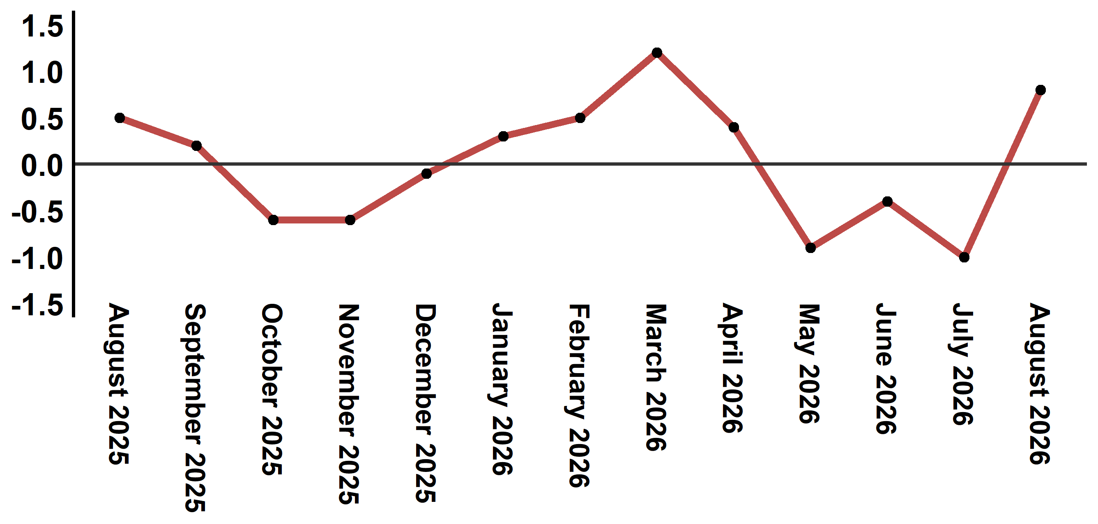
Reading: In August 2026, the consumer price index increased by 0.8% compared to July 2026

Consumer price index for the city of : August 2026 (2017 base: 100)
Product Divisions | Weightings | Monthly index |  |  |  |  | Variation (%)
Product Divisions | Weightings | August 2025 | May 2026 | June 2026 | July 2026 | August 2026 | 1 month | 3 months | 12 months
Food products | 39,009 | 131,8 | 129,1 | 128,1 | 125,6 | 126,8 | 1,0 | -1,8 | -3,8
01 – Food products and non-alcoholic | 37,502 | 131,3 | 128,2 | 127,2 | 124,6 | 125,8 | 1,0 | -1,9 | -4,2
02 –Alcoholicbeverages and tobacco | 1,507 | 145,0 | 150,5 | 150,5 | 150,5 | 150,6 | 0,1 | 0,1 | 3,9
Non foodproducts | 60,991 | 112,4 | 114,8 | 114,6 | 114,3 | 115,1 | 0,7 | 0,3 | 2,4
03 – Clothing and shoes | 4,323 | 117,1 | 118,0 | 117,9 | 117,7 | 117,9 | 0,2 | -0,1 | 0,7
04 - Housing, water, gas, electricity and other fuel | 14,575 | 109,4 | 110,9 | 110,8 | 110,9 | 110,9 | 0,0 | 0,0 | 1,4
05- Furniture, household items and routine maintenance of the home | 4,407 | 112,9 | 113,9 | 113,9 | 114,0 | 114,3 | 0,3 | 0,4 | 1,2
06 –Health | 7,741 | 101,4 | 101,6 | 101,7 | 101,7 | 101,7 | 0,0 | 0,1 | 0,3
07 – Transport | 10,040 | 117,2 | 124,7 | 123,4 | 121,7 | 125,8 | 3,4 | 0,9 | 7,3
08 – Communication | 2,958 | 103,9 | 103,6 | 103,6 | 103,7 | 103,7 | 0,0 | 0,1 | -0,2
09 – Leisure and culture | 2,735 | 104,8 | 104,9 | 104,8 | 104,8 | 104,8 | 0,0 | -0,1 | 0,0
10 –Education | 5,636 | 121,8 | 124,4 | 124,4 | 124,4 | 124,4 | 0,0 | 0,0 | 2,1
11 - Restaurants and hotels | 1,461 | 122,6 | 123,5 | 123,9 | 124,7 | 125,4 | 0,6 | 1,5 | 2,3
12 – Variousgoods and services | 7,115 | 117,1 | 120,7 | 120,7 | 120,4 | 120,8 | 0,3 | 0,1 | 3,2
General index | 100,000 | 120,0 | 120,4 | 119,9 | 118,7 | 119,6 | 0,8 | -0,7 | -0,3
Source: High Commission for Planning, Department of Statistics - National consumer price survey
Angle Avenue Ibn Tachafine et Avenue Ibn Toumart B.P.104 Tanger
****Tél:0539940698****Fax:0539940364 Site Web: www.hcp.ma/region-tanger Email:hcp.dr.tanger@hcp.ma
:::

