Information note from the regional directorate of Tangier-Tetouan-Al Hoceima
Consumer price index: city of Tétouan
In October 2025, the national consumer price index decreased by -0.9% compared to the previous month, while the consumer price index increased by 0.3% over a full year.
The consumer price index experienced a decrease of -1.9% during the month of October 2025 compared to the previous month. as a result of the decline in prices of «Fish and Seafood» by -7.9 %, «Vegetables» by -5 %, «Meat» by -1.9 %, «Oils and Fats» by -1.7 %, «Fruits» by -0.7 %, «Bread and Cereals» by -0.5 %, «Milk and Cheese and Eggs» by -0.3 %, «Mineral Waters, Soft Drinks and Fruit and Vegetable Juices (Nd)» by -0.1 %
The monthly variation in the non-food index stagnated following stagnation in prices in the following divisions: «Health» and «Education».
Over a year, the food product price index decreased by -0.8% in October 2025 compared to October 2024 , due to the decrease in the prices of «Oils and Fats» by -8.3 %, «Mineral Waters, Soft Drinks and Fruit and Vegetable Juices (Nd)» by -6.8 %, «Meat» by -4.4 %, «Bread and Cereals» by -1.4 %, «Vegetables» by -1 %. Moreover, the rise in prices of «Cafe and Tea and Cocoa» by 8.8 %, «Fruits» by 7.1 %, «Fish and Seafood» by 5.1 %, «Tobacco» by 3.6 %, «Sugar, Jam, Honey and Chocolate and Confectionery» by 0.5 %, «Food Products N.C.A.» by 0.4 %, «Milk and Cheese and Eggs» by 0.3 % and the stagnation in prices for did not affect the general evolution.
On the other hand, the annual variation in the non-food index increased by 1.2%. While the variation in prices of the divisions that make up non-food products fluctuated between a decrease of the division of «Transportation» by -2.3 % and the rise of the division of «Education» by 10.1 %
5- Annual evolution (%) of the consumer price index for the month of October
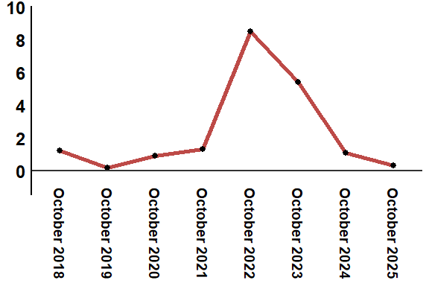
Reading: In October 2025, the consumer price index increased by 1.2% compared to October 2024

