Information note from the regional directorate of Tangier-Tetouan-Al Hoceima
Consumer price index: city of Tanger
In October 2025, the national consumer price index decreased by -0.7% compared to the previous month, while the consumer price index increased by 0.4% over a full year.
The consumer price index experienced a decrease of -1.7% during the month of October 2025 compared to the previous month. as a result of the decline in prices of «Oils and Fats» by -6.7 %, «Meat» by -5.1 %, «Fruits», «Vegetables» and «Food Products N.C.A.» by -0.4 %, «Milk, Cheese and Eggs», «Sugar, Jam, Honey and Chocolate and Confectionery» by -0.2 %, «Mineral Waters, Soft Drinks and Fruit and Vegetable Juices (Nd)» by -0.1 %
The monthly variation in the non-food index stagnated following stagnation in prices in the following divisions: «Housing, Water, Gas, Electricity and Other Fuels», «Health» and «Education».
Over a year, the food product price index increased by 0.3% in October 2025 compared to October 2024 , due to the rise in the prices of «Fruits» by 10.3 %, «Cafe and Tea and Cocoa» by 8.5 %, «Vegetables» by 4.6 %, «Tobacco» by 3.6 %, «Food Products N.C.A.» by 0.5 %, «Sugar, Jam, Honey and Chocolate and Confectionery» by 0.4 %, «Fish and Seafood», «Milk and Cheese and Eggs» by 0.2 %, «Bread and Cereals» by 0.1 %. Moreover, the decrease in prices of «Oils and Fats» by -12.8 %, «Mineral Waters, Soft Drinks and Fruit and Vegetable Juices (Nd)» by -3.9 %, «Meat» by -1.1 % and the stagnation in prices for did not affect the general evolution.
Similarly, the annual variation in the non-food index increased by 0.4%. While the variation in prices of the divisions that make up non-food products fluctuated between a decrease of the division of «Transportation» by -2.4 % and the rise of the division of «Furniture, Household Items and Routine Home Maintenance» and «Restaurants and Hotels» by 2.8 %
3- Annual evolution (%) of the consumer price index for the month of October
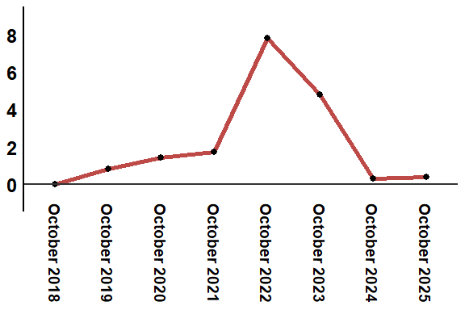
Reading: In October 2025, the consumer price index increased by 0.4% compared to October 2024

