Information note from the regional directorate of Tangier-Tetouan-Al Hoceima
Consumer price index: city of Al Hoceima
In October 2025, the national consumer price index decreased by -1.5% compared to the previous month, while the consumer price index increased by 0.2% over a full year.
The consumer price index experienced a decrease of -2.6% during the month of October 2025 compared to the previous month. as a result of the decline in prices of «Fish and Seafood» by -11.5 %, «Oils and Fats» by -2.8 %, «Meat» by -2.7 %, «Fruits» and «Vegetables» by -1 %, «Food Products N.C.A.» by -0.8 %, «Mineral Waters, Soft Drinks and Fruit and Vegetable Juices (Nd)» by -0.6 %, «Milk and Cheese and Eggs» by -0.2 %
Similarly, the monthly variation in the non-food index decreased by -0.2% due to price decreases in the following divisions: «Restaurants and Hotels» by -3.7 %, «Transportation» by -0.9 %, «Communications» by -0.2 %.
Over a year, the food product price index increased by 0.4% in October 2025 compared to October 2024 , due to the rise in the prices of «Vegetables» by 6.8 %, «Fruits» by 6 %, «Cafe and Tea and Cocoa» by 5 %, «Tobacco» by 4.5 %, «Sugar, Jam, Honey and Chocolate and Confectionery» by 0.8 %, «Milk and Cheese and Eggs» by 0.6 %. Moreover, the decrease in prices of «Oils and Fats» by -6.7 %, «Mineral Waters, Soft Drinks and Fruit and Vegetable Juices (Nd)» by -3.4 %, «Meat» by -3.3 %, «Bread and Cereals» by -0.8 %, «Food Products N.C.A.» by -0.7 %, «Fish and Seafood» by -0.4 % and the stagnation in prices for did not affect the general evolution.
On the other hand, the annual variation in the non-food index decreased by -0.4%. While the variation in prices of the divisions that make up non-food products fluctuated between a decrease of the division of «Transportation» by -4.8 % and the rise of the division of «Restaurants and Hotels» by 3.4 %
1- Annual evolution (%) of the consumer price index for the month of October
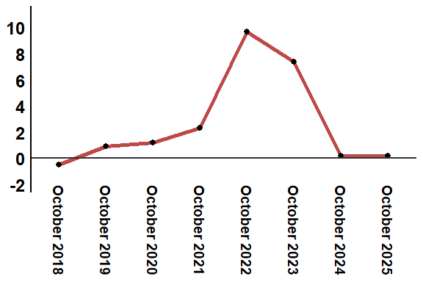
Reading: In October 2025, the consumer price index increased by -0.4% compared to October 2024

