Information note from the regional directorate of Tangier-Tetouan-Al Hoceima
Consumer price index: city of Tétouan
In November 2025, the national consumer price index decreased by -0.3% compared to the previous month, while the consumer price index increased by 0.6% over a full year.
The consumer price index experienced a decrease of -1% during the month of November 2025 compared to the previous month. as a result of the decline in prices of «Fruits» by -12.3 %, «Oils and Fats» by -1 %, «Food Products N.C.A.» by -0.7 %, «Meat» and «Fish and Seafood» by -0.6 %, «Cafe and Tea and Cocoa» by -0.2 %, «Mineral Waters, Soft Drinks and Fruit and Vegetable Juices (Nd)» by -0.1 %
On the other hand, the monthly variation in the non-food index increased by 0.1% due to price increases in the following divisions: «Education» by 0.7 %, «Clothing and Shoes» by 0.5 %, «Furniture, Household Items and Routine Home Maintenance», «Transportation» and «Miscellaneous Goods and Services» by 0.1 %
Over a year, the food product price index decreased by -0.5% in November 2025 compared to November 2024 , due to the decrease in the prices of «Oils and Fats» by -8.5 %, «Mineral Waters, Soft Drinks and Fruit and Vegetable Juices (Nd)» by -6.8 %, «Meat» by -5.2 %, «Food Products N.C.A.» by -1.4 %, «Bread and Cereals» by -1.2 %, «Milk and Cheese and Eggs» by -0.2 %. Moreover, the rise in prices of «Cafe and Tea and Cocoa» by 8.2 %, «Fish and Seafood» by 6.2 %, «Vegetables» by 5.5 %, «Fruits» by 3.9 %, «Tobacco» by 3.6 %, «Sugar, Jam, Honey and Chocolate and Confectionery» by 0.8 % and the stagnation in prices for did not affect the general evolution.
On the other hand, the annual variation in the non-food index increased by 1.4%. While the variation in prices of the divisions that make up non-food products fluctuated between a decrease of the division of «Transportation» by -1.6 % and the rise of the division of «Education» by 10.5 %
5- Annual evolution (%) of the consumer price index for the month of November
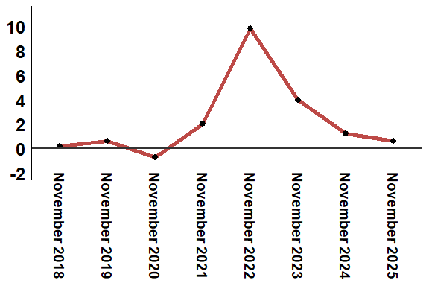
Reading: In November 2025, the consumer price index increased by 1.4% compared to November 2024

