Information note from the regional directorate of Tangier-Tetouan-Al Hoceima
Consumer price index: city of Tanger
In November 2025, the national consumer price index decreased by -0.4% compared to the previous month, while the consumer price index increased by 0.6% over a full year.
The consumer price index experienced a decrease of -1.4% during the month of November 2025 compared to the previous month. as a result of the decline in prices of «Fruits» by -9.9 %, «Meat» by -3.2 %, «Oils and Fats» by -1.6 %, «Cafe and Tea and Cocoa» by -0.2 %
On the other hand, the monthly variation in the non-food index increased by 0.3% due to price increases in the following divisions: «Miscellaneous Goods and Services» by 2.5 %, «Clothing and Shoes», «Housing, Water, Gas, Electricity and Other Fuels», «Furniture and Household Items and Routine Home Maintenance» by 0.1 %
Over a year, the food product price index increased by 0.2% in November 2025 compared to November 2024 , due to the rise in the prices of «Fish and Seafood» by 11.9 %, «Fruits» by 9.1 %, «Vegetables» by 6.5 %, «Cafe and Tea and Cocoa» by 5.2 %, «Tobacco» by 3.6 %, «Sugar, Jam, Honey and Chocolate and Confectionery» by 0.8 %. Moreover, the decrease in prices of «Oils and Fats» by -13.9 %, «Meat» by -4.6 %, «Mineral Waters, Soft Drinks and Fruit and Vegetable Juices (Nd)» by -1.3 %, «Milk and Cheese and Eggs» by -0.5 %, «Food Products N.C.A.» by -0.1 % and the stagnation in prices for «Bread and Cereals» did not affect the general evolution.
Similarly, the annual variation in the non-food index increased by 0.8%. While the variation in prices of the divisions that make up non-food products fluctuated between a decrease of the division of «Communications» by -2.3 % and the rise of the division of «Miscellaneous Goods and Services» by 4.5 %
3- Annual evolution (%) of the consumer price index for the month of November
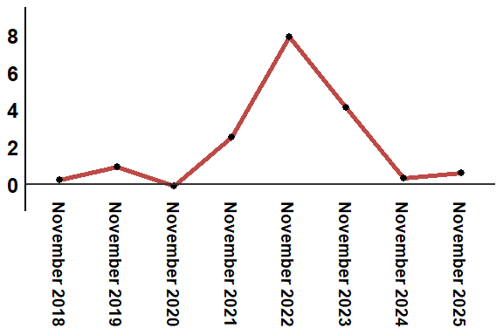
Reading: In November 2025, the consumer price index increased by 0.8% compared to November 2024

