Information note from the regional directorate of Tangier-Tetouan-Al Hoceima
Consumer price index: city of Al Hoceima
In November 2025, the national consumer price index decreased by -1.2% compared to the previous month, while the consumer price index decreased by -0.2% over a full year.
The consumer price index experienced a decrease of -2% during the month of November 2025 compared to the previous month. as a result of the decline in prices of «Fruits» by -8.9 %, «Fish and Seafood» by -5.9 %, «Bread and Cereals» by -1.5 %, «Meat» by -1 %, «Food Products N.C.A.» by -0.6 %, «Milk and Cheese and Eggs» by -0.4 %, «Oils and Fats» by -0.1 %
The monthly variation in the non-food index stagnated following stagnation in prices in the following divisions: «Health», «Communications», «Leisure and Culture», «Education» and «Miscellaneous Goods and Services».
Over a year, the food product price index decreased by -0.1% in November 2025 compared to November 2024 , due to the decrease in the prices of «Oils and Fats» by -9.1 %, «Meat» by -4.4 %, «Fish and Seafood» by -4.1 %, «Mineral Waters, Soft Drinks and Fruit and Vegetable Juices (Nd)» by -2.6 %, «Bread and Cereals» by -1.8 %, «Food Products N.C.A.» by -1.4 %, «Milk and Cheese and Eggs» by -0.6 %. Moreover, the rise in prices of «Vegetables» by 12.1 %, «Cafe and Tea and Cocoa» by 7.5 %, «Fruits» by 4.6 %, «Tobacco» by 4.5 %, «Sugar, Jam, Honey and Chocolate and Confectionery» by 0.8 % and the stagnation in prices for did not affect the general evolution.
Similarly, the annual variation in the non-food index decreased by -0.3%. While the variation in prices of the divisions that make up non-food products fluctuated between a decrease of the division of «Transportation» by -4.3 % and the rise of the division of «Restaurants and Hotels» by 2 %
1- Annual evolution (%) of the consumer price index for the month of November
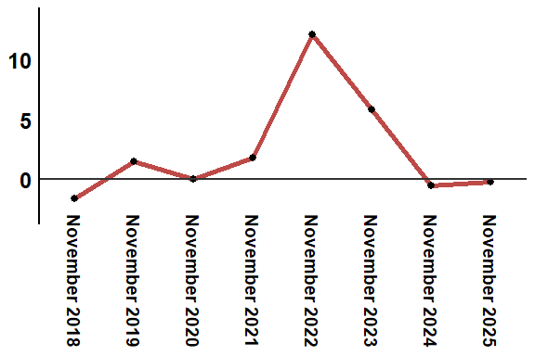
Reading: In November 2025, the consumer price index decreased by -0.3% compared to November 2024

