Consumer Price Index - August 2026 | City of Tangier
In August 2026, the consumer price index for households increased by 0,9% compared to the previous month. On an annual level, the consumer price index decreased by 0,3% over a full year.

Over a month, The food product price index increased by 1,3% in August 2026 compared to July 2026, as a result of the rise in prices of «Meat» by 5,5%, «Milk, Cheese and Eggs» by 4,2%, «Fish and Seafood» by 1,6%, «Food Productsnot elsewhere classified» by 0,8% and «Sugar, Jam, Honey, Chocolate and Confectionery», «Mineral Waters, Soft Drinks and Fruit and Vegetable Juices (Nd)» by 0,1%.
Similarly, the monthly variation of the index for the non-food products increased by 0,6% due to the increase in prices in the following divisions: «Transportation» by 3,4%, «Restaurants and Hotels» by 0,8%, «Various Goods and Services» by 0,4% and «Clothing and Shoes» and «Communications» by 0,2%. Also, the decrease in prices of the following divisions: «Leisure and Culture» by 0,3%. Thus, the stagnation of the indices of the other divisions did not impact the general evolution.
Over a year, the food product price index decreased by 4,3% in August 2026 compared to August 2025 , due to the decrease in the prices of «Oils and Fats» by 21,5%, «Fruits» by 7,5%, «Vegetables» by 4,9%, «Meat» by 3,1%, «Milk, Cheese and Eggs» by 3,0%, «Cafe, Tea and Cocoa» by 0,6% and «Food Productsnot elsewhere classified» by 0,4%. Moreover, the rise in prices of «Tobacco» by 4,0%, «Mineral Waters, Soft Drinks, Fruit and Vegetable Juices (Nd)» by 2,2%, «Bread and Cereals» and «Fish and Seafood» by 1,9% and «Sugar, Jam, Honey, Chocolate and Confectionery» by 0,6% and the stagnation in prices for NA did not affect the general evolution.
On the other hand, the annual variation in the non-food index increased by 2,3%. While the variation in prices of the divisions that make up non-food products fluctuated between a decrease of the division of «Communications» by 1,3% and the rise of the division of «Various Goods and Services» by 8,5%
1- Annual evolution (%) of the consumer price index for the month of August
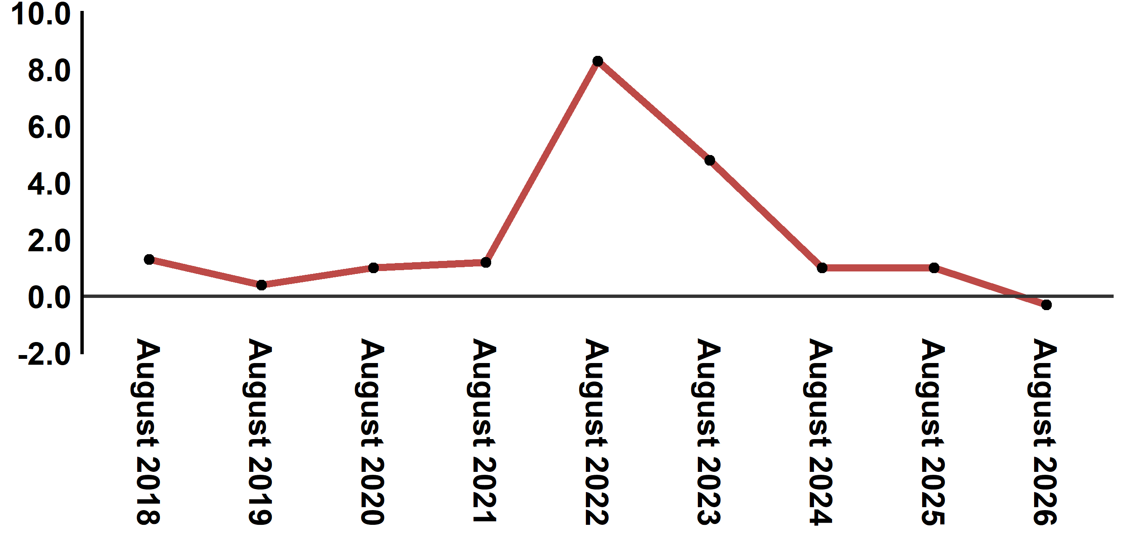
Reading: In August 2026, the consumer price index decreased by 0,3% compared to August 2025
2- Annual evolution (%) of the consumer price index for the month of August
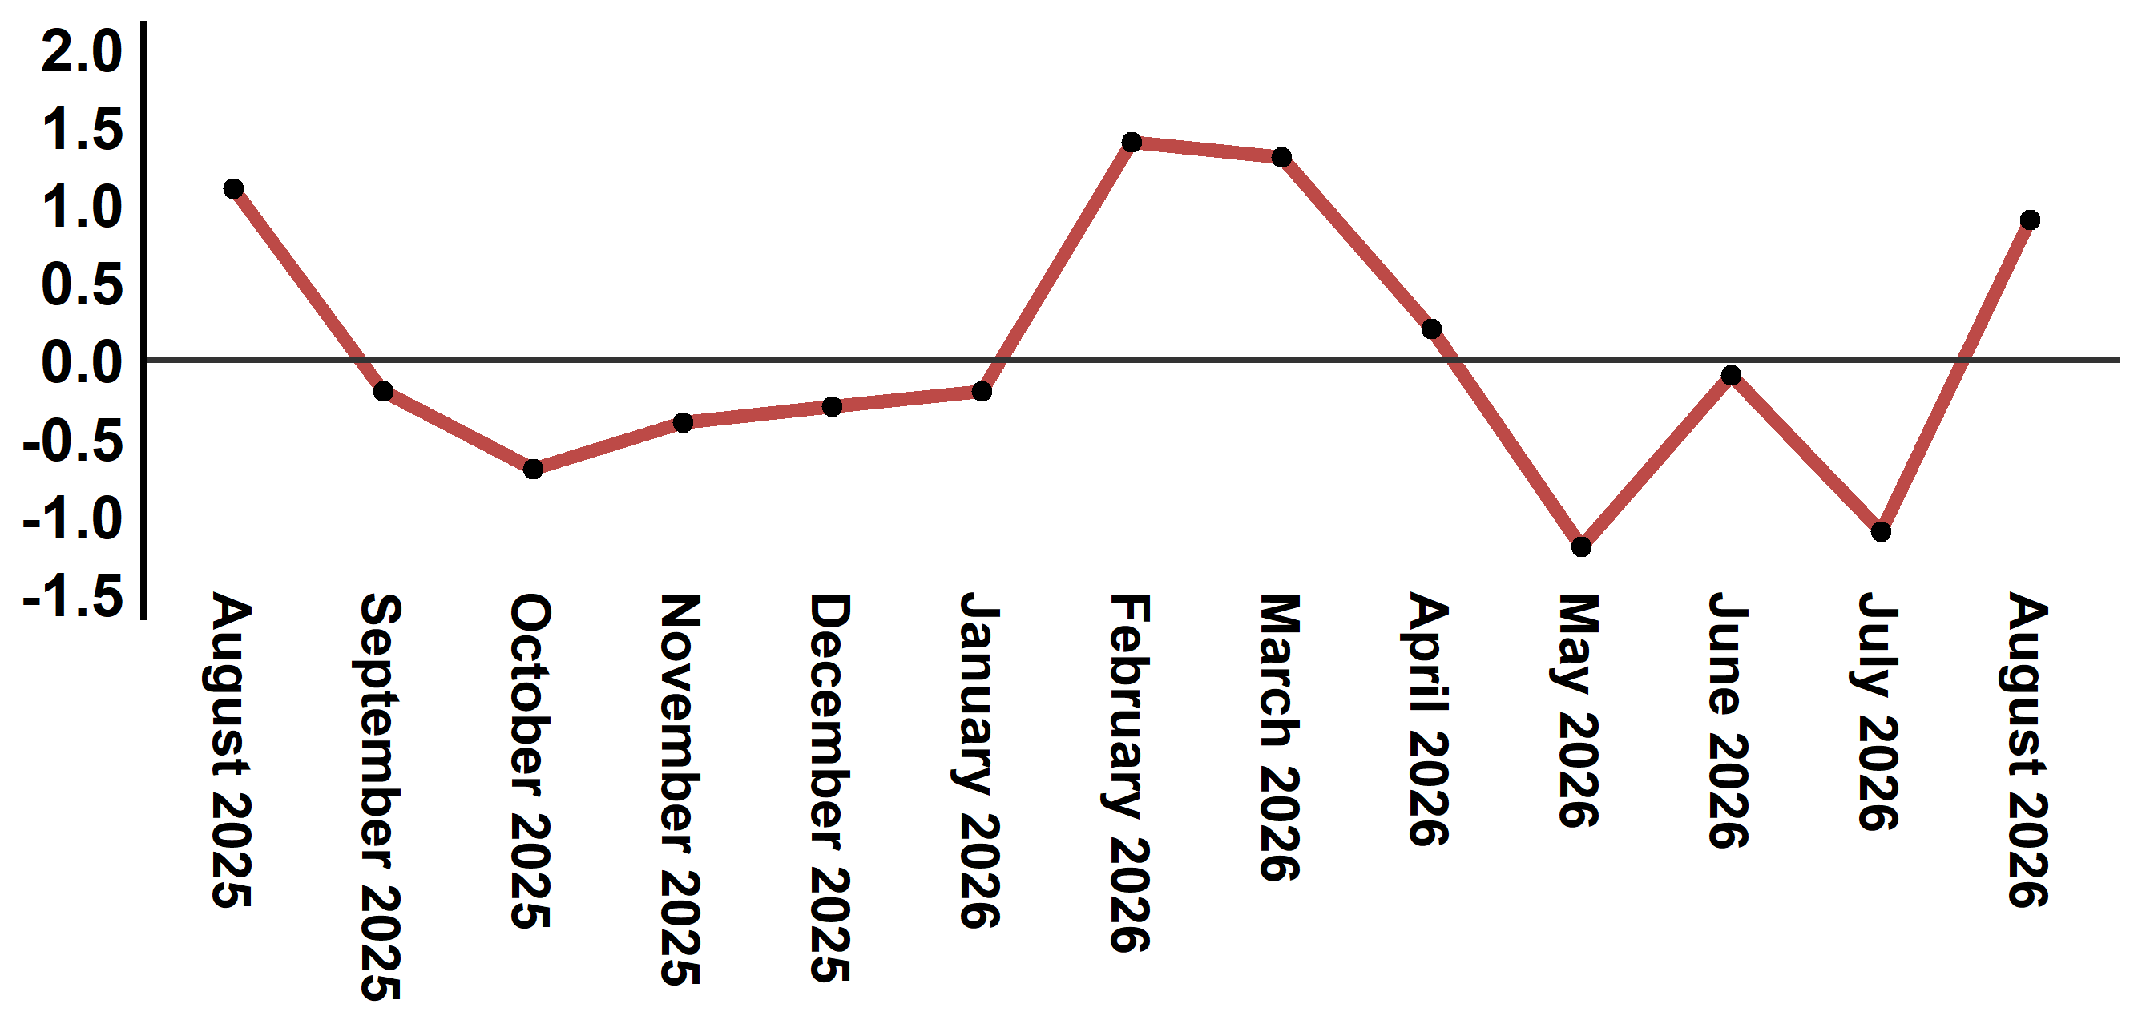
Reading: The level of price variation in August 2026 increased by 0,9% after being -1,1% in June 2026

Table 2: Consumer price index for the city of Tangier: August 2026 (2017 base: 100)
Product Divisions | Weightings | Monthly index |  |  |  |  | Variation (%)
Product Divisions | Weightings | August 2025 | May 2026 | June 2026 | July 2026 | August 2026 | 1 month | 3 months | 12 months
Food products | 36,115 | 134,1 | 129,3 | 129,3 | 126,8 | 128,4 | 1,3 | -0,7 | -4,3
01 – Food products and non-alcoholic | 34,708 | 133,6 | 128,4 | 128,4 | 125,8 | 127,5 | 1,4 | -0,7 | -4,6
02 –Alcoholicbeverages and tobacco | 1,407 | 145,4 | 151,1 | 151,1 | 151,1 | 151,1 | 0,0 | 0,0 | 3,9
Non foodproducts | 63,885 | 112,5 | 115,0 | 114,9 | 114,4 | 115,1 | 0,6 | 0,1 | 2,3
03 – Clothing and shoes | 6,449 | 113,5 | 113,3 | 113,3 | 113,4 | 113,6 | 0,2 | 0,3 | 0,1
04 - Housing, water, gas, electricity and other fuel | 16,656 | 111,6 | 112,7 | 112,8 | 112,8 | 112,8 | 0,0 | 0,1 | 1,1
05- Furniture, household items and routine maintenance of the home | 4,100 | 112,1 | 112,1 | 112,1 | 112,2 | 112,2 | 0,0 | 0,1 | 0,1
06 –Health | 8,218 | 109,3 | 109,3 | 109,4 | 109,5 | 109,5 | 0,0 | 0,2 | 0,2
07 – Transport | 9,751 | 116,8 | 123,2 | 121,5 | 119,4 | 123,5 | 3,4 | 0,2 | 5,7
08 – Communication | 3,199 | 101,1 | 99,3 | 99,3 | 99,6 | 99,8 | 0,2 | 0,5 | -1,3
09 – Leisure and culture | 2,350 | 104,4 | 104,7 | 104,7 | 104,6 | 104,3 | -0,3 | -0,4 | -0,1
10 –Education | 5,047 | 110,9 | 113,4 | 113,4 | 113,4 | 113,4 | 0,0 | 0,0 | 2,3
11 - Restaurants and hotels | 1,280 | 128,8 | 128,3 | 129,9 | 129,9 | 131,0 | 0,8 | 2,1 | 1,7
12 – Variousgoods and services | 6,835 | 117,7 | 128,9 | 129,1 | 127,2 | 127,7 | 0,4 | -0,9 | 8,5
General index | 100,000 | 120,4 | 120,3 | 120,2 | 118,9 | 120,0 | 0,9 | -0,2 | -0,3
Source: High Commission for Planning, Department of Statistics - National consumer price survey
Angle Avenue Ibn Tachafine et Avenue Ibn Toumart B.P.104 Tanger
****Tél:0539940698****Fax:0539940364 Site Web: www.hcp.ma/region-tanger Email:hcp.dr.tanger@hcp.ma
:::

