Consumer Price Index - August 2026 | City of Tetouan
In August 2026, the consumer price index for households increased by 1,2% compared to the previous month. On an annual level, the consumer price index increased by 0,7% over a full year.

Over a month, The food product price index increased by 1,6% in August 2026 compared to July 2026, as a result of the rise in prices of «Fish and Seafood» by 7,2%, «Meat» by 5,7%, «Milk, Cheese and Eggs» by 1,3%, «Food Productsnot elsewhere classified» by 0,9%, «Cafe, Tea and Cocoa» by 0,4% and «Mineral Waters, Soft Drinks, Fruit and Vegetable Juices (Nd)» by 0,1%.
Similarly, the monthly variation of the index for the non-food products increased by 0,9% due to the increase in prices in the following divisions: «Transportation» by 6,2%, «Restaurants and Hotels» by 0,9%, «Various Goods and Services» by 0,2% and «Furniture, Household Items and Routine Home Maintenance» by 0,1%. Also, the decrease in prices of the following divisions: «Clothing and Shoes» and «Communications» by 0,2%. Thus, the stagnation of the indices of the other divisions did not impact the general evolution. NA NA NA the monthly variation of the index for the non-food products increased by 0,9% due to the increase in prices in the following divisions: «Transportation» by 6,2%, «Restaurants and Hotels» by 0,9%, «Various Goods and Services» by 0,2% and «Furniture, Household Items and Routine Home Maintenance» by 0,1%. Also, the decrease in prices of the following divisions: «Clothing and Shoes» and «Communications» by 0,2%. Thus, the stagnation of the indices of the other divisions did not impact the general evolution. the monthly variation of the index for the non-food products increased by 0,9% due to the increase in prices in the following divisions: «Transportation» by 6,2%, «Restaurants and Hotels» by 0,9%, «Various Goods and Services» by 0,2% and «Furniture, Household Items and Routine Home Maintenance» by 0,1%. Also, the decrease in prices of the following divisions: «Clothing and Shoes» and «Communications» by 0,2%. Thus, the stagnation of the indices of the other divisions did not impact the general evolution.
Over a year, the food product price index decreased by 2,9% in August 2026 compared to August 2025 , due to the decrease in the prices of «Oils and Fats» by 18,3%, «Fruits» by 8,5%, «Vegetables» by 5,3%, «Milk, Cheese and Eggs» by 4,8%, «Fish and Seafood» by 2,9%, «Bread and Cereals» by 0,3% and «Food Productsnot elsewhere classified» by 0,1%. Moreover, the rise in prices of «Meat» by 6,9%, «Tobacco» by 4,0%, «Sugar, Jam, Honey, Chocolate and Confectionery» by 2,1%, «Cafe, Tea and Cocoa» by 0,6% and «Mineral Waters, Soft Drinks, Fruit and Vegetable Juices (Nd)» by 0,4% and the stagnation in prices for NA did not affect the general evolution.
On the other hand, the annual variation in the non-food index increased by 3,6%. While the variation in prices of the divisions that make up non-food products fluctuated between a decrease of the division of «Clothing and Shoes» by 1,3% and the rise of the division of «Transportation» by 12,4%
3- Annual evolution (%) of the consumer price index for the month of August
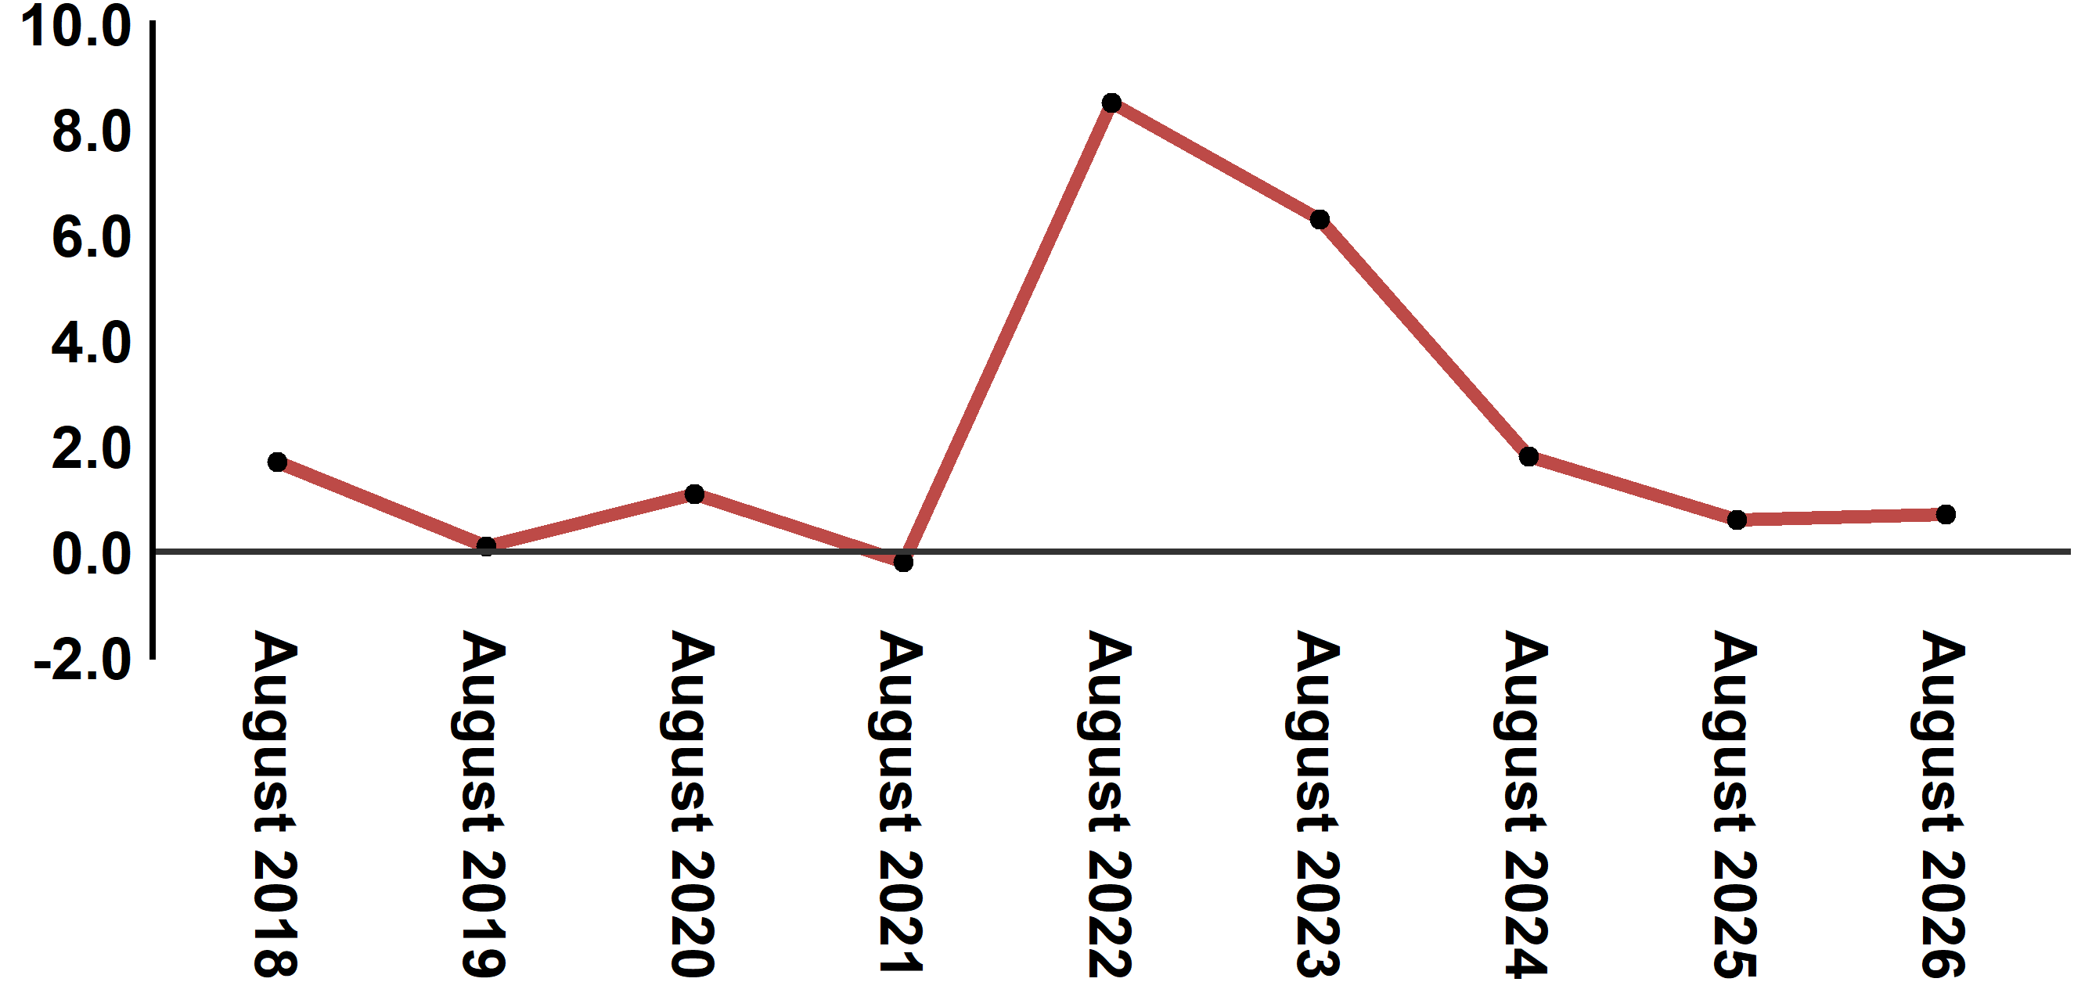
Reading: In August 2026, the consumer price index increased by 0,7% compared to August 2025
4- Annual evolution (%) of the consumer price index for the month of August
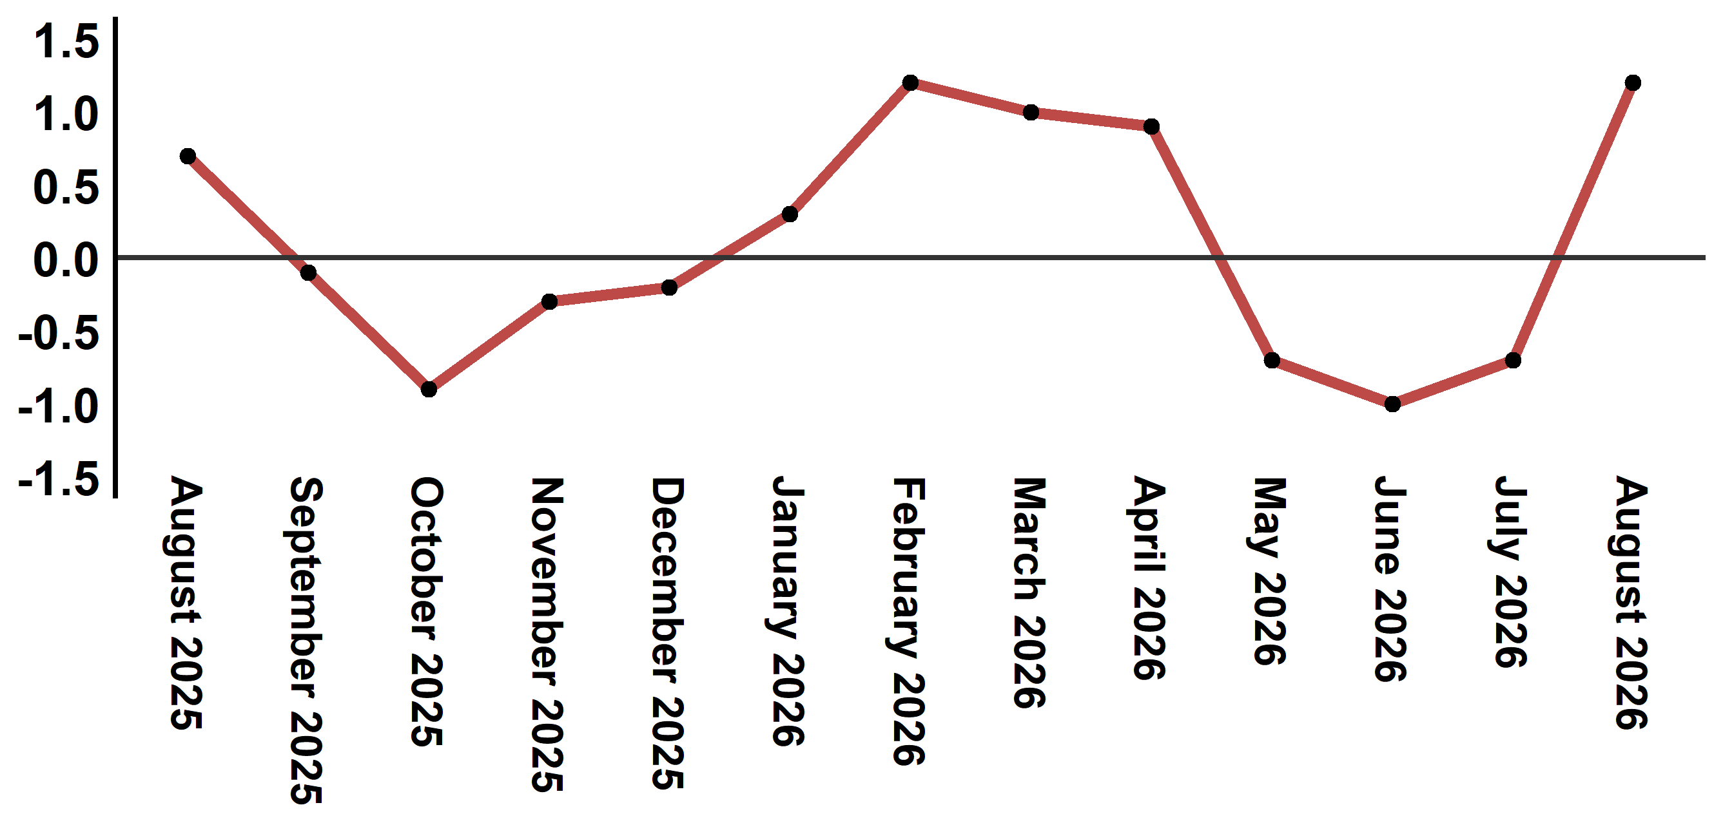
Reading: The level of price variation in August 2026 increased by 1,2% after being -0,7% in June 2026

Table 3: Consumer price index for the city of Tetouan: August 2026 (2017 base: 100)
Product Divisions | Weightings | Monthly index |  |  |  |  | Variation (%)
Product Divisions | Weightings | August 2025 | May 2026 | June 2026 | July 2026 | August 2026 | 1 month | 3 months | 12 months
Food products | 40,725 | 136,1 | 134,2 | 132,1 | 130,1 | 132,2 | 1,6 | -1,5 | -2,9
01 – Food products and non-alcoholic | 38,964 | 135,6 | 133,4 | 131,2 | 129,1 | 131,3 | 1,7 | -1,6 | -3,2
02 –Alcoholicbeverages and tobacco | 1,761 | 146,1 | 152,0 | 152,0 | 152,0 | 152,0 | 0,0 | 0,0 | 4,0
Non foodproducts | 59,275 | 111,2 | 114,9 | 114,3 | 114,2 | 115,2 | 0,9 | 0,3 | 3,6
03 – Clothing and shoes | 5,835 | 113,1 | 113,2 | 112,2 | 111,8 | 111,6 | -0,2 | -1,4 | -1,3
04 - Housing, water, gas, electricity and other fuel | 14,202 | 109,3 | 111,0 | 110,8 | 110,9 | 110,9 | 0,0 | -0,1 | 1,5
05- Furniture, household items and routine maintenance of the home | 5,602 | 110,9 | 111,2 | 111,6 | 111,4 | 111,5 | 0,1 | 0,3 | 0,5
06 –Health | 6,594 | 103,5 | 103,0 | 103,0 | 103,0 | 103,0 | 0,0 | 0,0 | -0,5
07 – Transport | 7,416 | 112,9 | 125,6 | 121,8 | 119,5 | 126,9 | 6,2 | 1,0 | 12,4
08 – Communication | 2,560 | 97,4 | 97,3 | 97,3 | 97,6 | 97,4 | -0,2 | 0,1 | 0,0
09 – Leisure and culture | 2,432 | 106,7 | 105,6 | 105,6 | 105,4 | 105,4 | 0,0 | -0,2 | -1,2
10 –Education | 5,358 | 116,8 | 129,5 | 129,5 | 129,5 | 129,5 | 0,0 | 0,0 | 10,9
11 - Restaurants and hotels | 2,468 | 117,9 | 122,9 | 123,1 | 129,1 | 130,2 | 0,9 | 5,9 | 10,4
12 – Variousgoods and services | 6,808 | 119,4 | 122,7 | 122,4 | 122,5 | 122,7 | 0,2 | 0,0 | 2,8
General index | 100,000 | 121,4 | 122,8 | 121,6 | 120,7 | 122,2 | 1,2 | -0,5 | 0,7
Source: High Commission for Planning, Department of Statistics - National consumer price survey
Angle Avenue Ibn Tachafine et Avenue Ibn Toumart B.P.104 Tanger
****Tél:0539940698****Fax:0539940364 Site Web: www.hcp.ma/region-tanger Email:hcp.dr.tanger@hcp.ma
:::

