Consumer Price Index - August 2026 | City of Al Hoceima
In August 2026, the consumer price index for households increased by 1,6% compared to the previous month. On an annual level, the consumer price index decreased by 2,1% over a full year.

Over a month, The food product price index increased by 2,1% in August 2026 compared to July 2026, as a result of the rise in prices of «Fish and Seafood» by 12,0%, «Milk, Cheese and Eggs» by 5,0%, «Mineral Waters, Soft Drinks, Fruit and Vegetable Juices (Nd)» by 2,1%, «Meat» by 0,8%, «Oils and Fats» by 0,4%, «Fruits» by 0,3% and «Sugar, Jam, Honey, Chocolate and Confectionery» by 0,2%.
Similarly, the monthly variation of the index for the non-food products increased by 1,0% due to the increase in prices in the following divisions: «Transportation» by 5,6%, «Restaurants and Hotels» by 1,0% and «Various Goods and Services» by 0,3%. Also, the decrease in prices of the following divisions: NA. Thus, the stagnation of the indices of the other divisions did not impact the general evolution. NA the monthly variation of the index for the non-food products increased by 1,0% due to the increase in prices in the following divisions: «Transportation» by 5,6%, «Restaurants and Hotels» by 1,0% and «Various Goods and Services» by 0,3%. Also, the decrease in prices of the following divisions: NA. Thus, the stagnation of the indices of the other divisions did not impact the general evolution. the monthly variation of the index for the non-food products increased by 1,0% due to the increase in prices in the following divisions: «Transportation» by 5,6%, «Restaurants and Hotels» by 1,0% and «Various Goods and Services» by 0,3%. Also, the decrease in prices of the following divisions: NA. Thus, the stagnation of the indices of the other divisions did not impact the general evolution.
Over a year, the food product price index decreased by 6,0% in August 2026 compared to August 2025 , due to the decrease in the prices of «Oils and Fats» by 26,9%, «Fruits» by 11,5%, «Vegetables» by 7,5%, «Milk, Cheese and Eggs» by 4,7%, «Fish and Seafood» by 3,4%, «Food Productsnot elsewhere classified» by 2,2% and «Bread and Cereals» by 1,0%. Moreover, the rise in prices of «Cafe, Tea and Cocoa» by 8,9%, «Tobacco» by 5,0%, «Meat» by 4,6%, «Mineral Waters, Soft Drinks, Fruit and Vegetable Juices (Nd)» by 1,6% and «Sugar, Jam, Honey, Chocolate and Confectionery» by 0,4% and the stagnation in prices for NA did not affect the general evolution.
On the other hand, the annual variation in the non-food index increased by 3,3%. While the variation in prices of the divisions that make up non-food products fluctuated between a decrease of the division of «Furniture, Household Items and Routine Home Maintenance» by 0,9% and the rise of the division of «Transportation» by 11,3%
4- Annual evolution (%) of the consumer price index for the month of August
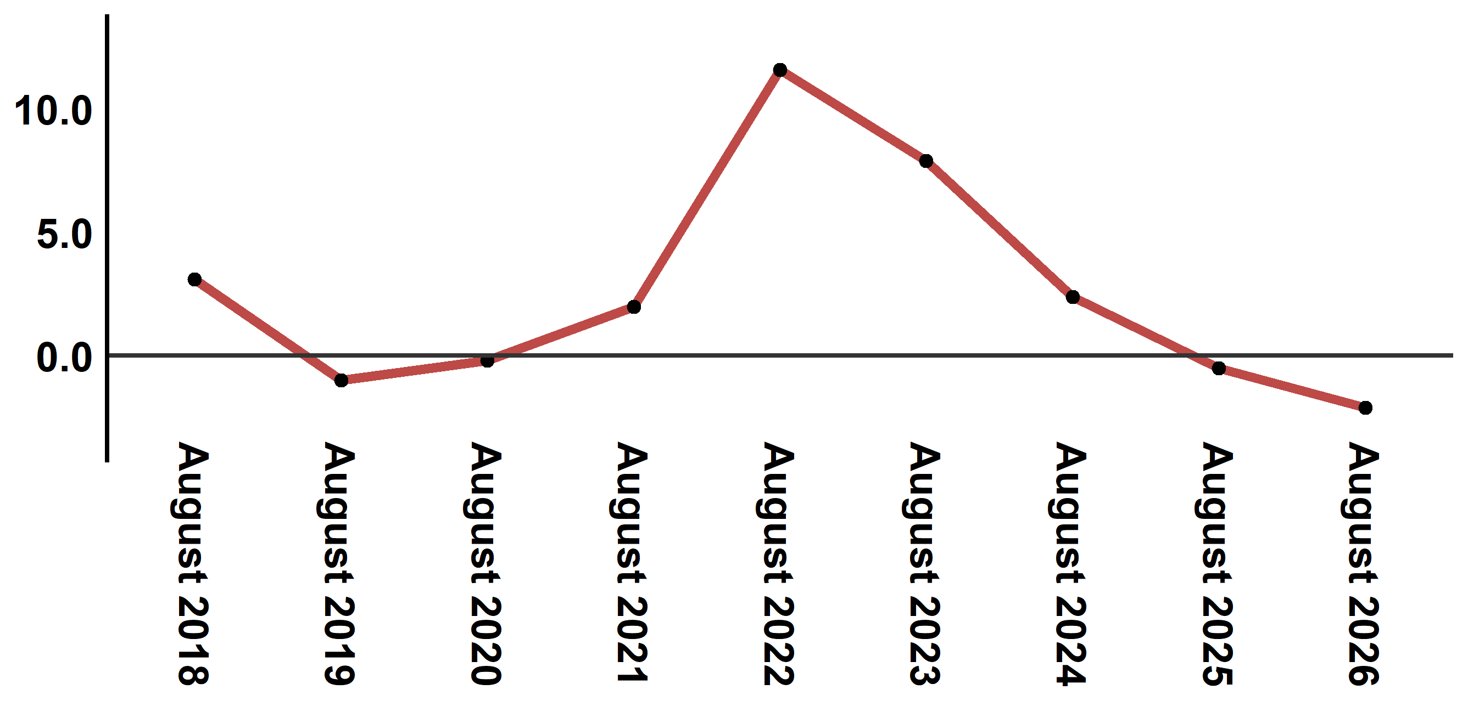
Reading: In August 2026, the consumer price index decreased by 2,1% compared to August 2025
6- Annual evolution (%) of the consumer price index for the month of August
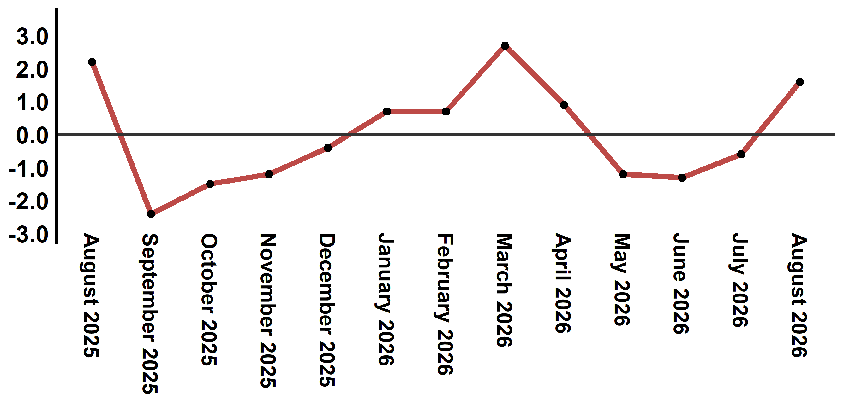
Reading: The level of price variation in August 2026 increased by 1,6% after being -0,6% in June 2026

Table 4: Consumer price index for the city of Al Hoceima: August 2026 (2017 base: 100)
Product Divisions | Weightings | Monthly index |  |  |  |  | Variation (%)
Product Divisions | Weightings | August 2025 | May 2026 | June 2026 | July 2026 | August 2026 | 1 month | 3 months | 12 months
Food products | 49,716 | 147,2 | 140,2 | 137,1 | 135,4 | 138,3 | 2,1 | -1,4 | -6,0
01 – Food products and non-alcoholic | 48,371 | 147,1 | 139,7 | 136,5 | 134,8 | 137,7 | 2,2 | -1,4 | -6,4
02 –Alcoholicbeverages and tobacco | 1,345 | 150,1 | 158,1 | 158,1 | 158,1 | 158,1 | 0,0 | 0,0 | 5,3
Non foodproducts | 50,284 | 110,5 | 113,1 | 112,9 | 113,1 | 114,2 | 1,0 | 1,0 | 3,3
03 – Clothing and shoes | 5,155 | 117,4 | 118,8 | 118,8 | 118,9 | 118,9 | 0,0 | 0,1 | 1,3
04 - Housing, water, gas, electricity and other fuel | 11,732 | 106,2 | 109,9 | 109,9 | 109,3 | 109,3 | 0,0 | -0,5 | 2,9
05- Furniture, household items and routine maintenance of the home | 3,094 | 113,3 | 112,7 | 112,7 | 112,3 | 112,3 | 0,0 | -0,4 | -0,9
06 –Health | 6,413 | 98,8 | 99,1 | 99,1 | 99,1 | 99,1 | 0,0 | 0,0 | 0,3
07 – Transport | 7,704 | 118,9 | 131,9 | 129,6 | 125,3 | 132,3 | 5,6 | 0,3 | 11,3
08 – Communication | 2,892 | 101,6 | 101,4 | 101,4 | 101,5 | 101,5 | 0,0 | 0,1 | -0,1
09 – Leisure and culture | 1,933 | 95,0 | 96,5 | 96,5 | 96,4 | 96,4 | 0,0 | -0,1 | 1,5
10 –Education | 3,842 | 114,1 | 114,8 | 114,8 | 114,8 | 114,8 | 0,0 | 0,0 | 0,6
11 - Restaurants and hotels | 2,258 | 130,9 | 113,7 | 116,6 | 137,4 | 138,8 | 1,0 | 22,1 | 6,0
12 – Variousgoods and services | 5,261 | 113,1 | 115,7 | 115,2 | 116,0 | 116,3 | 0,3 | 0,5 | 2,8
General index | 100,000 | 129,1 | 126,8 | 125,1 | 124,4 | 126,4 | 1,6 | -0,3 | -2,1
Source: High Commission for Planning, Department of Statistics - National consumer price survey
Angle Avenue Ibn Tachafine et Avenue Ibn Toumart B.P.104 Tanger
****Tél:0539940698****Fax:0539940364 Site Web: www.hcp.ma/region-tanger Email:hcp.dr.tanger@hcp.ma
:::

