Information note from the regional directorate of Tangier-Tetouan-Al Hoceima
Consumer price index: city of Tanger
In December 2025, the national consumer price index decreased by -0.3% compared to the previous month, while the consumer price index increased by 0.4% over a full year.
The consumer price index experienced a decrease of -0.7% during the month of December 2025 compared to the previous month. as a result of the decline in prices of «Fruits» by -5 %, «Oils and Fats» by -2.7 %, «Meat» by -1.8 %, «Cafe and Tea and Cocoa» by -1.3 %, «Food Products N.C.A.» by -0.1 %
On the other hand, the monthly variation in the non-food index increased by 0.1% due to price increases in the following divisions: «Leisure and Culture» by 0.4 %, «Miscellaneous Goods and Services» by 0.2 %, «Housing, Water, Gas and Electricity and Other Fuels» by 0.1 %
Over a year, the food product price index decreased by -0.2% in December 2025 compared to December 2024 , due to the decrease in the prices of «Oils and Fats» by -16.5 %, «Meat» by -8.9 %, «Milk and Cheese and Eggs» by -0.6 %, «Mineral Waters, Soft Drinks and Fruit and Vegetable Juices (Nd)» by -0.4 %. Moreover, the rise in prices of «Vegetables» by 12.8 %, «Fish and Seafood» by 9.9 %, «Fruits» by 8.4 %, «Cafe and Tea and Cocoa» by 4.2 %, «Tobacco» by 3.6 %, «Sugar, Jam, Honey and Chocolate and Confectionery» by 0.4 %, «Food Products N.C.A.» by 0.3 % and the stagnation in prices for «Bread and Cereals» did not affect the general evolution.
On the other hand, the annual variation in the non-food index increased by 0.8%. While the variation in prices of the divisions that make up non-food products fluctuated between a decrease of the division of «Communications» by -2.7 % and the rise of the division of «Miscellaneous Goods and Services» by 4.7 %
3- Annual evolution (%) of the consumer price index for the month of December
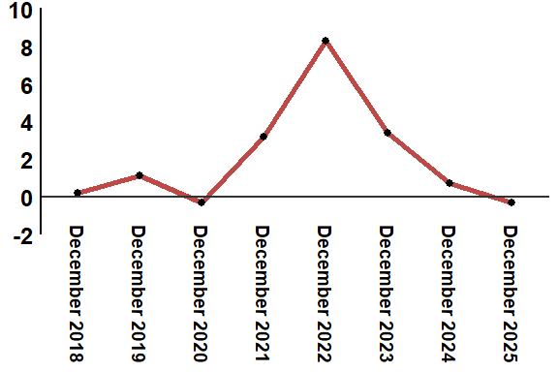
Reading: In December 2025, the consumer price index increased by 0.4% compared to December 2024
4- Annual evolution (%) of the consumer price index for the month of December
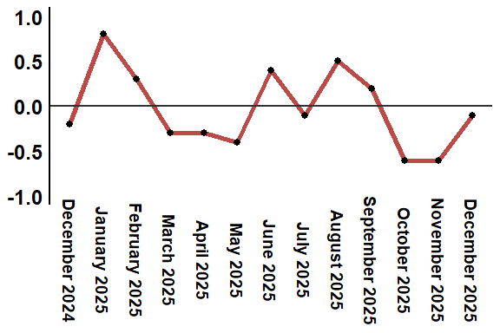
Reading: In December 2025, the consumer price index decreased by -0.3% compared to November 2025
Table 4: Consumer price index for the city of Tanger: December 2025 (2017 base: 100)
Product Divisions | Weightings | Monthly index |  |  |  |  | Variation (%)
 |  | December 2024 | September 2025 | October 2025 | November 2025 | December 2025 | 1 month | 3 months | 12 months
Food products | 39,009 | 129,9 | 132,0 | 130,3 | 128,6 | 128,2 | -0,3 | -2,9 | -1,3
01 – Food products and non-alcoholic | 37,502 | 129,5 | 131,5 | 129,7 | 127,9 | 127,5 | -0,3 | -3,0 | -1,5
02 –Alcoholicbeverages and tobacco | 1,507 | 140,1 | 144,9 | 145,0 | 145,0 | 145,0 | 0,0 | 0,1 | 3,5
Non foodproducts | 60,991 | 112,0 | 112,5 | 112,5 | 112,5 | 112,6 | 0,1 | 0,1 | 0,5
03 – Clothing and shoes | 4,323 | 116,5 | 117,6 | 117,6 | 117,4 | 117,5 | 0,1 | -0,1 | 0,9
04 - Housing, water, gas, electricity and other fuel | 14,575 | 108,9 | 109,4 | 109,5 | 109,5 | 109,6 | 0,1 | 0,2 | 0,6
05- Furniture, household items and routine maintenance of the home | 4,407 | 112,4 | 113,1 | 113,0 | 113,1 | 113,2 | 0,1 | 0,1 | 0,7
06 –Health | 7,741 | 101,2 | 101,4 | 101,5 | 101,5 | 101,5 | 0,0 | 0,1 | 0,3
07 – Transport | 10,040 | 117,4 | 116,1 | 115,9 | 115,8 | 115,7 | -0,1 | -0,3 | -1,4
08 – Communication | 2,958 | 104,2 | 103,8 | 103,8 | 103,8 | 103,8 | 0,0 | 0,0 | -0,4
09 – Leisure and culture | 2,735 | 105,4 | 104,9 | 105,0 | 104,9 | 104,9 | 0,0 | 0,0 | -0,5
10 –Education | 5,636 | 121,8 | 124,3 | 124,4 | 124,4 | 124,4 | 0,0 | 0,1 | 2,1
11 - Restaurants and hotels | 1,461 | 119,5 | 122,5 | 122,2 | 122,2 | 122,8 | 0,5 | 0,2 | 2,8
12 – Variousgoods and services | 7,115 | 115,9 | 117,1 | 117,4 | 117,8 | 117,9 | 0,1 | 0,7 | 1,7
General index | 100,000 | 119,0 | 120,2 | 119,5 | 118,8 | 118,7 | -0,1 | -1,2 | -0,3
Source: High Commission for Planning, Department of Statistics - National consumer price survey

