Information note from the regional directorate of Tangier-Tetouan-Al Hoceima
Consumer price index: city of Tétouan
In February 2026, the national consumer price index increased by 1.2% compared to the previous month, while the consumer price index increased by 0.7% over a full year.
The consumer price index experienced an increase of 2.3% during the month of February 2026 compared to the previous month. as a result of the rise in prices of «Fish and Seafood» by 6.9 %, «Vegetables» by 5.9 %, «Fruits» by 5.5 %, «Cafe and Tea and Cocoa» by 2.3 %, «Meat» by 2 %, «Bread and Cereals» by 0.7 %, «Food Products N.C.A.» by 0.4 %, «Milk and Cheese and Eggs» by 0.3 %
Similarly, the monthly variation in the non-food index increased by 0.2% due to price increases in the following divisions: «Transportation» by 1.2 %, «Miscellaneous Goods and Services» by 0.7 %
Over a year, the food product price index increased by 0.1% in February 2026 compared to February 2025 , due to the rise in the prices of «Fish and Seafood» by 15.4 %, «Vegetables» by 14.4 %, «Cafe and Tea and Cocoa» by 6.2 %, «Fruits» by 4.5 %, «Tobacco» by 3.7 %, «Food Products N.C.A.» by 1 %, «Sugar, Jam, Honey and Chocolate and Confectionery» by 0.8 %. Moreover, the decrease in prices of «Oils and Fats» by -14.3 %, «Meat» by -7.4 %, «Milk and Cheese and Eggs» by -0.8 %, «Bread and Cereals» by -0.6 % and the stagnation in prices for «Mineral Waters, Soft Drinks and Fruit and Vegetable Juices (Nd)» did not affect the general evolution.
Similarly, the annual variation in the non-food index increased by 1.2%. While the variation in prices of the divisions that make up non-food products fluctuated between a decrease of the division of «Transportation» by -4.5 % and the rise of the division of «Education» by 10.9 %
5- Annual evolution (%) of the consumer price index for the month of February
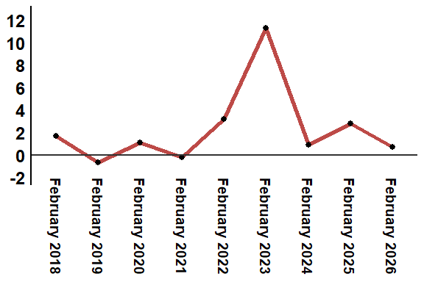
Reading: In February 2026, the consumer price index increased by 0.7% compared to February 2025
6- Annual evolution (%) of the consumer price index for the month of February
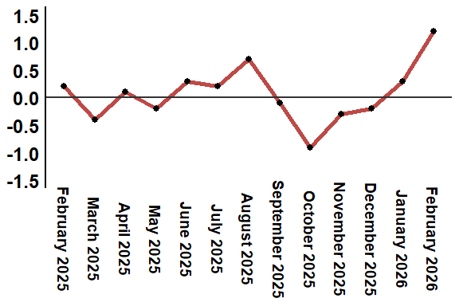
Reading: In February 2026, the consumer price index increased by 1.2% compared to January 2026
Table 3: Consumer price index for the city of Tétouan: February 2026 (2017 base: 100)
Product Divisions | Weightings | Monthly index |  |  |  |  | Variation (%)
 |  | February 2025 | November 2025 | December 2025 | January 2026 | February 2026 | 1 month | 3 months | 12 months
Food products | 40,725 | 134,2 | 130,5 | 130,1 | 131,4 | 134,4 | 2,3 | 3,0 | 0,1
01 – Food products and non-alcoholic | 38,964 | 133,7 | 129,8 | 129,4 | 130,5 | 133,7 | 2,5 | 3,0 | 0,0
02 –Alcoholicbeverages and tobacco | 1,761 | 145,1 | 146,1 | 146,1 | 150,5 | 150,5 | 0,0 | 3,0 | 3,7
Non foodproducts | 59,275 | 111,0 | 112,2 | 112,3 | 112,1 | 112,3 | 0,2 | 0,1 | 1,2
03 – Clothing and shoes | 5,835 | 112,1 | 113,9 | 114,3 | 114,5 | 113,9 | -0,5 | 0,0 | 1,6
04 - Housing, water, gas, electricity and other fuel | 14,202 | 108,7 | 109,4 | 109,4 | 109,5 | 109,5 | 0,0 | 0,1 | 0,7
05- Furniture, household items and routine maintenance of the home | 5,602 | 110,5 | 111,3 | 111,5 | 112,1 | 112,0 | -0,1 | 0,6 | 1,4
06 –Health | 6,594 | 103,5 | 103,5 | 103,5 | 103,5 | 103,4 | -0,1 | -0,1 | -0,1
07 – Transport | 7,416 | 114,5 | 111,4 | 111,2 | 108,1 | 109,4 | 1,2 | -1,8 | -4,5
08 – Communication | 2,560 | 97,8 | 97,2 | 97,1 | 97,1 | 96,8 | -0,3 | -0,4 | -1,0
09 – Leisure and culture | 2,432 | 106,0 | 106,5 | 106,4 | 106,4 | 106,4 | 0,0 | -0,1 | 0,4
10 –Education | 5,358 | 116,8 | 129,5 | 129,5 | 129,5 | 129,5 | 0,0 | 0,0 | 10,9
11 - Restaurants and hotels | 2,468 | 115,1 | 116,0 | 115,8 | 116,6 | 116,6 | 0,0 | 0,5 | 1,3
12 – Variousgoods and services | 6,808 | 119,2 | 119,7 | 119,8 | 120,8 | 121,6 | 0,7 | 1,6 | 2,0
General index | 100,000 | 120,5 | 119,8 | 119,6 | 120,0 | 121,4 | 1,2 | 1,3 | 0,7
Source: High Commission for Planning, Department of Statistics - National consumer price survey

