Information note from the regional directorate of Tangier-Tetouan-Al Hoceima
Consumer price index: city of Tanger
In February 2026, the national consumer price index increased by 1.4% compared to the previous month, while the consumer price index increased by 0.5% over a full year.
The consumer price index experienced an increase of 2.7% during the month of February 2026 compared to the previous month. as a result of the rise in prices of «Fish and Seafood» by 10.7 %, «Fruits» by 6.6 %, «Meat» and «Vegetables» by 3.5 %, «Cafe and Tea and Cocoa» by 2.4 %, «Milk and Cheese and Eggs» by 1.5 %, «Bread and Cereals» by 0.6 %, «Sugar, Jam, Honey and Chocolate and Confectionery» by 0.1 %
Similarly, the monthly variation in the non-food index increased by 0.5% due to price increases in the following divisions: «Miscellaneous Goods and Services» by 3.9 %, «Transportation» by 0.9 %, «Leisure and Culture» by 0.2 %
Over a year, the food product price index decreased by -0.7% in February 2026 compared to February 2025 , due to the decrease in the prices of «Oils and Fats» by -18.4 %, «Meat» by -6.6 %, «Food Products N.C.A.» by -3.1 %, «Milk and Cheese and Eggs» by -2 %, «Mineral Waters, Soft Drinks and Fruit and Vegetable Juices (Nd)» by -0.5 %. Moreover, the rise in prices of «Fish and Seafood» by 18.5 %, «Fruits» by 6.9 %, «Cafe and Tea and Cocoa» by 6.5 %, «Vegetables» by 4 %, «Tobacco» by 3.7 %, «Sugar, Jam, Honey and Chocolate and Confectionery» by 0.3 %, «Bread and Cereals» by 0.2 % and the stagnation in prices for did not affect the general evolution.
On the other hand, the annual variation in the non-food index increased by 1.2%. While the variation in prices of the divisions that make up non-food products fluctuated between a decrease of the division of «Transportation» by -3.1 % and the rise of the division of «Miscellaneous Goods and Services» by 10.8 %
3- Annual evolution (%) of the consumer price index for the month of February
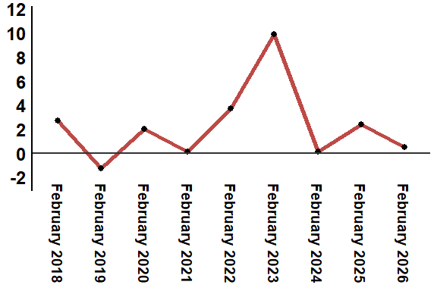
Reading: In February 2026, the consumer price index increased by 0.5% compared to February 2025
4- Annual evolution (%) of the consumer price index for the month of February
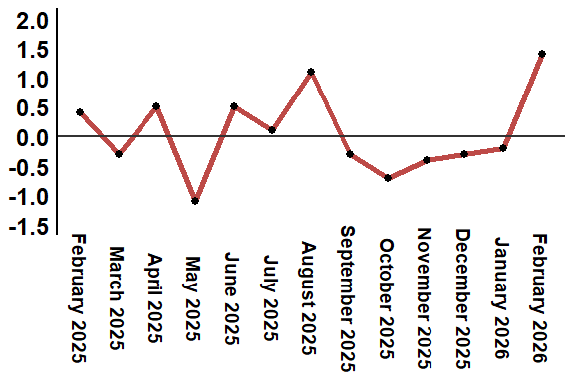
Reading: In February 2026, the consumer price index increased by 1.4% compared to January 2026
Table 4: Consumer price index for the city of Tanger: February 2026 (2017 base: 100)
Product Divisions | Weightings | Monthly index |  |  |  |  | Variation (%)
 |  | February 2025 | November 2025 | December 2025 | January 2026 | February 2026 | 1 month | 3 months | 12 months
Food products | 36,115 | 132,1 | 129,2 | 128,3 | 127,7 | 131,2 | 2,7 | 1,5 | -0,7
01 – Food products and non-alcoholic | 34,708 | 131,6 | 128,5 | 127,6 | 126,8 | 130,4 | 2,8 | 1,5 | -0,9
02 –Alcoholicbeverages and tobacco | 1,407 | 144,4 | 145,4 | 145,4 | 149,7 | 149,7 | 0,0 | 3,0 | 3,7
Non foodproducts | 63,885 | 112,0 | 112,7 | 112,8 | 112,8 | 113,4 | 0,5 | 0,6 | 1,3
03 – Clothing and shoes | 6,449 | 113,1 | 113,6 | 113,6 | 113,7 | 113,7 | 0,0 | 0,1 | 0,5
04 - Housing, water, gas, electricity and other fuel | 16,656 | 110,8 | 111,7 | 111,8 | 111,9 | 111,8 | -0,1 | 0,1 | 0,9
05- Furniture, household items and routine maintenance of the home | 4,100 | 109,1 | 112,5 | 112,5 | 112,5 | 112,1 | -0,4 | -0,4 | 2,7
06 –Health | 8,218 | 109,3 | 109,3 | 109,3 | 109,3 | 109,3 | 0,0 | 0,0 | 0,0
07 – Transport | 9,751 | 117,4 | 114,7 | 114,7 | 112,8 | 113,8 | 0,9 | -0,8 | -3,1
08 – Communication | 3,199 | 103,4 | 101,4 | 101,4 | 101,4 | 101,4 | 0,0 | 0,0 | -1,9
09 – Leisure and culture | 2,350 | 104,4 | 104,7 | 105,1 | 105,0 | 105,2 | 0,2 | 0,5 | 0,8
10 –Education | 5,047 | 110,9 | 113,4 | 113,4 | 113,4 | 113,4 | 0,0 | 0,0 | 2,3
11 - Restaurants and hotels | 1,280 | 125,7 | 126,6 | 126,6 | 127,1 | 127,1 | 0,0 | 0,4 | 1,1
12 – Variousgoods and services | 6,835 | 115,8 | 121,0 | 121,3 | 123,5 | 128,3 | 3,9 | 6,0 | 10,8
General index | 100,000 | 119,4 | 118,8 | 118,5 | 118,3 | 120,0 | 1,4 | 1,0 | 0,5
Source: High Commission for Planning, Department of Statistics - National consumer price survey

