Information note from the regional directorate of Tangier-Tetouan-Al Hoceima
Consumer price index: city of Al Hoceima
In February 2026, the national consumer price index increased by 0.7% compared to the previous month, while the consumer price index decreased by -0.2% over a full year.
The consumer price index experienced an increase of 1.1% during the month of February 2026 compared to the previous month. as a result of the rise in prices of «Fish and Seafood» by 7.8 %, «Fruits» by 4.5 %, «Meat» by 3.3 %, «Food Products N.C.A.» by 0.1 %
Similarly, the monthly variation in the non-food index increased by 0.2% due to price increases in the following divisions: «Miscellaneous Goods and Services» by 1 %, «Transportation» and «Restaurants and Hotels» by 0.4 %
Over a year, the food product price index decreased by -0.4% in February 2026 compared to February 2025 , due to the decrease in the prices of «Oils and Fats» by -23.6 %, «Meat» by -5.1 %, «Milk and Cheese and Eggs» by -5 %, «Mineral Waters, Soft Drinks and Fruit and Vegetable Juices (Nd)» by -2.1 %, «Bread and Cereals» by -1.9 %, «Food Products N.C.A.» by -1 %. Moreover, the rise in prices of «Fish and Seafood» by 18.6 %, «Vegetables» by 11.8 %, «Cafe and Tea and Cocoa» by 8.4 %, «Tobacco» by 4.7 %, «Fruits» by 2.1 %, «Sugar, Jam, Honey and Chocolate and Confectionery» by 0.5 % and the stagnation in prices for did not affect the general evolution.
Similarly, the annual variation in the non-food index decreased by -0.1%. While the variation in prices of the divisions that make up non-food products fluctuated between a decrease of the division of «Transportation» by -5.6 % and the rise of the division of «Miscellaneous Goods and Services» by 3.6 %
1- Annual evolution (%) of the consumer price index for the month of February
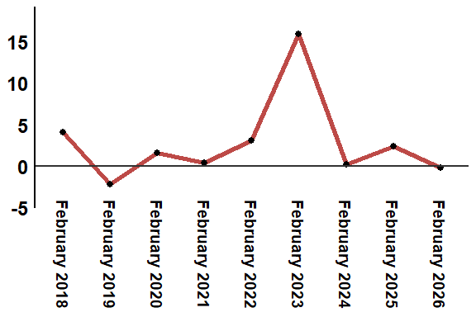
Reading: In February 2026, the consumer price index decreased by -0.2% compared to February 2025
2- Annual evolution (%) of the consumer price index for the month of February
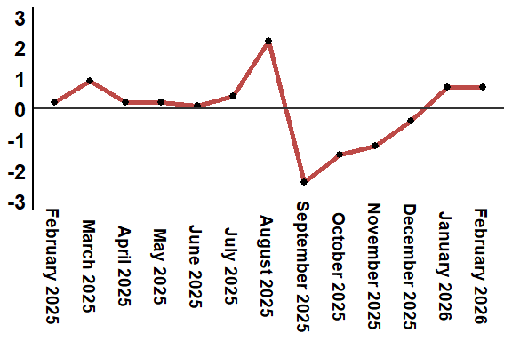
Reading: In February 2026, the consumer price index increased by 0.7% compared to January 2026
Table 2: Consumer price index for the city of Al Hoceima: February 2026 (2017 base: 100)
Product Divisions | Weightings | Monthly index |  |  |  |  | Variation (%)
 |  | February 2025 | November 2025 | December 2025 | January 2026 | February 2026 | 1 month | 3 months | 12 months
Food products | 49,716 | 138,3 | 135,3 | 134,1 | 136,2 | 137,7 | 1,1 | 1,8 | -0,4
01 – Food products and non-alcoholic | 48,371 | 138,0 | 134,9 | 133,6 | 135,6 | 137,2 | 1,2 | 1,7 | -0,6
02 –Alcoholicbeverages and tobacco | 1,345 | 148,9 | 150,1 | 150,8 | 156,3 | 156,3 | 0,0 | 4,1 | 5,0
Non foodproducts | 50,284 | 109,8 | 109,6 | 109,8 | 109,5 | 109,7 | 0,2 | 0,1 | -0,1
03 – Clothing and shoes | 5,155 | 118,5 | 117,3 | 117,5 | 117,5 | 117,4 | -0,1 | 0,1 | -0,9
04 - Housing, water, gas, electricity and other fuel | 11,732 | 105,5 | 106,9 | 106,9 | 107,1 | 107,1 | 0,0 | 0,2 | 1,5
05- Furniture, household items and routine maintenance of the home | 3,094 | 113,4 | 113,1 | 113,0 | 112,9 | 112,8 | -0,1 | -0,3 | -0,5
06 –Health | 6,413 | 98,8 | 98,8 | 98,8 | 99,1 | 99,1 | 0,0 | 0,3 | 0,3
07 – Transport | 7,704 | 121,1 | 116,2 | 116,8 | 113,9 | 114,3 | 0,4 | -1,6 | -5,6
08 – Communication | 2,892 | 101,6 | 101,4 | 101,4 | 101,4 | 101,4 | 0,0 | 0,0 | -0,2
09 – Leisure and culture | 1,933 | 95,0 | 94,9 | 96,4 | 97,0 | 97,0 | 0,0 | 2,2 | 2,1
10 –Education | 3,842 | 114,1 | 114,8 | 114,8 | 114,8 | 114,8 | 0,0 | 0,0 | 0,6
11 - Restaurants and hotels | 2,258 | 110,1 | 113,2 | 113,3 | 112,8 | 113,3 | 0,4 | 0,1 | 2,9
12 – Variousgoods and services | 5,261 | 112,3 | 114,3 | 114,4 | 115,1 | 116,3 | 1,0 | 1,7 | 3,6
General index | 100,000 | 124,2 | 122,6 | 122,1 | 123,0 | 123,9 | 0,7 | 1,1 | -0,2
Source: High Commission for Planning, Department of Statistics - National consumer price survey

