**Medical Report: Paracetamol in Pediatrics and**

**Adults**

Paracetamol, also known as acetaminophen, is one of the most commonly used medications

worldwide. It is widely prescribed for pain relief and fever management in both children and adults.



**Paracetamol Usage in Children**

In pediatric medicine, liquid suspensions of paracetamol are commonly prescribed. They are dosed

according to the child's weight, making them safe and effective when used appropriately. They are

particularly important in managing fever in infants and young children.



**Paracetamol Formulations**

Paracetamol is available in multiple formulations including tablets, capsules, and syrups. This

makes it adaptable for both pediatric and adult use. Extended-release forms are also available for

prolonged pain relief.

**Formulation**

**Advantages**

**Limitations**

Syrup

Easy for children, weight-based dosing

Shorter duration, taste issues

Tablets

Convenient, precise dose

Difficult for children under 6

Capsules

Portable, stable

Not suitable for very young children

Extended-release

Longer effect, fewer doses

Risk of overdose if misused

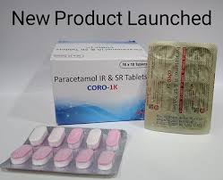

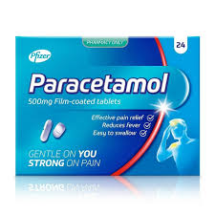

**Conclusion**

Paracetamol remains a cornerstone in the management of pain and fever across all age groups. Its

availability in multiple formulations ensures accessibility and convenience for both healthcare

providers and patients. However, appropriate dosing is critical to avoid toxicity.

