1)Calc:

a)Create 2 buttons that will move your text(label,textbox,exc)

b)Change the **FONT SIZE** of the text by using **TrackBar**

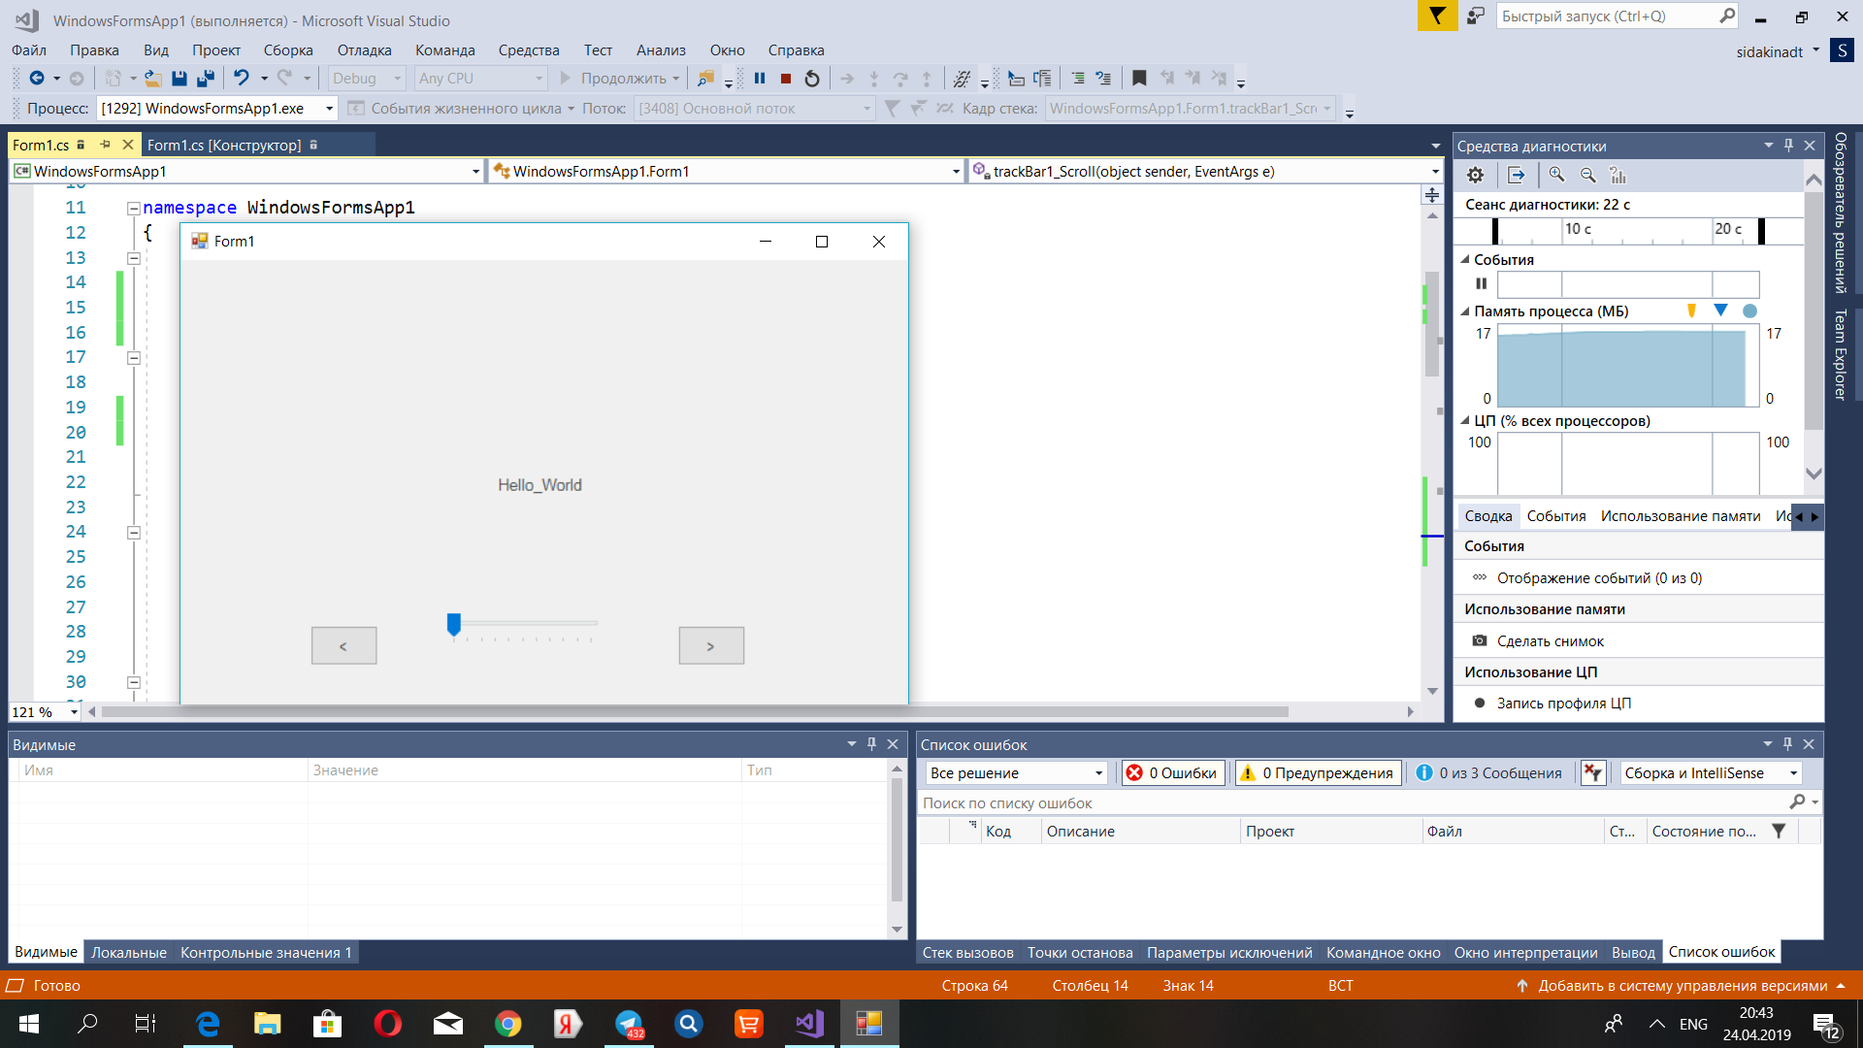

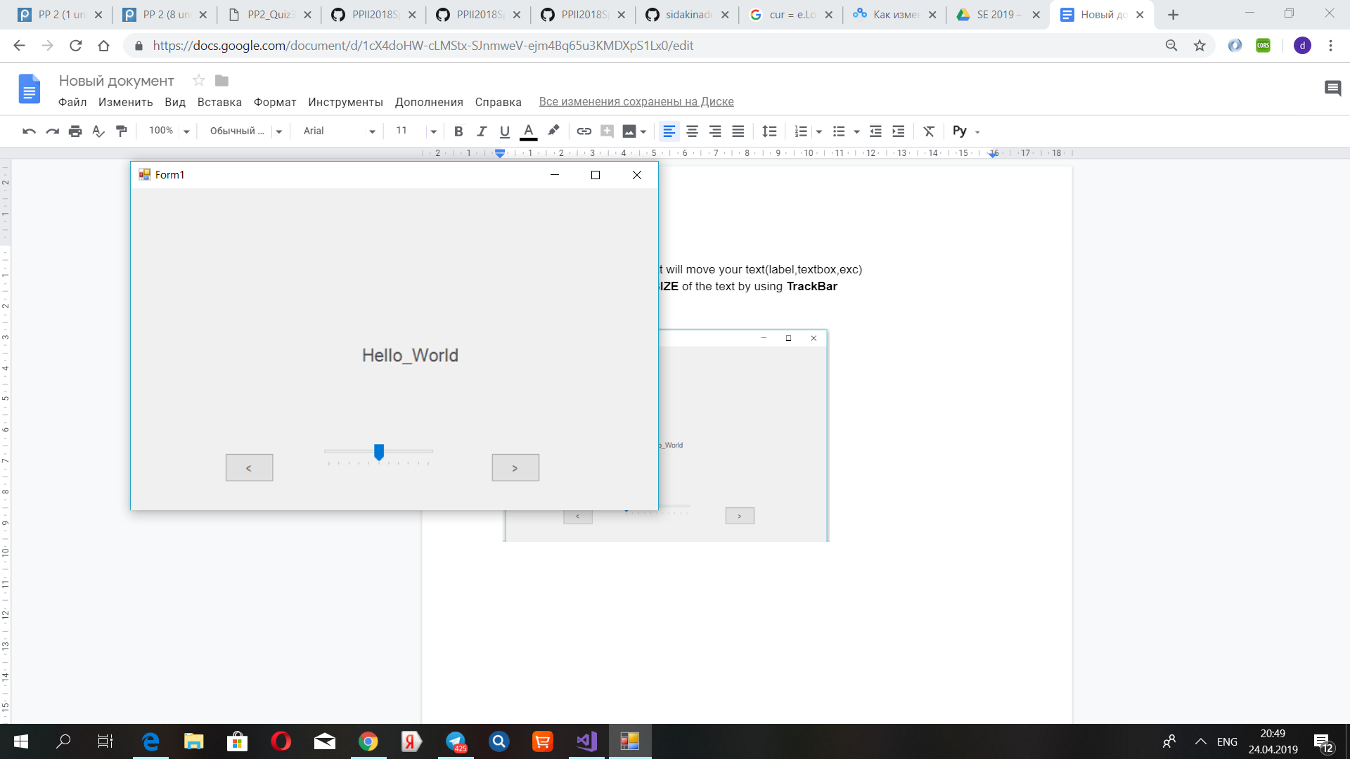

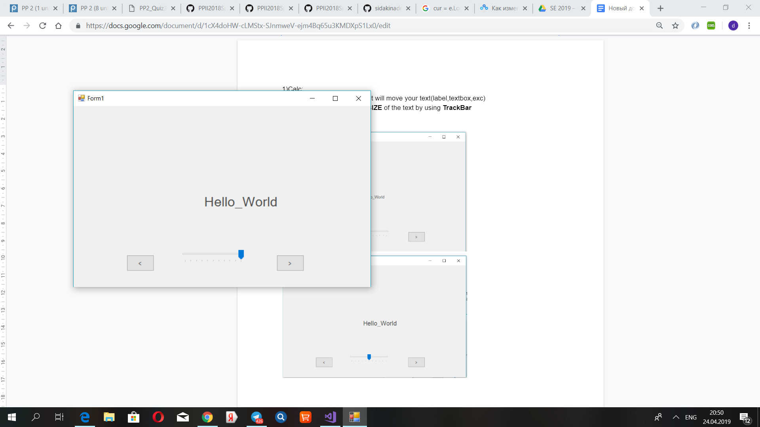

2)Graphics:

You should create button and picturebox;

a)In picturebox there should be 5 circles.

b)If you press the button, circles will start move to random position every 1 second. You do not to need check collision between circles.

c)If you click the picturebox the colors of picturebox and circle should become other colors

.