Technical Report
Team Members
Zhumanova Zhanel - 22B030544
Zeinolla Dilnaz – 22B0331177
Olzhas Sengaliyev - 23B151050

1. API Justification
We selected **CoinGecko API** (endpoint: `https://api.coingecko.com/api/v3/coins/markets`) for our data pipeline. After evaluating several options, we chose cryptocurrency data because it's dynamic , provides rich information (250+ coins with prices, volumes, market caps), has free API access suitable for demo projects, and represents real-world financial data pipelines used in industry.
2. Kafka Topic Schema
Topic: crypto_raw_events | Broker: kafka:29092
Message structure :
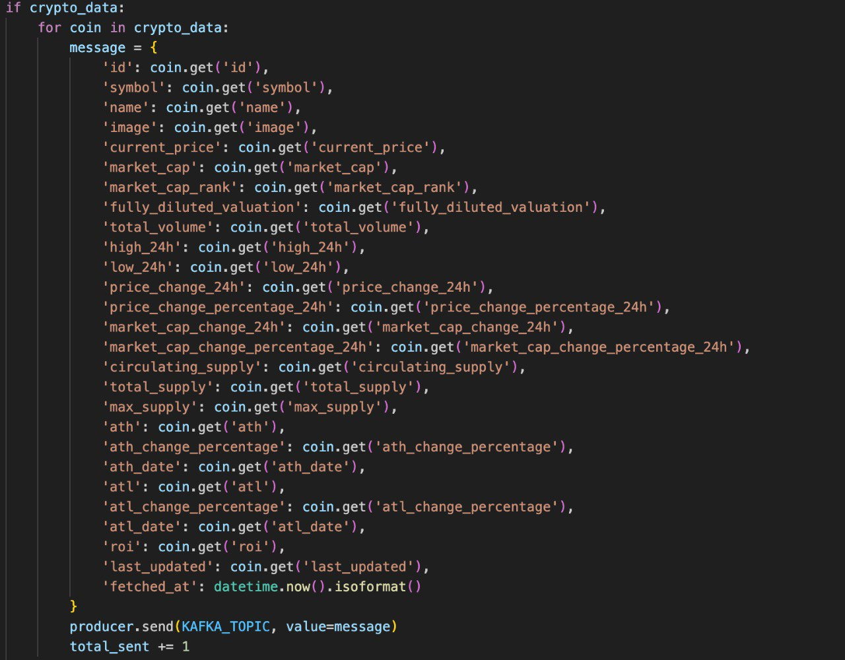

3. Data Cleaning Rules
We implemented six Pandas-based cleaning operations:
1. Drop incomplete records- Remove entries missing critical fields
2. Fill missing numerics - Replace NaN values with 0 for fields like `market_cap`, `total_volume`
3. Standardize text - Normalize coin IDs to lowercase, symbols to UPPERCASE
4. Convert timestamps- Parse timestamp strings to datetime objects for `last_updated`, `ath_date`, `atl_date`
5. Remove duplicates - Sort by timestamp and keep latest version of each `(coin_id, last_updated)` pair
6. Validate prices - Filter negative prices, prices over $1B, and negative market cap ranks

4. SQLite Database Schema
Table 1: events (stores cleaned cryptocurrency data)
Table 2: daily_summary
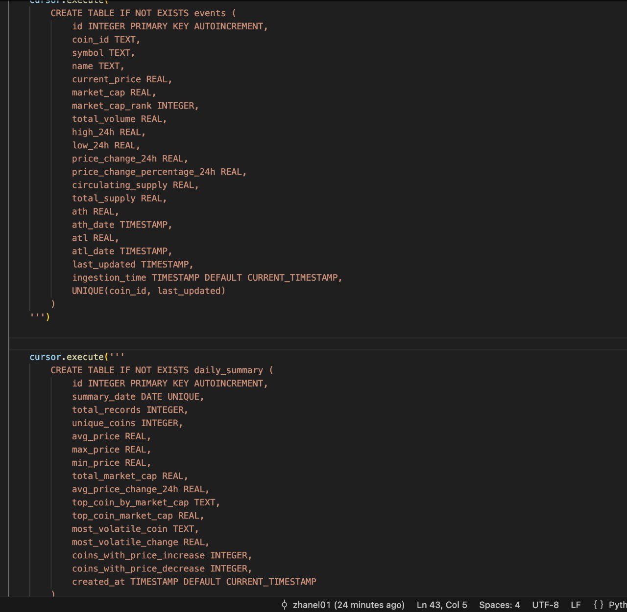
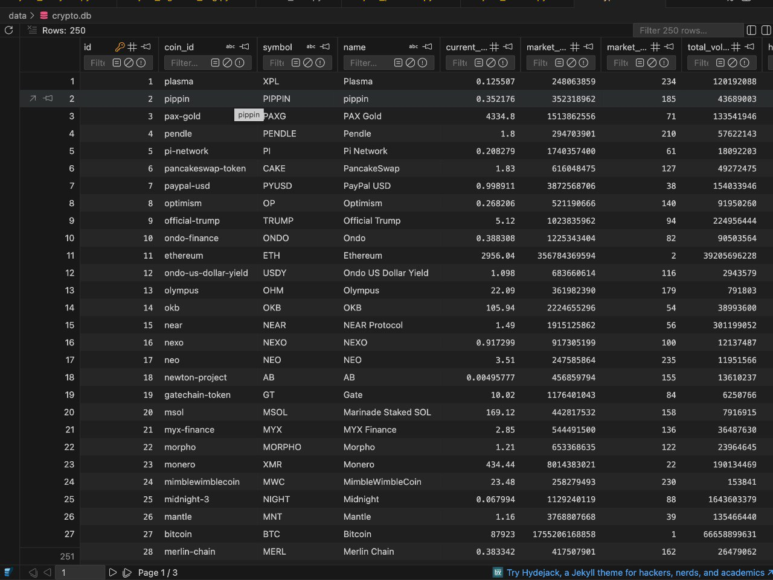
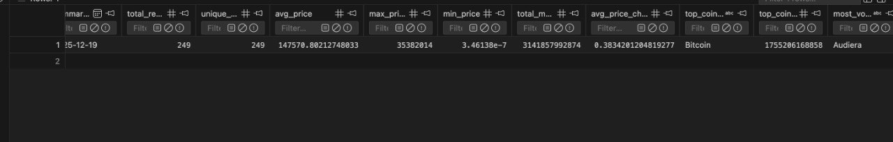
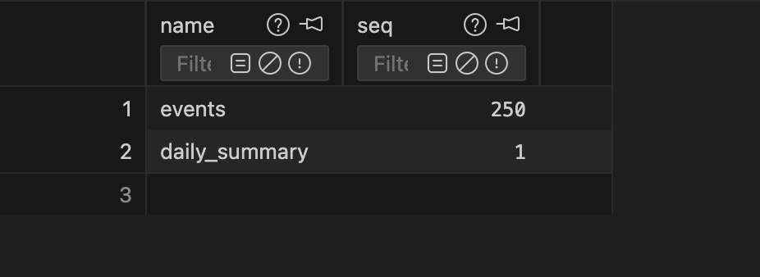
5. Pipeline Architecture & DAGs
DAG 1: job1_crypto_continuous_ingestion (1-2 minute)
- Fetches crypto data for 2 minutes, sends around 250 messages to Kafka
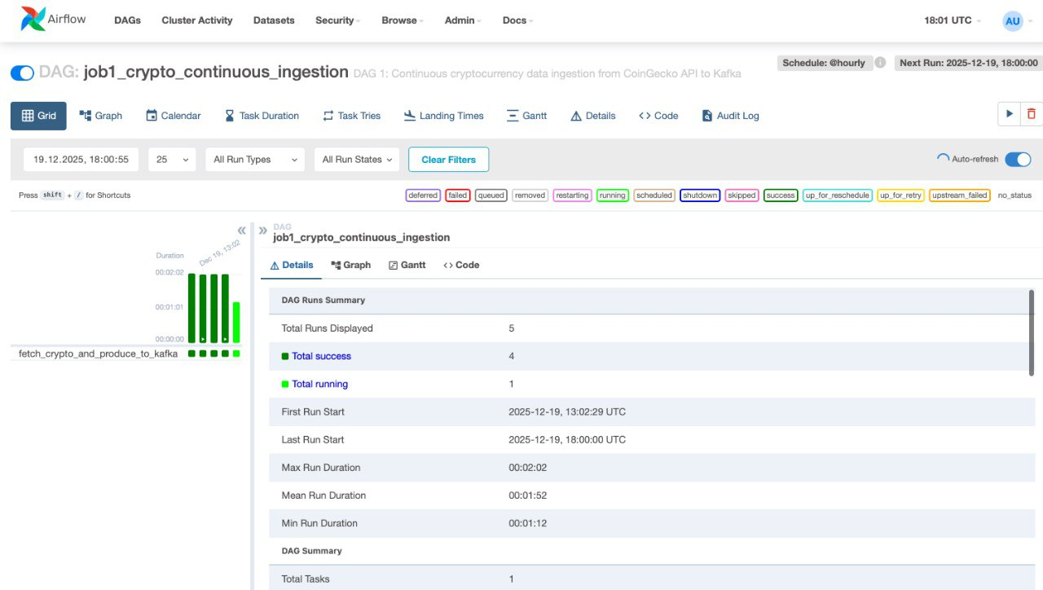
DAG 2: job2_crypto_hourly_cleaning (hourly)
- Consumes Kafka messages, applies cleaning rules, inserts into events table
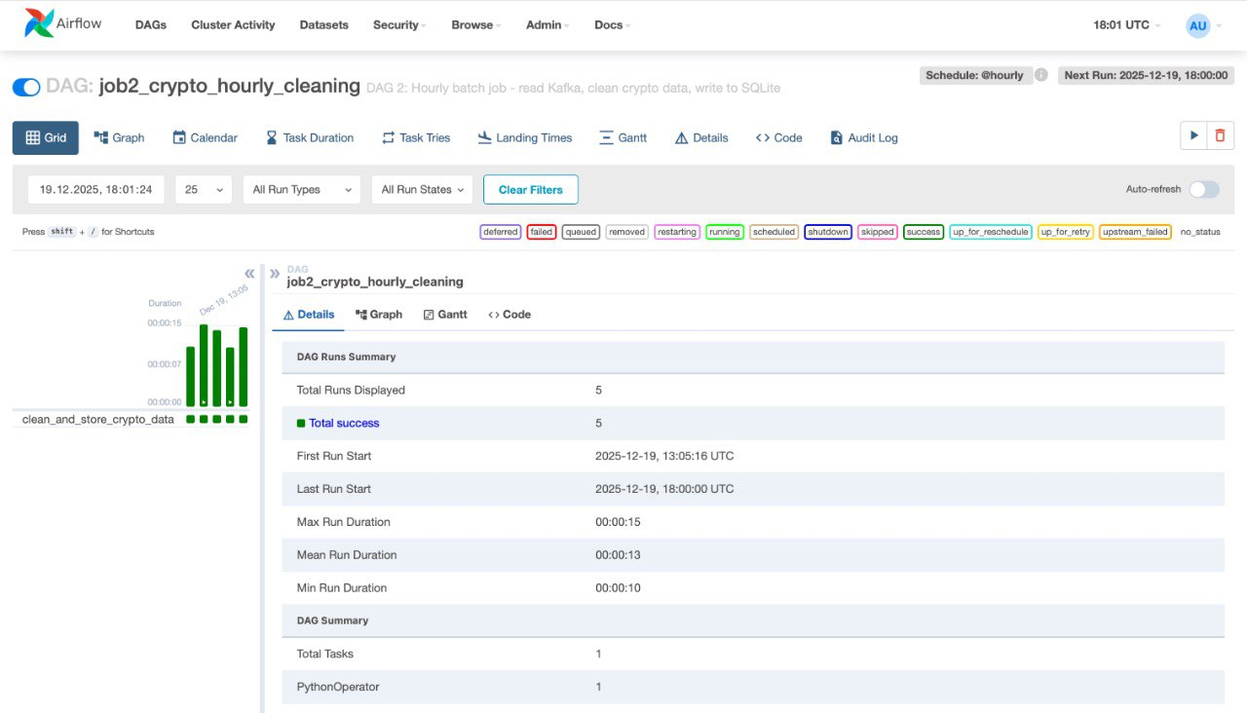
DAG 3: job3_crypto_daily_analytics (daily)
- Reads previous day's records, computes statistics, stores in daily_summary
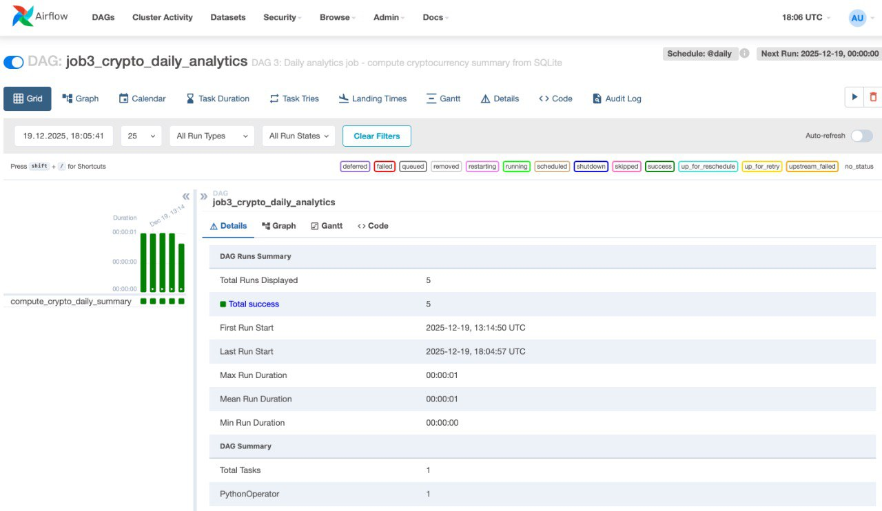
6. Screenshots & Verification
