**Exact Text of Reviewer’s comments**

“The Authors propose a hybrid modeling approach to upscale fractured rock reservoirs comprised of discrete fracture networks embedded within a porous rock matrix of constant permeability. An effective partitioning size is both semi-analytically and numerically determined to define the level of upscaling achievable while still maintaining the necessary network structure to match simulated equivalent permeability and flow rates/pressure changes. This Authors developed and tested this methodology using numerical simulations comprised of three-dimensional DFNs with synthetic properties and a two-dimensional DFN parameterized by (mostly) field measurements.

Overall, I find some of the results interesting and the manuscript well written and organized. Yet, I do not believe the manuscript is suitable for publication in Geophysical Research Letters for the following reasons: (1) the upscaling methodology is not sufficiently novel or high-impact, and the level of upscaling is ambiguous, (2) the length-aperture correlation is too closely connected to the main hypothesis of the upscaling method, and (3) lack of sufficient detail for the Reader to fully understand and grasp the methods and findings of the work. These three points are further discussed below.

First, the Authors heavily rely on Effective Medium Theory (EMT) which is poorly defined in the manuscript. The EMT symmetric self-consistent EMT and asymmetric EMT functions proposed by Saevik et al. (2013) were used to semi-analytically generate Ke/Km versus partitioning size. The Reader is left in the dark as to how these trends are generated and what symmetric self-consistent and asymmetric functions are other than a reference to Saevik. This leaves many questions such as the functional form used [i.e., there are at least three different forms of these functions in Saevik et al. (2013), the Authors are likely using eqns (60) and (61)], how the parameters in these two functions are defined, and finally how the functions are solved. The applicability of the analytical EMT is endorsed in Section 4.2 and in the Conclusions, so this is a large aspect of the work that deserves its own Section to definitely address these details. There is also mention that some Ke/Km trends in Figure 1 better follow either the symmetric or asymmetric trends better, and the Authors do not attempt to explain the reason for this.

For the numerical simulations, the DFN and subsets of the DFN are embedded into a low permeability rock matrix using the Embedded Discrete Fracture Model option in the Matlab Reservoir Simulation Tool. The fractures included in the DFN subsets are at or above a partitioning size. The process is termed "Fracture Subset Upscaling" in the manuscript, and also refers to the semi-analytical EMT functions. The sizes of fractures included in the DFN subsets are changed until a threshold value is reached and an optimal "partitioning size" is achieved.

The primary differences between past studies and the upscaling method proposed by the Authors is that: (1) equivalent permeability and flow within the simulations are only accounted for fractures that are at or above the length-scale of the partitioning size, neglecting contributions from smaller fractures and (2) a hydraulic backbone is not defined prior to meshing. Similar types of decisions are also made in some of the fracture continuum modeling approaches (another hybrid approach) where fracture transmissivity is only accounted for fractures that span a grid cell. Another similar upscaling approach was proposed by Roubinet et al. (2010) who mapped flow contributions from smaller sub-grid fractures to nodes along a grid face, essentially forming an upscaled and geometrically reorganized DFN. All DFN techniques themselves require setting a lower cutoff limit to fracture size, and many of the times this is based on a combination of the resolution of the fracture data collected in the field and simulation scale to balance computational constraints. The tools and methods used in the manuscript are not developed by the authors and the work presented only provide an incremental advance or variation that is not sufficiently novel for GRL.

The use of a linear relationship between fracture size and aperture is problematic. First, a linear relationship: 1.75e-5 and 3.5e-5 is implemented by the Authors to assign aperture on the basis of fracture size in the 3D and 2D simulations, respectively. A citation supporting this decision is not provided. Given the influence of the stress field, it is unlikely that fractures of all orientations will experience this relationship due to different amounts of stress acting normal to the fracture plane.

It is also unclear why this relationship differs for the 2D and 3D cases. The relations used in this paper lead to apertures on the order of 87.5 microns (for 5 m radius) and 350 microns (for 20 m radius) for the 3D networks; the 2D case appears to have some very long fractures such that a 100 m long fracture corresponds to a fracture aperture of around 2 mm! The proposed relation leads to unrealistically high apertures as hydraulic (cubic law) apertures obtained from borehole testing are typically more in the range between 50 and 350 microns from personal experience; but certainly not millimeters. Also note that the square dependence of aperture and permeability in the cubic law further enlarges differences in flow contributions for fractures on the basis of length - see next point below.

The Authors' proposed method revolves around removing shorter fractures until an ideal partitioning size is reached. The use of the linear relation between length and aperture creates a very distinct flow (and permeability) hierarchy that feeds directly into the primary hypothesis or assumption of the upscaling methodology: shorter fractures are less hydraulically important than longer fractures. While longer fractures tend to dominate the connectivity structure of a network, shorter fractures can also be hydraulically important particularly when they provide critical connectivity (i.e., critical links) within network structures and/or have large apertures.

Uncorrelating fracture length and aperture, by randomly assigning aperture values from the same range used in the simulations, will likely lead to different results; mainly, that the fracture network subset corresponding to the ideal partitioning scale will more closely represent the geometry to the hydraulic backbone since percolation effects were observed when defining equivalent permeability, and that the partitioning size will likely decrease since smaller fractures can are now more hydraulically important. The ideal partitioning size assigned to 3D Cases A through D appear to be 7.5, 6.25, and 6.25 and 7.5 m, respectively, with Cases B and D (6.25 m) being sufficiently more connected. These ideal partitioning sizes for these Cases are not significantly greater than the lower radii cutoff of 5 m defined in the power-law size distribution. How many fractures do these higher partitioning sizes eliminate from the simulations? What type of numerical efficiency results from the exclusion of the smaller fractures? How much different is the upscaling DFN subset than the hydraulic backbone? How many disconnected fractures remain embedded in the matrix at the optimal partitioning scale?

It is very difficult for the Reader to distinguish the level of upscaling occurring for the cases presented in the manuscript because the hydraulic backbone is undefined. It is understandable why the hydraulic backbone is undefined as the matrix (although kmatrix is only 1 mD) contributes to flow in the embedded model, but again, isolation of the hydraulic backbone is fairly standard practice for DFN modeling and many hybrid upscaling approaches, and could potentially yield valuable insight into the observed percolation threshold behavior and help to define the level of upscaling.

Addressing these types of concerns would better help the Reader understand the significance of the proposed upscaling.

Some comments about the DFN models:

• Assigning a power-law of fracture length is appropriate, yet allowing fracture length to vary between 10 to 40 m does not provide the scaling and connectivity that power-law distributions typically impart on a network.

• The scale of the simulations is listed in the supplemental information but absent from the manuscript.

• The orthogonality of the three fracture sets in the 3D DFN provides a significantly more homogenized network structure amenable for upscaling on continuum grids.

Other comments:

• The FSU approach is central to the method, a figure illustrating this approach would be helpful for the Reader.

• Lines 225-227: concepts of symmetric self-consistent EMT and asymmetric EMT are mentioned, but not defined. These are important details that need to be thoroughly addressed.

• All of the figures are too small and difficult to read in the high-resolution pdf.

As a minor note, the Authors over-used of acronyms in a short, communications style manuscript. The Reader is exposed to NFR, EMT, DFN, EDFM, MRST, FSU in less than 3 pages.

Connectivity‐consistent mapping method for 2‐D discrete fracture networks

D Roubinet, JR de Dreuzy, P Davy - Water Resources Research, 2010”

**Point-by-point Response to Review**

Reviewer 1’s comments contain three main points and several small comments. Please find below our response to each other points:

1. *Reviewer does not consider the work to be novel*   
   Admittedly, we did not provide enough details to adequately delineate our work from previous approaches. In particular, we should emphasize that we are focusing on fractured porous media where flow occurs in both fractures and host rock at different timescales. This is different from the case of flow in a fractured but impermeable media, which the reviewer drew many concepts from in his/her feedback.   
     
   Reviewer 1’s main critique would hold true if we were presenting work on fracture networks in impermeable media. Indeed, we are fully aware of concepts applied in this context with respect to hydraulic backbone of the network etc. However, for a permeable rock matrix the role of the hydraulic backbone is – as far as we are aware – unclear. This motivates our research. Obviously, we should have pointed this out more prominently to avoid the confusion.  
     
   We have updated our manuscript to highlight this better (Lines 51-140 in the redlined manuscript with tracked changes).
2. *Insufficient details on the Effective Medium Theory*  
   The reviewer pointed out correctly that the Effective Medium Theory (EMT) was poorly defined in the manuscript. We are glad to improve on this (Lines 210-227 in the redlined manuscript with tracked changes).
3. *Problematic assumption of linear aperture-size relationship*  
   The reviewer challenged our use of a linear relationship between fracture size and aperture and suggested that randomly assigning apertures will likely lead to different results. While we did not consider this exact approach, we previously did case studies with constant apertures and reached the same findings as our other studies. We chose not to include this in the manuscript as we felt that a de-correlated aperture-size relationship is unrealistic. Instead, in the supplementary information, we provided two extra case studies with square and square root relationships to show that the findings are undisturbed by the choice of correlation.   
     
   If needed, we are glad to include the constant aperture case study (See Figures 1 and 2 in this document).  
     
   Two related issues raised were with regards to the aperture and size ranges of the DFNs used. Our aperture range is designed to be around 1mm. This is based on the order of magnitude studied in a paper by Bisdom et al. (2015). We have clarified this in the manuscript (Line 177 in redlined manuscript). In terms of the size range, our goal was to study hybrid modelling in the context of a polydisperse fracture network which can follow any size distribution. While 10-40m is a small range, we feel that this does not invalidate the use of a power-law distribution. We have updated our manuscript to cite Ebigbo et al. (2016) who used a power law distribution on a size range of 8-40m (Line 173 in redlined manuscript).
4. *Various Small comments*
   1. *Scale of simulations absent from the manuscript*  
      The scale of the simulations is now included in the manuscript (Lines 168 and 189 in redlined manuscript).
   2. *Orthogonal fracture sets make upscaling easier*  
      While the 3D DFNs have orthogonal fracture sets, we have also studied 2D realistic outcrop trace maps that do not exhibit the same orthogonality.
   3. *Illustration of the Fracture Subset Upscaling approach would be helpful*  
      An illustration of the FSU approach is now provided in the supplementary information (See Figure S4 in Supporting Information).
   4. *Effective Medium Theory needs to be defined*Addressed in point 2.
   5. *Figures are too small*  
      Figures in the manuscript have been enlarged.
   6. *Overuse of acronyms*Established acronyms like DFN, EDFM, DFM are retained. NFR, EMT and MRST have been removed. The only author defined acronym left is FSU.

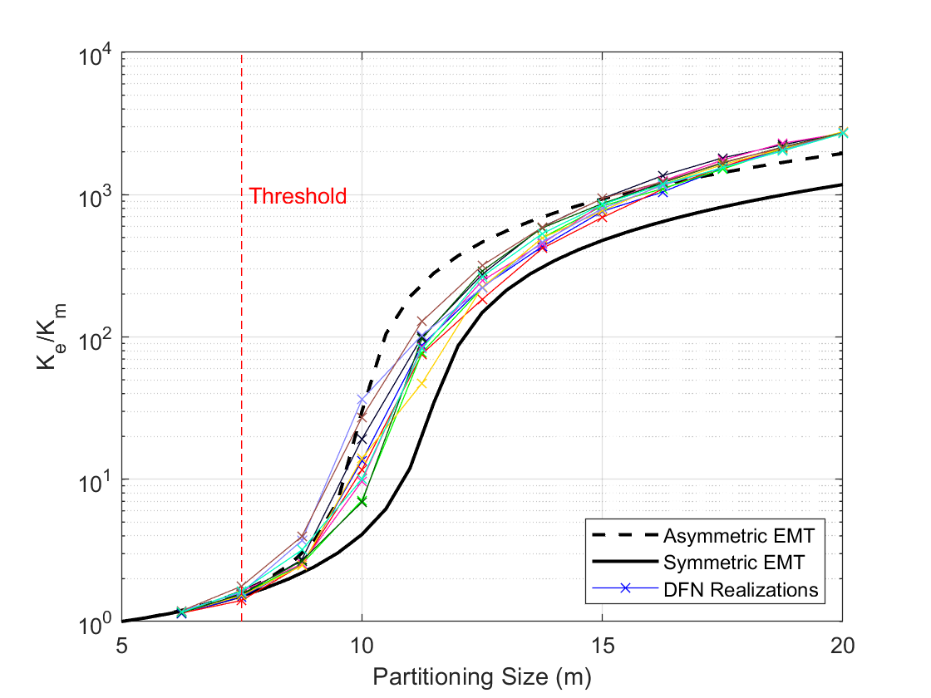

Figure 1: Fracture Subset Upscaling for 3D DFNs containing fractures ranging from 10m to 40m in diameter but having a constant aperture of 1.225mm. The effective permeavility-partitioning size relationship shows a rapid increase starting from a threshold of 7.5m. This is similar to all the other cases presented in the manuscript.

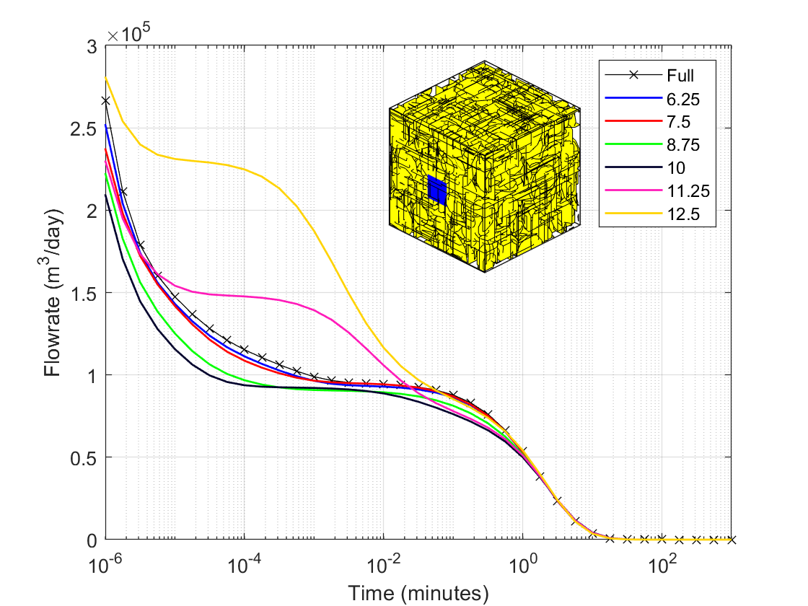

Figure 2: Drawdown curves for fully resolved and hybrid models. Apertures are fixed for all fractures. The matrix permeabilities in the hybrid models are enhanced beyond the original matrix permeability due to the integration of small fractures into the background permeability. Beyond a partitioning size of 7.5m, hybrid model results begin to deviate from the fully resolved model solution. This is again consistent with the findings shown in the manuscript for all the other cases.