

*Geophysical Research Letters*

Supporting Information for

**Partitioning Thresholds in Hybrid Implicit and Explicit Representations of Naturally Fractured Reservoirs**

Daniel Wong1, Florian Doster1, Sebastian Geiger1, Arjan Kamp2

1Institute of Petroleum Engineering, Heriot-Watt University  
2Total S.A.

**Contents of this file**

Text S1

Table S1

Figures S1, S2 and S3

**Introduction**

Additional numerical studies performed that corroborate the findings in the paper are presented here. In addition to the four 3D cases presented in the paper, we present here nine other cases. The properties for these nine cases are discussed in Text S1 and summarized in Table S1. The results of Fracture Subset Upscaling (FSU) and drawdown simulations are shown in Figures S1 and S2.

For the outcrop based datasets – Apodi 2 and 4, we also performed additional well test simulations by using different well positions. The results are shown in Figure S3.

Text S1.

The main controls for 3D DFN generation, as discussed in the paper, are:

1. Fracture density per fracture set, – cumulative fracture area per unit volume.
2. Power law size distribution, with and , where is fracture size and is the number of fractures.
3. Domain size, , where the DFN is generated in a real space.
4. Aperture-size relationship, .
5. Shape of the fractures – set to be circular.
6. Three orthogonal fracture sets.

We analyzed 13 cases by varying , , , , and individually. The parameter values used are shown in Table S1. For each case, FSU curves are produced numerically and analytically. Four of the cases have been presented in the paper. Figure S1 shows the FSU curves for the remaining cases.

Numerical studies were also performed to compare drawdown simulation results of hybrid and full non-upscaled models for each case. The results are shown in Figure S2.

Table S1. Parameters used for 3D DFN generation.*

|  |  |  |  |  |  |  |  |
| --- | --- | --- | --- | --- | --- | --- | --- |
| **Case** |  |  |  |  |  |  | **Remarks** |
| **1 (A)** | 0.150 | 1.50 | 5.0 | 20 | 100 | 1 | Base parameters |
| **2** | 0.075 | 1.50 | 5.0 | 20 | 100 | 1 |  |
| **3 (B)** | 0.300 | 1.50 | 5.0 | 20 | 100 | 1 |  |
| **4** | 0.150 | 0.75 | 5.0 | 20 | 100 | 1 |  |
| **5 (C)** | 0.150 | 3.00 | 5.0 | 20 | 100 | 1 |  |
| **6** | 0.150 | 1.50 | 2.5 | 20 | 100 | 1 |  |
| **7 (D)** | 0.150 | 1.50 | 10.0 | 20 | 100 | 1 |  |
| **8** | 0.150 | 1.50 | 5.0 | 10 | 100 | 1 |  |
| **9** | 0.150 | 1.50 | 5.0 | 40 | 100 | 1 |  |
| **10** | 0.150 | 1.50 | 5.0 | 20 | 50 | 1 |  |
| **11** | 0.150 | 1.50 | 5.0 | 20 | 150 | 1 |  |
| **12** | 0.150 | 1.50 | 5.0 | 20 | 100 | 0.5 |  |
| **13** | 0.150 | 1.50 | 5.0 | 20 | 100 | 2 |  |

*Cases 1, 3, 5 and 7 correspond to Cases A, B, C and D in the paper. See Text S1 for definition of terms.

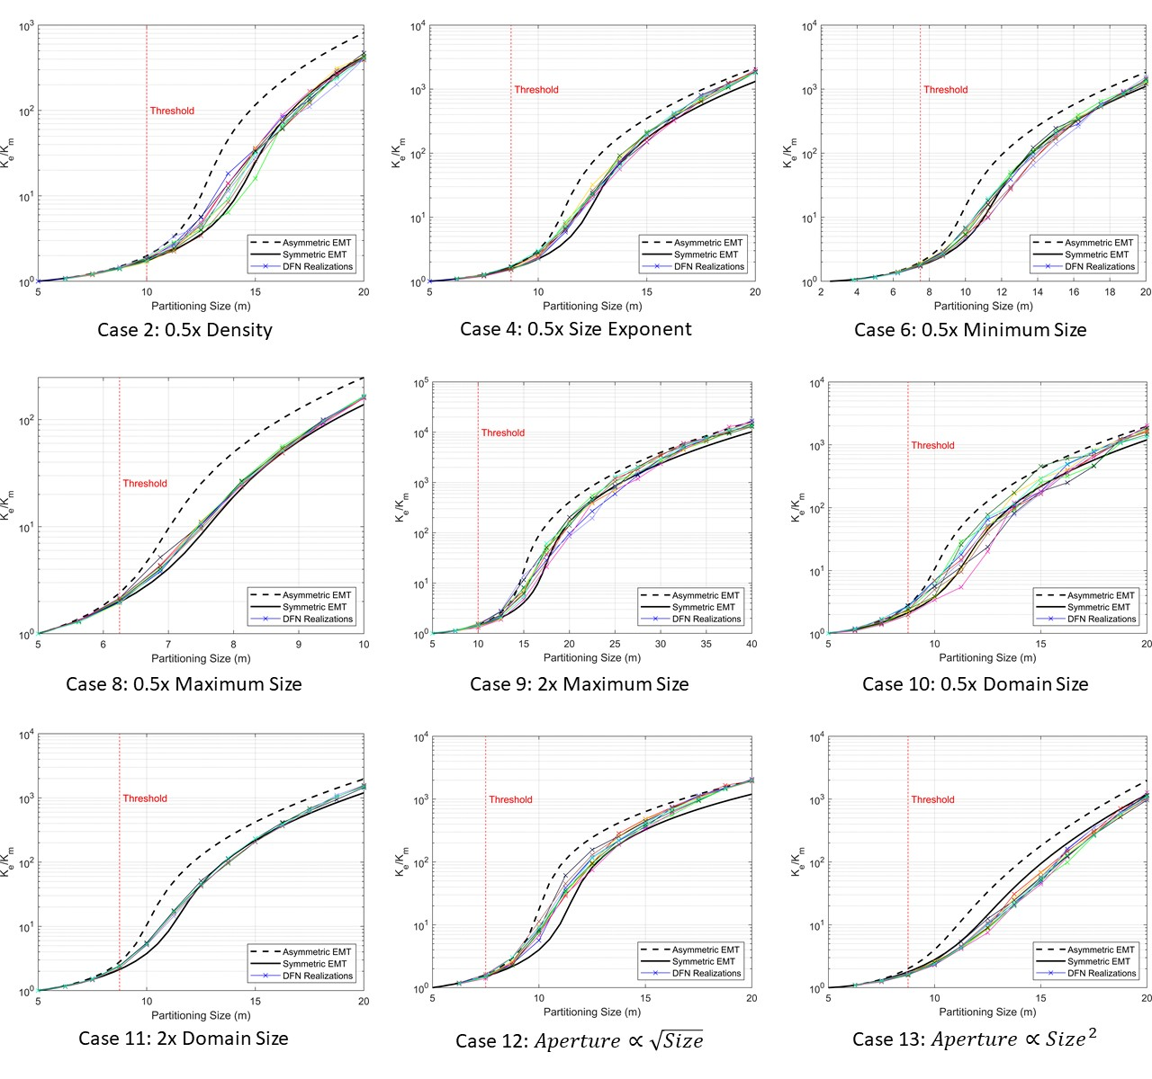

Figure S1. Fracture Subset Upscaling results for the cases shown in Table S1. Cases 1, 3, 5 and 7 are shown in Figure 1 in the paper. Partitioning sizes that are above the labelled threshold produce hybrid models that are inaccurate according to Figure S2.

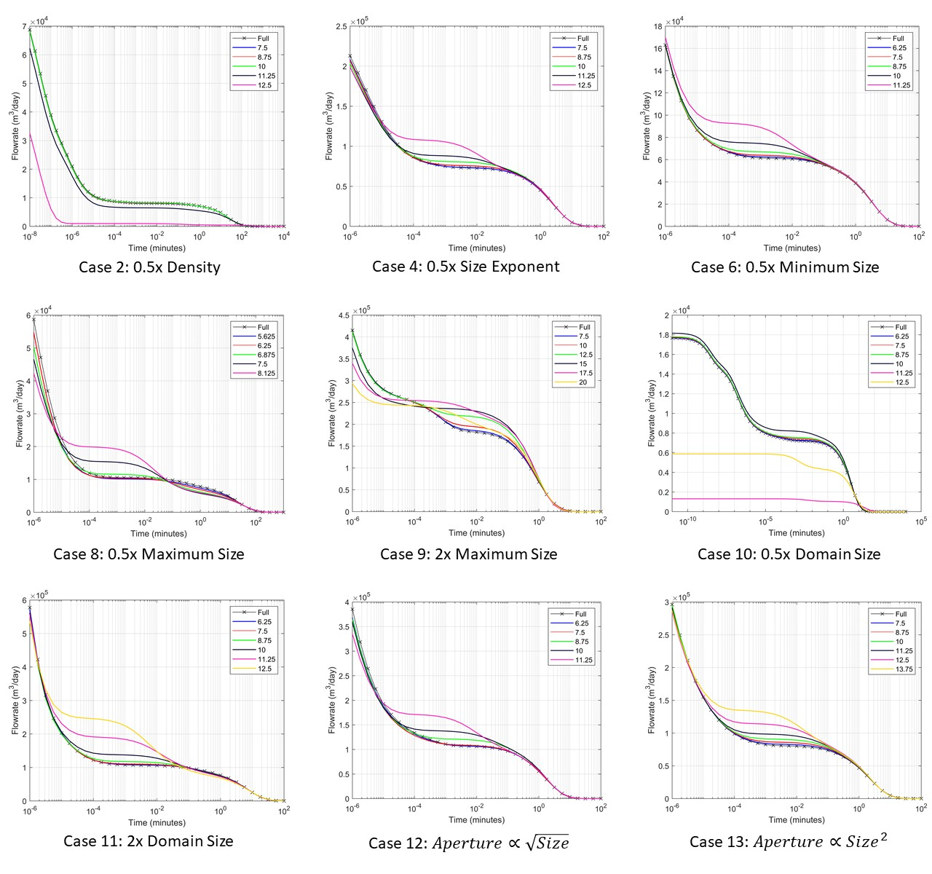

Figure S2. Drawdown simulation results for the 3D cases in Table S1. Results for Cases 1, 3, 5 and 7 are shown in Figure 2. Simulation outputs are are shown for fully resolved models, and hybrid models corresponding to different partitioning sizes. A fixed pressure condition is applied on the model boundary to initiate flow, as illustrated in Figure 2.

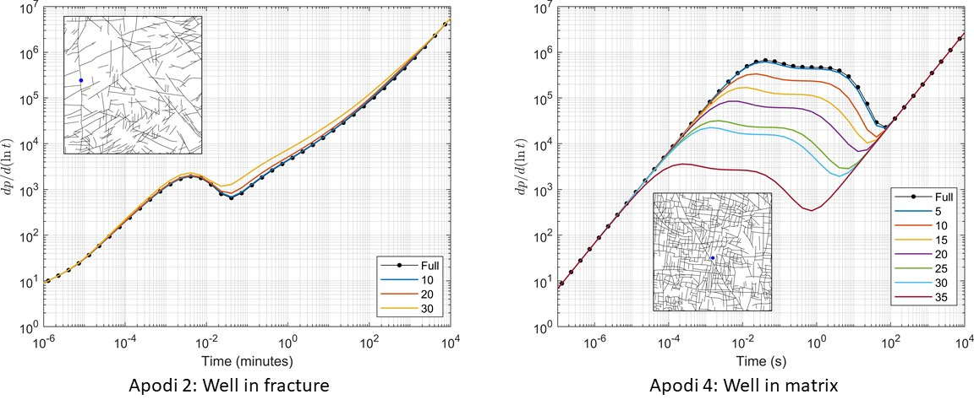

Figure S3. Well test pressure derivative curves for Apodi 2 and 4. Fixed flowrate is applied at locations marked with a blue circle.