Figure1
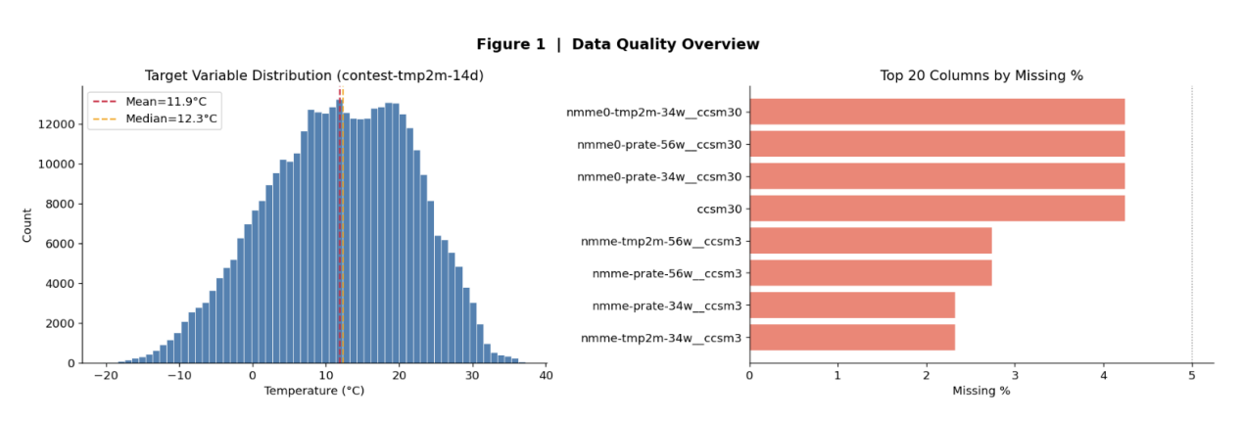
Figure 1 presents an overview of data quality. The left panel shows the distribution of the target variable, contest-tmp2m-14d (temperature in°C), with mean 11.9°C and median 12.3°C. The distribution appears approximately symmetric and close to normal, though the slightly lower mean relative to the median indicates a mild left skew. Most values cluster between 5°C and 20°C, suggesting a typical temperature range for the forecast period. The right panel lists the top 20 columns with the highest missingness rates. Notably, all 20 columns exhibit 100% missing values, meaning they contain no valid data at all. These columns belong predominantly to the CCSM3 model family (e.g., nrmme0-tmp2m-34w_ccsm30, nrmme0-prate-56w_ccsm30), indicating a systematic issue with that particular model output. Other high‑missing columns also follow a similar naming pattern, suggesting that a whole subset of features is entirely absent.

Key findings:

The target variable is near‑normally distributed (mean ≈ 11.9°C, median ≈ 12.3°C) with a slight negative skew.
All top‑20 missing columns have 100% missing data, concentrated in CCSM3‑based features.
These completely empty columns must be dropped or imputed; their absence likely stems from model‑specific data generation failures.

