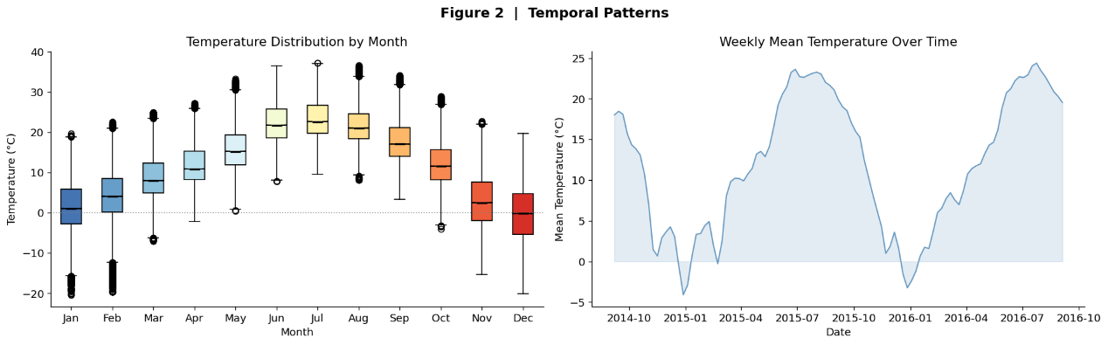
In the above pictures, the left one is a box plot of monthly temperatures, and the right one is a time series of weekly average temperatures.

As illustrated in the left panel, the period from June to August exhibits the highest temperatures, while November to January corresponds to the coldest months. Monthly temperature fluctuations range between 5 and 10 degrees Celsius. The median temperature difference between winter and summer is approximately 20 degrees Celsius, and the temperature gap between the coldest and hottest periods can exceed 30 degrees Celsius.

The right panel reveals a distinct seasonal cycle, which corroborates the data presented in the left panel. Temperature trends over the two-year period are relatively consistent, though minor deviations are observed—for instance, a notable temperature drop occurred around February 2015.

Overall, the temperature shows a clear seasonal pattern, with the weekly average temperature peaking at approximately 22 degrees Celsius in July and August. The temperature patterns across the two years are largely analogous. Although there are some outliers in the chart, the box plot still clearly shows the pattern of temperature changes. These anomalies may indicate the presence of extreme weather. From the box plot, it can be seen that the weather in January and February seems harder to predict.

