Figure 3 | NMME Ensemble Models vs Target
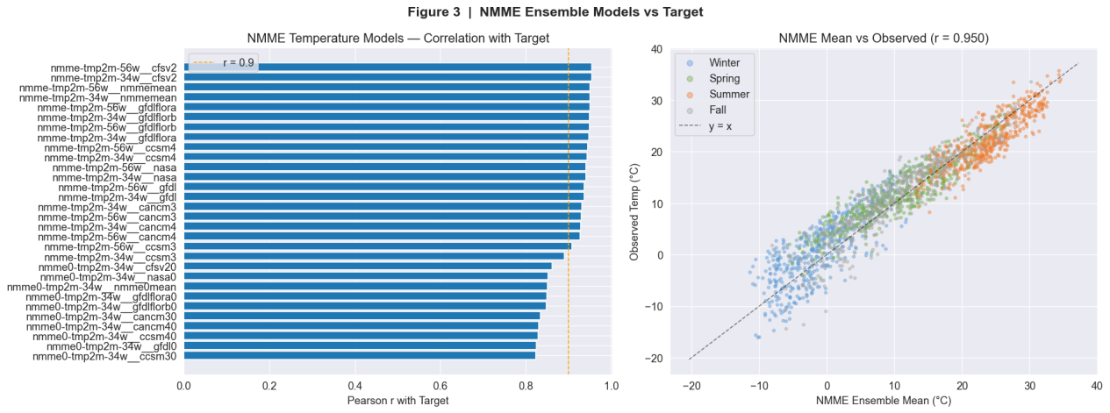
Left: Pearson correlation of individual NMME models with the target variable.
Right: Scatter plot of NMME ensemble mean vs observed temperature, colored by season.

The left panel displays the correlation coefficients between each NMME model’s forecasted 14‑day 2‑m temperature and the observed values. The vast majority of models achieve correlations around r ≈ 0.90 , indicating strong predictive skill. Notably, more than 20 models exceed r = 0.9 , including all CFSv2, GFDL, NASA, CanCM3/4, and most CCSM4 variants. However, the CCSM3 models (e.g., `nmmme-tmp2m-56w_ccsm3` and `-34w_ccsm3`) stand out with noticeably lower correlations, falling slightly below the 0.9 threshold. This suggests that CCSM3 is the least skillful member of the ensemble.

The right panel shows the ensemble mean (average of all NMME models) plotted against observed temperatures, with points colored by season. The scatter points cluster tightly around the y = x line , demonstrating excellent agreement and no systematic over‑ or under‑prediction. The overall Pearson correlation is r = 0.950 , confirming an extremely strong linear relationship. Moreover, the four seasons (Winter, Spring, Summer, Fall) are well mixed along the diagonal, indicating that the ensemble mean performs consistently across all seasons without notable seasonal bias.

Key Findings
- The NMME ensemble mean achieves a correlation of r = 0.95 with observed temperatures, closely following the y = x line and showing no seasonal bias.
- Most individual NMME models exhibit correlations around 0.90, with over 20 models surpassing r = 0.9.
- CCSM3 models consistently underperform relative to the ensemble, with correlations slightly below 0.9; they could be downweighted or excluded in future ensemble constructions.

