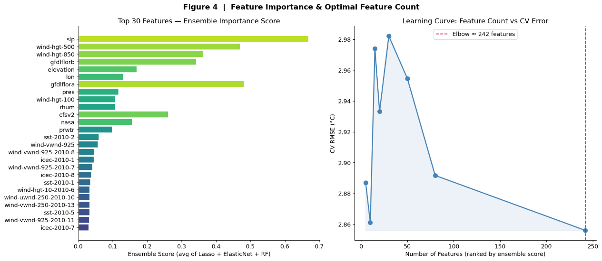
The figure 4 presents the feature importance ranking and the effect of feature count on model performance. The left panel reports the top 30 features based on the ensemble importance score, computed as the normalized average of Lasso, ElasticNet, and Random Forest. The most important feature is contest-slp-14d__slp, followed by nmme-tmp2m-56w__gfdlflora, contest-wind-h500-14d__wind-hgt-500, and other contest and NMME predictors. The Top 10 features mainly come from contest reanalysis variables and NMME climate forecasts, suggesting that both short-term atmospheric conditions and subseasonal climate signals contribute substantially to 14-day temperature prediction. In addition, several SST and sea-ice features, such as: sst-2010-, icec-2010- These also appear in the top ranks. Although these predictors are less expected, their presence is physically reasonable because oceanic boundary conditions can influence subseasonal temperature variability.
The right panel shows the learning curve of CV RMSE as features are added in order of importance. A clear elbow appears at around 242 features, after which the RMSE shows minimal improvement. This indicates that the model has already captured most of the useful information by this point, and that additional low-importance features mainly introduce noise rather than improving predictive skill. The flattening of the curve also suggests diminishing returns in model complexity, reinforcing the value of selecting a compact yet informative feature subset.
All in all, the results show that contest and NMME features provide the main useful signals, the model reaches its best performance at around 242 features, but adding more low-importance features mostly brings noise and weakens generalization.

