

ULMS549
Venture Dynamics: Buying, Building and Selling Enterprises

Assessment 1: Individual Assignment

Title: Maximizing Value for Selling- A Strategic Report on the Sale of Super Farmer E-Commerce Company.

Student ID: 201786593

Words: 1983

Table of Contents
1. Executive Summary 1
2. Business Model: Current Status and Future Development Plans 2
2.1 Visual Representation of the BMC 2
2.2 Analyzing Core Components of the Business Model 2
2.3 For Better Price Preparation 5
2.4 Ready for Sale: Future Vision BMC 6
3. Strategic Assessment 7
3.1 SWOT 7
3.2 PEST 7
4. Financial Assessment 8
4.1 EBTIDA Multiple Valuation 8
4.2 Market Value Valuation 8
4.3 Asset-Based Valuation 8
4.4 VC Method 8
5. Challenges and Implementation 10
5.1 Operational Complexity 10
5.2 Emotional Attachment 10
6. Conclusion 11
6.1 Pricing Range 11
6.2 Future Analysis Suggestions 11
References 12
Appendixes 13

1. Executive Summary
Super Farmer is a small e-commerce company dedicated to promoting eco-friendly development and facilitating rural poverty through the sale of agricultural products in China. This company connects rural farmers with urban consumers by leveraging innovative technologies such as live streaming and short videos. This business model aligns with emerging e-commerce trends and the Chinese government's initiatives focused on rural development.
To maximise the selling price, these reports propose implementing several strategic enhancements that will help increase the business appeal to potential buyers and achieve the most favorable outcome in the market after 5 years of selling this company.
To estimate the company's valuation for a planned sale, the report uses four methods that consider the company’s financial projections, market trends, and strategic enhancements outlined in its future vision.
Based on these methods, this report gives a minimum price estimate of £38,387,355 for Super Farmer, with room to pursue a higher price of up to £50 million. The final price needs to be negotiated with the buyer according to the specific situation.
NB: Some information and data cannot be available online, for analysis, there are assumptions.

2. Business Model: Current Status and Future Development Plans
To maximise the sale price, this report analyses the current status of Super Farmer and optimises the business model via Business Model Canvas (BMC) (Osterwalder et al. 2013) plan to sell after 5 years.

2.1 Visual Representation of the BMC
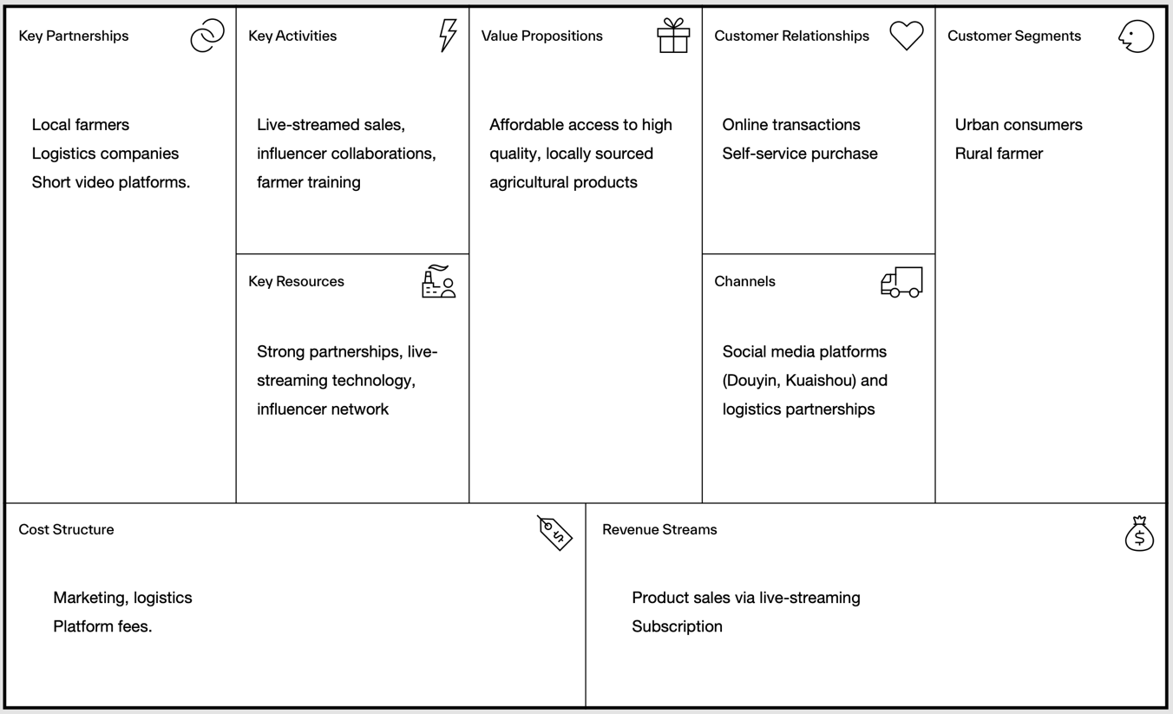
Figure 1. Current BMC
Source: Made by Author utilize Strategyzer
https://www.strategyzer.com/library/the-business-model-canvas
Figure 1 illustrates the current situation and operation of Super Farmer. According to Greiner’s model of how organisations develop, this company is still in stage 2 as it needs leadership and centralised decision-making. Organisations begin to establish some basic management functions and operational processes to support the expansion of the business. Founders and executives often use direct oversight and control to ensure the organisation stays on track, but as the business scales, this approach may look inefficient.

2.2 Analyzing Core Components of the Business Model
Super Farmer delivers value through technology, partnerships and live produce, fulfilling their proposition of affordable, high-quality, locally sourced goods. Social media and logistics make market access possible while livestreaming and influencer partnerships attract customers. Cooperation with farmers, logistics companies and video platforms ensures a reliable supply chain and core activities such as sales and training. Success depends on strong partnerships, reliable logistics, strong technology and farmer engagement. However, over-reliance on third-party platforms, product quality challenges and logistical complexity are the main risks. The model balances the strengths and weaknesses of modern technology and collaboration to achieve its goals.
To better present its business activities, the following real product photos, live screenshots, certificates of honours, and patents are included in Figure 2 to Figure 11.
 | 
Figure 2. screenshots of the online sale process | Figure 3. Fish products cooperated with fishermen in Liaoning

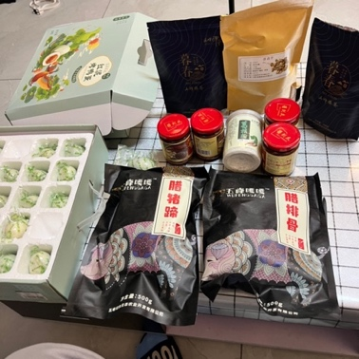 | 
Figure 4. Agricultural products cooperated with Wuhan Rural Farmer | Figure 5. Live broadcast poster

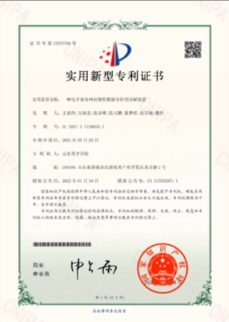 | 
Figure 6. The company leader is the second inventor of the patent | Figure 7. Provincial honor

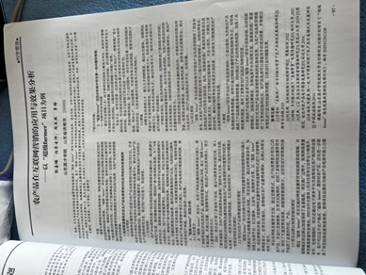 | 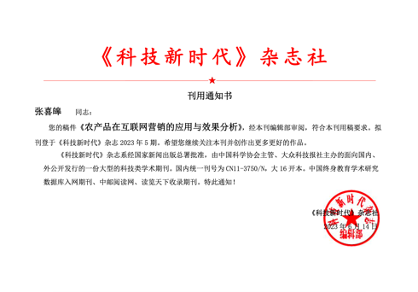
Figure 8. The article used Super Farmer as a case study | Figure 9. Notice of article submission

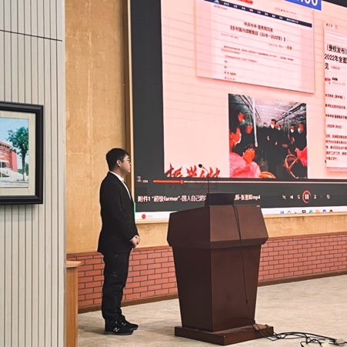 | 
Figure 10. Pull investment roadshows | Figure 11. National honor

2.3 For Better Price Preparation
Blayney (2008), Haigh (2009), and other scholars provide valuable insights into the complexities of selling a business. Combining those insights and considering the issues Super Farmer in this stage and to scale this company, there are several implementations for maximising the sale price as follows in Table 1.
Table 1. Implementations
Transformation of management structure | Create more layers of management; Appoint specialized manager; Establish standardized processes (Frank et al., 2023).
Financial management improvement | Establish a more standardized cash flow forecasting and management mechanism to deal with possible market fluctuations and provide clear financial outlook for acquirers.  Present revenue growth forecasts and market expansion plans for the next few years (Blayney, 2008), especially if the company plans to expand into international markets or launch new product lines, providing reliable financial data to support growth potential.
Enhanced market coverage and customer relationship management | Establish customer loyalty programs, such as bonus points, VIP customer service, etc., to improve customer buyback rate and word-of-mouth effect.  Use data analytics and artificial intelligence (AI) technology to provide personalized product recommendations and customer service to enhance customer engagement (Sjödin et al., 2021).
Enhance technology and innovation capabilities | Build company own e-commerce platform, use data analytics and AI technology to improve supply chain management and customer relationship management (CRM), and improve operational efficiency (Sjödin et al., 2021).  Launch organic, green, sustainable and other product lines in line with market trends to enhance product differentiation and brand added value.
Increase brand value | Strengthen the brand image and market awareness to make it a brand with social responsibility and environmental protection characteristics (Haigh, 2009). Attract potential buyers who focus on ESG (environmental, social, governance) investments, especially those focused on sustainable development and rural poverty alleviation.
Source: Created by author based on literature review

2.4 Ready for Sale: Future Vision BMC
To pursue scale this company and combine those implementations, after 5 years, Super Farmer will be ready for sale, and the new BMC will transfer, as shown in Figure 12.
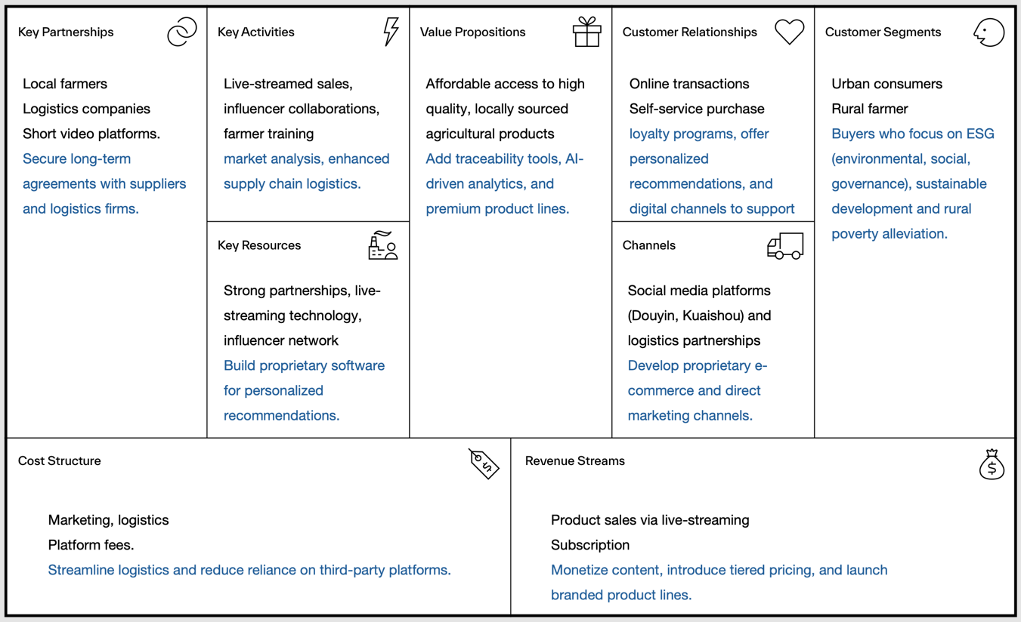
Figure 12. Estimated BMC after 5 years
Source: Made by Author utilize Strategyzer
https://www.strategyzer.com/library/the-business-model-canvas
This shift toward technical independence and sustainability integrates several elements. Proprietary software reduces reliance on third-party platforms and improves cost efficiency and customer experience. Ai-driven tools and traceability systems improve value creation, meet the need for transparency, and enable premium product lines. Deepen customer relationships through loyalty programs and personalised recommendations aimed at ESG-conscious buyers. Long-term supplier agreements and logistics improvements ensure consistent quality backed by data-driven market insights. Diversified revenue streams, such as branded products, are aligned with an expanded value proposition. ESG integration links social impact to operations, strengthening the sustainability and competitive positioning of the entire business model.

3. Strategic Assessment
This section analyses the company's strengths, weaknesses, opportunities, and threats (SWOT analysis) (Puyt et al., 2023) and external factors, including political, economic, social, and technological (PEST analysis), preparation for the sale.

3.1 SWOT
Table 2. SWOT Analysis for Super Farmer
Strengths | Weaknesses
`Innovative business model using live streaming  `Sustainability focus aligning with government initiatives  `Recognition through honours and patents  `Effective use of data analytics and Al | `Dependence on third-party platforms  `Limited management roles and processes  `Temporary pause in operations  `Need for better financial forecasting
Opportunities | Threats
`Market expansion into international markets  `Technological enhancements with proprietary platform  `Increased ESG investment interest  `Development of loyalty programs | `Intense competition from larger platforms  `Market fluctuations affecting demand  `Regulatory risks  `Need to keep up with rapid technology changes

3.2 PEST
Table 3. PEST Analysis for Super Farmer
Strengths | Economic
`Alignment with rural development policies  `Potential risks from e-commerce taxation  `Focus on ESG initiatives by government | `China's growing middle class driving demand  `Economic instability may affect purchasing power  `Continuous e-commerce market growth  `Rising labour and operational costs
Opportunities | Technological
`Consumer preference for sustainable products  `Health-conscious urban consumers  `Increased use of live streaming for sales  `Support for rural farmers improves brand trust | `Potential to utilize Al for personalization  `Building a proprietary platform for efficiency  `Continuous investment in e-commerce tools needed  `Leveraging mobile apps and live streaming

4. Financial Assessment

4.1 EBTIDA Multiple Valuation
Enterprise Value (EV) = EBITDA×EBITDA Multiple
Assumption: SHIN et al. (2023) and Thompson (2009) argued that the EBITDA multiple for e-commerce is 3 in 2009 and 5 in 2023, this report assumes an EBITDA multiple of 6/7 in 2029.
According to the financial data in the appendix, 2029 EBITDA is £6,800,000.
Based on the provided assumptions and industry benchmarks, the estimated valuation of Super Farmer as of 31 Dec 2029 ranges from £40,800,000 to £54,400,000.

4.2 Market Value Valuation
Estimated Market Value = Net Income × P/E Ratio
Assumption: Macrotrends points out that leading e-commerce enterprise Alibaba’s PE Ratio reached its highest of 11.84 from 2011 to 2024, considering Super Farmer belonging Small and Middle Enterprises (SMEs), this report assumes the P/E Ratios of 8/9.
According to the financial data in the appendix, 2029 Net Income is £5,080,000.
Based on the assumptions and industry factors, the estimated valuation of Super Farmer on 31 Dec 2029 is £40,640,000 to £45,720,000.

4.3 Asset-Based Valuation
Net Asset Value (NAV) =Total Assets − Total Liabilities
This method is applied without any additional adjustments for goodwill, market perception, or earning potential beyond tangible and intangible assets recorded (Wilkins et al., 1997).
From the appendix, total Assets in 2029 are £16,500,000; Total Liabilities in 2029 is £4,600,000.
Based on the NAV calculation, the value of the company as of 31 Dec 2029 is £11,900,000

4.4 VC Method
Venture capitalists typically expect high annualized returns due to the high risk. Assume a target return of 35% annually for Super Farmer.
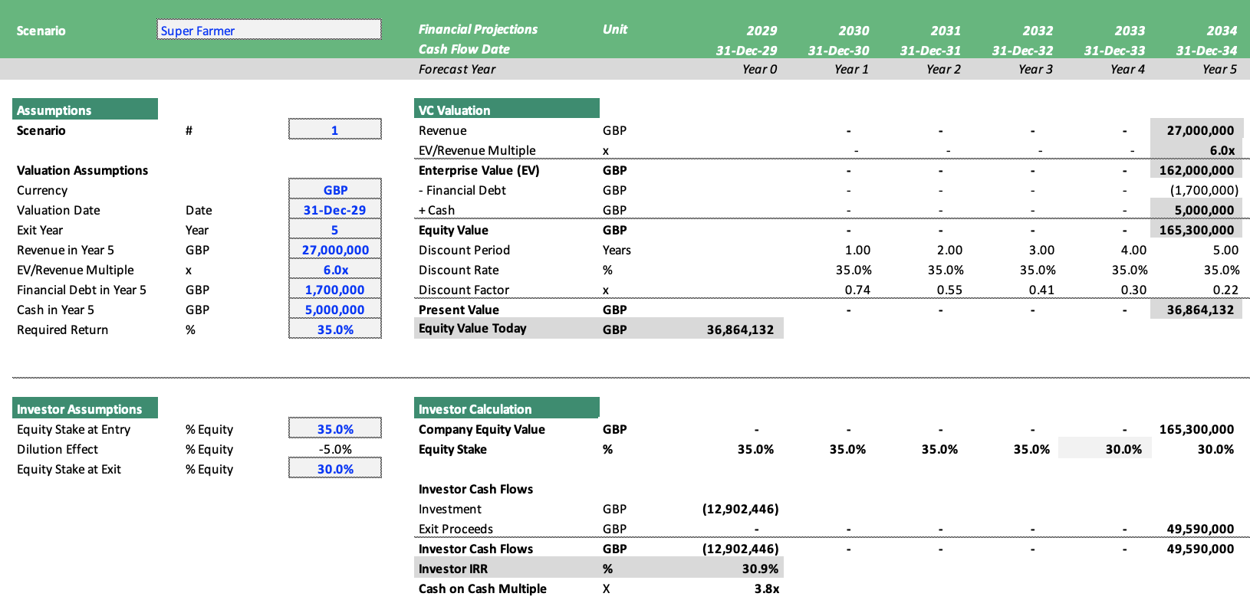
Figure 13. Estimated VC Valuation after 5 years
Source: Made by Author powered by VC Valuation Template
https://www.efinancialmodels.com/downloads/simple-vc-valuation-template-445210/

The present value of equity is estimated at £36,864,132, reflecting a discounted valuation of the company based on projected exit metrics and a required return of 35.0%. The IRR (30.9%) and Cash-on-Cash Multiple (3.8X) indicate strong returns for the investor, aligning with venture capital expectations for high-growth investments. The EV/Revenue multiple (6.0x) provides a more conservative valuation, balancing growth potential with realistic industry benchmarks.

5. Challenges and Implementation

5.1 Operational Complexity
Super Farmer sources products from various provinces in China, which can lead to inconsistent quality or delayed logistics due to the decentralised supply chain. This raises concerns for potential buyers, particularly about scalability if the business expands to new markets.
To address these challenges, Super Farmer should streamline its operations by automating inventory management, standardizing product quality checks, and optimizing supply chain processes. Implementing centralized inventory systems and automated order fulfilment will enhance efficiency. Additionally, introducing an e-commerce platform with AI-based demand forecasting and inventory control can reassure buyers that the business is scalable and prepared for growth. These improvements demonstrate that the company can manage increased transactions and operate efficiently across markets.

5.2 Emotional Attachment
The founders of Super Farmer may have a strong emotional connection to the business due to their mission of promoting eco-friendly development and supporting rural communities in China. After years of building relationships with farmers and focusing on social impact, the founders may struggle to assess the business’s value from a purely financial standpoint. This emotional attachment could make them hesitant to sell, especially if they fear a potential loss of the company’s social mission under new ownership.
To navigate this, the founders should work with professional advisors, such as M&A experts or business brokers, to gain an objective, market-based valuation of the business. This will help them understand the company’s value from a strategic and financial perspective. Additionally, the founders can develop a transition plan to ensure that the business’s mission and values are maintained post-sale. This may involve negotiating terms that allow the founders to stay involved or retain a stake, ensuring continuity of the business’s social goals while still achieving a fair sale price.

6. Conclusion

6.1 Pricing Range
Prediction of prices on 31 Dec 2029 for different evaluation methods are shown in Table 4.
Table 4. Price Compression
Types of Method | Price
EBTIDA Method | £40,800,000 to £54,400,000
Market Value Method | £40,640,000 to £45,720,000
Net Asset Value Method | £11,900,000
VC Method | £36,864,132
The price differences between the approaches arise primarily from the different assumptions and core factors considered in each method. Especially because e-commerce companies derive most of their value from intangible assets, the Asset value method value yields much lower numbers than the others. This report suggests using the average price from these four methods as the minimum price, estimated at £38,387,355. And pursue higher price space up to £50,000,000.

6.2 Future Analysis Suggestions
This report lays emphasis on scale enterprises and to maximise sales, in the future analysis, it also needs to prepare due diligence, knowledge transfer strategy and stakeholder planning.

References

Alibaba pe ratio 2011-2024 | baba (no date). Available at: https://www.macrotrends.net/stocks/charts/BABA/alibaba/pe-ratio(Accessed: 19 December 2024).

Blayney, M. (2008) How to sell your business for the price you want : preparing your business for sale and getting the best possible price / Mark Blayney. 2nd ed. Oxford: How to Books.

Frank, H., Kessler, A., Beck, S., Suess-Reyes, J. and Fuetsch, E. (2023) ‘The enterprises of business families: Conceptualization, scale development and validation’, Journal of Family Business Strategy, 14(2), p. 100522. Available at: https://doi.org/10.1016/j.jfbs.2022.100522.

Greiner, L.E., 1989. Evolution and revolution as organizations grow (pp. 373-387). Macmillan Education UK.

Haigh, J. (2009) Buying and selling a business : an entrepreneur’s guide / Jo Haigh. London: Piatkus.

Osterwalder, A. and Pigneur, Y. (2013) Business model generation: a handbook for visionaries, game changers, and challengers. New York: Wiley&Sons.

Puyt, R.W., Lie, F.B. and Wilderom, C.P.M. (2023) ‘The origins of SWOT analysis’, Long Range Planning, 56(3), p. 102304. Available at: https://doi.org/10.1016/j.lrp.2023.102304.

Sjödin, D., Parida, V., Palmié, M. and Wincent, J. (2021) ‘How AI capabilities enable business model innovation: Scaling AI through co-evolutionary processes and feedback loops’, Journal of Business Research, 134, pp. 574–587.

Strategyzer. Business model canvas – download the official template (no date). Available at: https://www.strategyzer.com/library/the-business-model-canvas(Accessed: 18 December 2024).

SHIN, I., YOON, I. and LEE, H. (2023) ‘A case study of valuation considering the characteristics of e-commerce distribution: focusing on the coupang ipo’, Journal of Distribution Science, 21(4), pp. 91–101. Available at: https://doi.org/10.15722/JDS.21.04.202304.91.

Trusculescu, A., Draghici, A. and Albulescu, C.T., 2015. Operational Drivers of Business Valuations in The E-Commerce Sector–Focus on Public Companies That Assume Inventory Risk. Managing Intellectual Capital and Innovation for Sustainable and Inclusive Society, pp.787-794.

Appendixes
(assumptions)
