Task1
Group50_solution.ipynb
Require | Ownd by | Progress | Reviewed by
1.Parse the JSON file using a structured JSON parser and the XML file using a structured XML parser. Do not parse document structure as plain text using regular expressions. / 使用结构化 JSON 和 XML 解析器读取文件，不得使用正则表达式解析文档结构。
2. Investigate major objects, nested arrays, repeated XML elements and source-specific representations. / 调查主要对象、嵌套数组、重复 XML 元素以及不同数据源特有的表示方式。
3. Investigate candidate primary keys and foreign keys. / 调查候选主键和外键。
4. Identify the grain of each source collection. / 确定每个源数据集合的记录粒度。
5. Investigate date, timestamp, boolean, currency, percentage and missing-value formats. / 调查日期、时间戳、布尔值、货币、百分比和缺失值格式。
6. Identify fields that appear in one source or both sources. / 确定各字段仅存在于某一个数据源，还是同时存在于两个数据源
7. Investigate duplicate records within each source. / 调查每个数据源内部的重复记录。
8. Investigate overlapping records across the JSON and XML sources. / 调查 JSON 与 XML 数据源之间的重叠记录。
9. Document assumptions required before transformation. / 记录数据转换开始前所需的假设和处理决策。
10. Complete all six blank columns of the source-to-target mapping for every required output field: source format, JSON path, XML path, transformation or derivation, overlap or conflict rule, and notebook evidence. / 为所有目标字段完整填写 mapping 的六列。

Task2

Require | Ownd by | Progress | Reviewed by
Orders、order items | Lucy Zhao
Customers | 王裕Jason
Deliveries
Products、product reviews
Table name

Group50_orders_standardised.csv
Group50_order_items_standardised.csv
Group50_customers_standardised.csv
Group50_deliveries_standardised.csv
Group50_products_standardised.csv
Group50_product_reviews_standardised.csv

Each table should

1. Produce exactly standardised relational tables
2. Preserve the required grain and primary key of each table. / 保持每张表规定的数据粒度和主键。
3. Enforce all required, non-null primary and foreign keys between the six tables. / 确保六张表之间规定的主键和外键均非空。
4. Follow public_data_dictionary.csv for field names, field order, data types, nullability and comparison rules. / 严格遵循数据字典中的字段名、顺序、类型、可空性及比较规则。
5. Flatten nested arrays without changing the intended entity grain and preserve valid one-to-many relationships. / 展开嵌套数组，但不得破坏实体粒度和一对多关系。
6. Normalise stable identifiers while preserving leading zeros and identifier/category case. / 标准化稳定标识符，同时保留前导零和大小写。
7. Standardise dates as YYYY-MM-DD and timestamps as YYYY-MM-DD HH:MM:SS. / 将日期和时间戳转换为规定格式。
8. Standardise booleans as True or False. / 将布尔值统一为 True 或 False。
9. Remove currency labels and thousands separators before numeric conversion. / 数值转换前移除货币标签和千位分隔符。
10. Convert percentages to the required numeric percentage points. / 将百分比转换为规定的数值百分比点。
11. Derive line_revenue, order_price, tax_amount and order_total using the published arithmetic sequence. / 按规范顺序计算订单相关派生金额。
12. Use the literal string NaN for prescribed missing string outputs, not empty strings or pandas/Python missing values. / 对规定的缺失字符串使用字面值 NaN。
13. Reconcile within-source duplicates and cross-source overlap using stable business keys and field-level comparison. / 使用稳定业务键和字段级比较处理源内重复及跨源重叠。
14. Record conflicting non-missing values in validation instead of silently preferring JSON or XML. / 非空字段发生冲突时必须记录，不得静默选择某一数据源。
15. Produce deterministic outputs derived from the allocated source files without hard-coded row counts, duplicate IDs or expected values. / 输出必须可重复生成，且不得硬编码记录数、重复 ID 或预期值。
16. Export the six CSVs using the exact Group50 filenames and without helper or EDA-only columns. / 使用准确文件名导出六张 CSV，不得加入辅助列或 EDA 专用列。
CODE
Code should put in Group50_solution.ipynb
Task 3

Require | Owned by | Progress | Reviewed by
3.1 Narrative cleaning: clean_narrative_text | Task 2 Orders/order items owner  Lucy
3.2 Order-reference extraction: extract_order_reference | Task 2 Customers owner  Jason
3.3 SKU and promotion extraction: extract_product_sku, extract_promo_code | Task 2 Deliveries owner
3.4 Multilingual processing: build_latin_analysis, contains_non_latin_script | Task 2 Products/product reviews owner

3.1
should do
处理 None 和字符串；
HTML entity decoding；
Unicode NFC normalization；
删除 HTML/XML tags；
删除规定的 markers；
删除 URL；
删除 emoji；
删除 review reference wrapper；
删除 PROMO: 和促销码；
合并空格、Tab 和换行；
转小写；
清洗后为空时返回 "NaN"。
3.2
Order-reference extraction
接收 None 或字符串；
匹配 HORD 或 CORD；
后面必须刚好六位数字；
返回大写；
无有效结果时返回 "NaN"；
拒绝过长、嵌入或格式错误的 near-match。
3.3 SKU and promotion extraction
从原始文本提取；
返回大写；
无有效结果返回 "NaN"；
正确处理边界；
拒绝 malformed 和 near-match。

3.4 build_latin_analysis(value)
contains_non_latin_script(value)

3.4.1 build_latin_analysis

从 review_body_clean 构建；
保留 Latin-script 字母；
保留欧洲语言变音符号，例如 é；
保留适用的数字和标点；
删除非拉丁文字母；
没有 Latin letter 时返回 "NaN"。
3.4.2 ontains_non_latin_script

检查清洗后的多语言 review；
存在非拉丁文字母时返回 True；
否则返回 False；
不能简单地将所有非 ASCII 字符视为非拉丁文字。

6个函数整合在 Group050_text_functions.py

Task4 Group 50_solution.ipynb

Require | Owned by | progress | Reviewed by
Orders/order items keys and arithmetic validation | Task 2 Orders/order items owner  Lucy
Schema, types, customers and source-coverage validation | Task 2 Customers owner  Jason
Deliveries and temporal validation | Task 2 Deliveries owner
Products/reviews, text and final validation-register integration | Task 2 Products/product reviews owner

YOU should check
从头运行 Group050_solution.ipynb；
查看每个 validation 的 observed result；
检查 PASS/FAIL 是否与结果一致；
检查失败项是否有合理解释；
检查没有通过硬编码结果让 validation 强制通过；
检查字面字符串 "NaN"、空字符串、Python None 和 pandas missing value 没有混淆；
检查所有 VAL-... ID 唯一且稳定；

In each validation should show：
Validation ID
Check description
Observed result
PASS/FAIL
Resolution or interpretation

Eg
{
"validation_id": "VAL-PK-01",
"check": "orders.order_id completeness and uniqueness",
"observed_result": {
"missing_count": missing_count,
"duplicate_count": duplicate_count
},
"status": "PASS" if missing_count == 0 and duplicate_count == 0 else "FAIL",
"resolution": "No missing or duplicate canonical order IDs."
Task5 Group 50_EDA.ipynb

Require | Owned by | progress | reviewed by
Figure 1–2: Orders and order-item analysis | Task 2 Orders/order items owner  Lucy
3-4 | Customers Jason
5-6 | Deliveries
7-8 | Products/product reviews

MAIN
- Produce 6–8 clearly labelled assessed visualisations. / 制作 6–8 张明确标注的考核图表。
- Label them Figure 1, Figure 2, and so on. / 按顺序标注 Figure 1、Figure 2 等。
- Cover all six required analytical categories. / 覆盖规定的六类分析。
- Use evidence from at least four of the six output tables. / 至少使用六张输出表中的四张。
- Include at least two analyses that correctly join related tables. / 至少包含两项正确连接关系表的分析。
- State the analytical question for every figure. / 每张图说明分析问题。
- State the observation unit and denominator. / 每张图说明观察单位和分母。
- Identify tables and join keys used. / 说明使用的表和连接键。
- Use readable titles, axes, legends and units. / 图表标题、坐标轴、图例和单位必须清晰。
- Explain the result and one material limitation. / 每张图说明结果和至少一个重要局限。
- Demonstrate that joins did not accidentally multiply rows. / 证明表连接没有造成意外的记录倍增和指标重复计算。

六类必须覆盖的分析
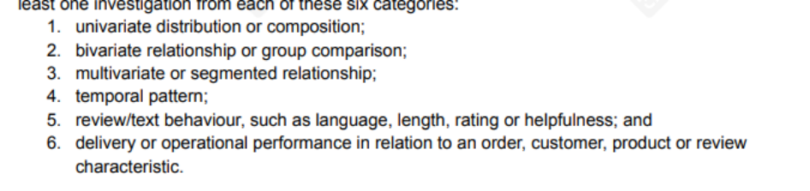
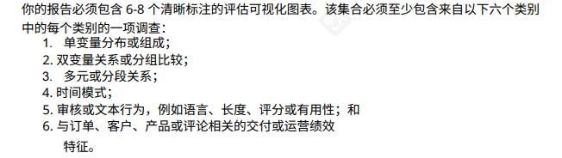

Required category | Proposed figure
Univariate distribution or composition | Figure 1
bivariate relationship or group comparison; | Figures 2, 3 or 5
multivariate or segmented relationship; | Figures 4, 6 or 7
temporal pattern; | Figure 4
review/text behaviour, such as language, length, rating or helpfulness; and | Figures 7 and 8
delivery or operational performance in relation to an order, customer, product or review characteristic. | Figures 5 and 6
自主选择研究问题，你可能使用其他人的table
这部分8张图满足6类调查即可，按选择的调查类别先后分配，图中只是预设

EG 这部分也只是预设

Figure 1：Order-total distribution
Analytical question：
What is the distribution of canonical order totals, and how strongly is it affected by extreme orders?

Figure 2：Order size and order value
Analytical question：
How does the number of items in an order relate to the order total?

Person 2：Customers and orders

Figure 3：Order value by customer segment
Analytical question：
How does order value differ across customer segments or loyalty tiers?

Figure 4：Temporal order pattern by customer or sales segment
Analytical question：
How did order activity or revenue change over time, and did the pattern differ by sales channel or customer segment?

Person 3：Deliveries and operations

Figure 5：Delivery delays by service level
Analytical question：
How does delivery delay performance differ across service levels or carriers?

Figure 6：Order characteristics and delivery performance
Analytical question：
Is on-time delivery performance associated with order value and expedited-delivery status?

Person 4：Products and reviews

Figure 7：Review rating and text behaviour
Analytical question：
How do review length and helpful votes vary across rating or language groups?

Figure 8：Product category and review outcomes
Analytical question：
How do review ratings differ across product categories, and does review volume affect the apparent category result?
最后 每张 Figure 必须包含的说明模板
Figure N: Figure title
Analytical question:
Observation unit:
Denominator:
Tables used:
Join keys:
Join multiplication check:
Result:
Material limitation:

Task6 Group50_EDA.ipynb

REQUIRE | OWNED BY | PROGRESS | Reviewed by
Findings 1–3 and MLQ1: order/order-item evidence | Orders/order items owner
Findings 4–5 and MLQ2: customer evidence | Customers owner
Findings 6–8 and MLQ3: delivery evidence | Deliveries owner
Findings 9–10 and MLQ4–5: product/review evidence | Products/product reviews owner

Finding require
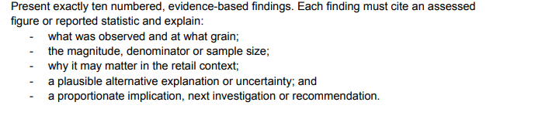
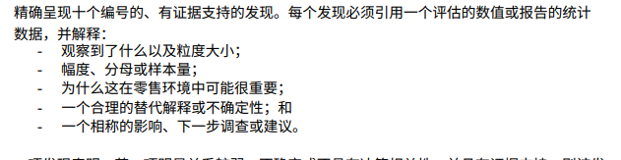

MLQ require
注意字数
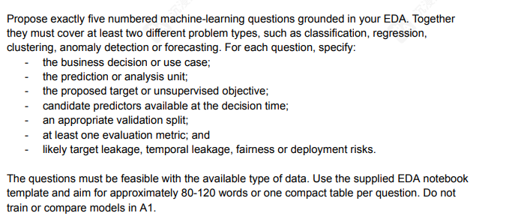
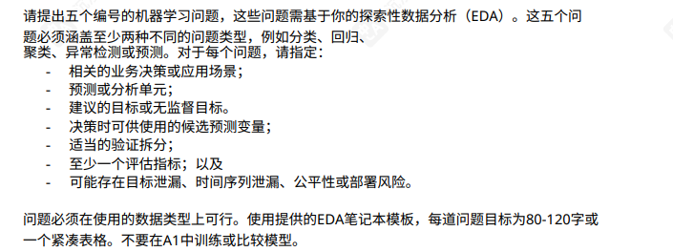

Question type | MLQ NUMBER
classification
regression
clustering
anomaly detection
forecasting
每个问题（来自于上一阶段你的figure）自主选择两个question type ,确保每个type被使用，先后自主分配
MLQ建议使用同意格式 先说明问题 再说明你的问题来自哪张图表，接着随意发挥

Eg ：Can late-delivery risk be predicted at dispatch? Motivated by Figure 6, this binary-classification question would support proactive customer notifications and logistics intervention. The unit is one dispatched delivery, and the target is whether it arrives after the promised date…………

Task7 Reproducibility and code requirements

require | owned by | progress | reviewed by
7.1task1-4
7.2task5-6
7.1 整合 Task 1–4 的代码；
完成 Group050_solution.ipynb；
确保配置单元包含：
GROUP_ID = "Group050"
INPUT_DIR = Path("raw_input")
OUTPUT_DIR = Path("outputs")
使用相对或可配置路径；
删除个人电脑的绝对路径；
确保能够从 raw JSON/XML 重新生成六张 CSV；
确保 validation register 能重新运行；
导出与 notebook 一致的Group050_solution.py
7.2 整合 Task 5–6；
完成 Group050_EDA.ipynb；
确保 EDA notebook 只读取六张标准化 CSV；
确保它不会重新运行另一套隐藏的数据清洗流程；
确保 6–8 张图和所有 reported statistics 都可以重新生成；
检查所有 import 和 dependency；
需要时创建：requirements.txt
检查 workflow 可以完全离线运行；
检查没有 API、网络下载、账户、API key 或未提交文件依赖；
负责最终的 Restart and Run All 测试.
Task8 EDA report requirements
structure 1-7 详情EDA report requirements
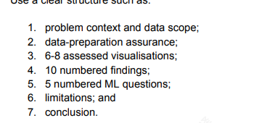

require | owned by | progress | reviewed by
8.1 structure 1-3
8.2 structure 4-7

Cover page
Contents page

1. Problem context and data scope
2. Data-preparation assurance
3. Assessed visualisations
4. Ten evidence-based findings
5. Five machine-learning questions
6. Limitations
7. Conclusion

References
8.1 确定报告格式 cover page content page 制作 整个报告框架 structure 1-3

8.2 检查 并 structure 4-7 确认报告中的数字、图表和陈述都有可复现证据

Task 9 Generative AI use
optional

随便写写 每个人需要signed AI-use declaration

Group member | Submission requirement and status

Task10 提交

require | owned by | reviewed by
整合所有文件 确认名称格式符合要求 |  | Each member

