**public interface** Aware {  
}

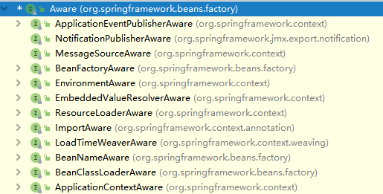

* 提供了ApplicationContext组件

**public interface** ApplicationContextAware **extends** Aware {**void** setApplicationContext(ApplicationContext applicationContext) **throws** BeansException;  
}