**Tensorflow动态链接(DLL)初始化例程失败问题及其解决方案**

报错：

ImportError: DLL load failed while importing _pywrap_tensorflow_internal: 动态链接库(DLL)初始化例程失败

说明：

由于我为程序创建了一个虚拟环境，因此后续操作都将在虚拟环境中进行

解决方案：

1、首先将Terminal设置在虚拟环境下（File-Settings-Tools-Terminal）

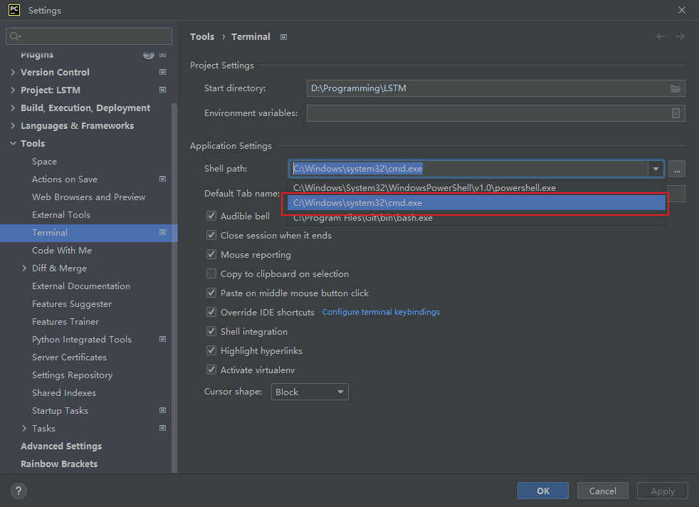

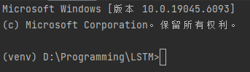

参考链接：<https://zhuanlan.zhihu.com/p/698633454>

2、根据提示下载并解压对应python版本的sse2文件

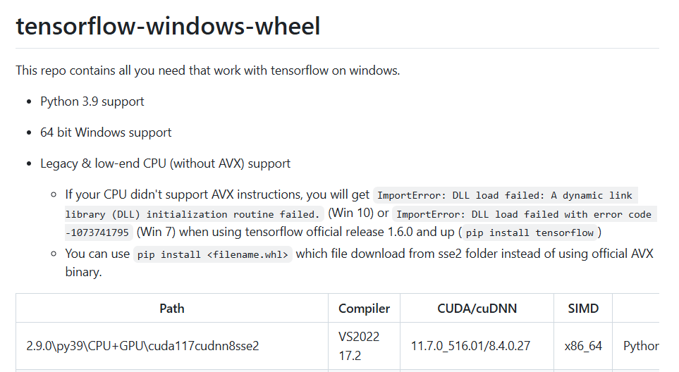

参考链接：

<https://blog.csdn.net/weixin_45685889/article/details/103242219>

<https://github.com/fo40225/tensorflow-windows-wheel/tree/master>

3、从Terminal中进入到刚刚下载并解压的文件路径下，运行

pip install tensorflow-2.9.0-cp39-cp39-win_amd64.whl

（由于已经将Terminal设置在虚拟环境下，因此这里的pip是虚拟环境的，对应的库也会安装在虚拟环境中）

报错1：

A module that was compiled using NumPy 1.x cannot be run in

NumPy 2.0.2 as it may crash. To support both 1.x and 2.x

versions of NumPy, modules must be compiled with NumPy 2.0.

Some module may need to rebuild instead e.g. with 'pybind11>=2.12'.

If you are a user of the module, the easiest solution will be to

downgrade to 'numpy<2' or try to upgrade the affected module.

We expect that some modules will need time to support NumPy 2.

解决方案：

在虚拟环境中卸载原版本，安装低版本

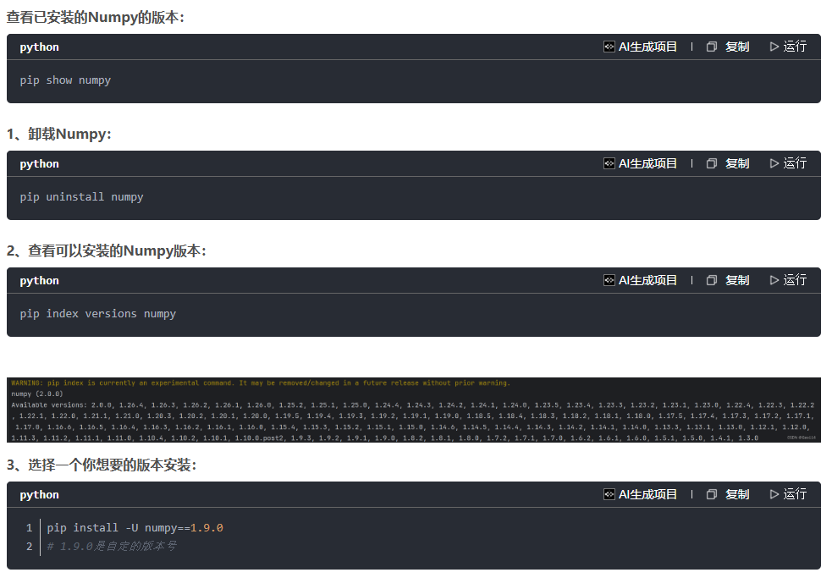

参考链接：<https://blog.csdn.net/Geo114/article/details/139899328>

报错2：

ERROR: pip's dependency resolver does not currently take into account all the packages that are installed. This behaviour is the source of the following dependency conflicts.

tensorflow-intel 2.13.0 requires flatbuffers>=23.1.21, but you have flatbuffers 1.12 which is incompatible.

tensorflow-intel 2.13.0 requires keras<2.14,>=2.13.1, but you have keras 2.9.0 which is incompatible.

tensorflow-intel 2.13.0 requires protobuf!=4.21.0,!=4.21.1,!=4.21.2,!=4.21.3,!=4.21.4,!=4.21.5,<5.0.0dev,>=3.20.3, but you have protobuf 3.19.6 which is incompatible.

tensorflow-intel 2.13.0 requires tensorboard<2.14,>=2.13, but you have tensorboard 2.9.1 which is incompatible.

tensorflow-intel 2.13.0 requires tensorflow-estimator<2.14,>=2.13.0, but you have tensorflow-estimator 2.9.0 which is incompatible.

tensorflow-intel 2.13.0 requires typing-extensions<4.6.0,>=3.6.6, but you have typing-extensions 4.14.1 which is incompatible.

解决方案：

在虚拟环境中按要求添加对应版本的库